FINAL PROJECT 1 REPORT
Segmentation for Region of Interest (ROI) in Normal Chest and
Pneumonia of X-Ray, Heart Cancer of CT-Scan, Normal and
Retinography of Fundus Retina, and Fetus Ultrasound Images



Name : Jeremia Christ Immanuel Manalu
NRP : 5023231017
Course : Biomedical Image Processing
Class : A
Lecturer : Nada Fitrieyatul Hikmah, S.T., M.T.
Department : Biomedical Engineering

FACULTY OF INTELLIGENT ELECTRICAL AND INFORMATICS TECHNOLOGY
INSTITUT TEKNOLOGI SEPULUH NOPEMBER
2026

CHAPTER I. FUNDAMENTAL THEORY
  - Image in Different Modalities
Digital image processing in the medical field is predicated on the representation of anatomical structures as a two-dimensional function $f(x,y)$, where $(x, y)$ denotes the spatial coordinates in a discrete plane and the amplitude $f$ represents the intensity or gray level at that specific point, commonly referred to as a pixel. According to Gonzalez and Woods, the transition from a continuous physical phenomenon to a digital format requires the processes of sampling and quantization, which determine the spatial resolution and intensity resolution respectively. In a discrete system, an image is represented as a matrix of size $M×N$ as shown in the following equation:
$$f\left(x,y\right)=\left[\begin{matrix}f(0,0) & f(0,1) & … & f(0, N-1) \\ f(1,0) & f(1,1) & ⋯ & f(1,N-1) \\ ⋮ & ⋮ & ⋱ & ⋮ \\ f(M-1,0) & f(M-1,1) & ⋯ & f(M-1,N-1)\end{matrix}\right]$$
In medical practice, the choice of imaging modality is determined by the specific clinical requirements, such as tissue contrast, depth of penetration, and the nature of the radiation or energy used to probe the biological structure.
    - Retinography
Retinography, or fundus imaging, is a non-invasive optical modality used to capture the interior surface of the eye, including the retina, optic disc, and macula. Unlike many radiological modalities, fundus images are typically captured in full color using the RGB (Red, Green, Blue) model. Each pixel is a vector $(R,G,B)$, but for specific clinical tasks such as optic disc segmentation, practitioners often isolate the Green channel due to its superior contrast against the retinal background, or the Red channel for detecting deeper lesions. Fundamental to this modality is the identification of the Optic Disc (OD) as a primary landmark, which is characterized by higher luminance and specific morphological properties compared to the surrounding vasculature. An example of Retinography image can be seen in Figure 1.1 below:
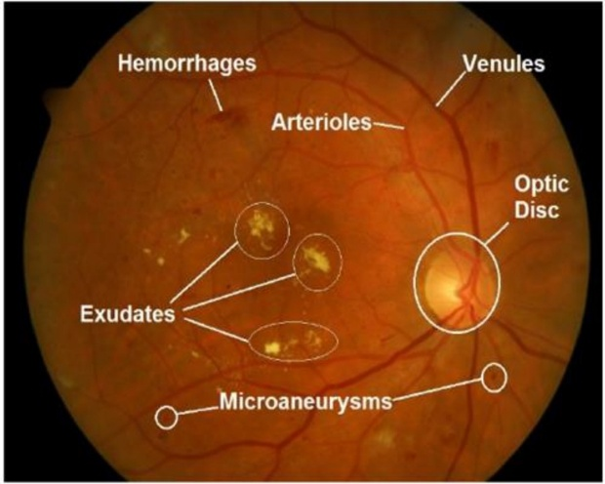
Figure 1.1. Example of Retinography image on Eye Fundus region
    - CT-Scan Imaging
Tomography (CT) provides cross-sectional anatomical details by measuring the attenuation of X-rays from multiple angles and reconstructing them into a 3D volume or 2D axial slices. The intensity values in CT imaging are standardized into Hounsfield Units (HU), which represent a linear transformation of the original linear attenuation coefficients $(μ)$ of tissues relative to the attenuation of water $\left(μ_{water}\right)$ and air $(μ_{air})$. The HU scale is defined as:
$$HU=100×\frac{μ_{tissue}-μ_{water}}{μ_{water}-μ_{air}}$$
On this scale, water is defined as 0 HU and air as -1000 HU. This quantitative nature allows for precise "windowing" (adjusting the center and width of the intensity display) to highlight specific tissues, such as the mediastinal window for heart segmentation or the lung window for pulmonary parenchyma analysis. An example of CT-Scan on Thoracic image can be seen in Figure 1.2 below:
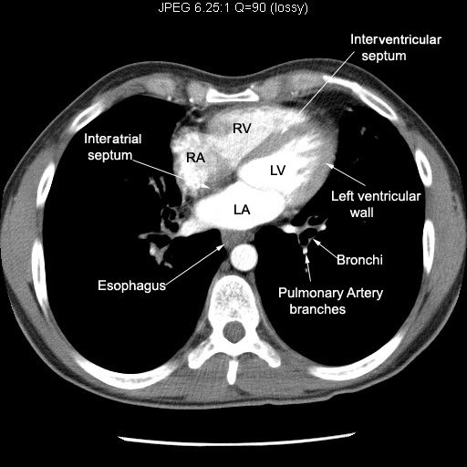
Figure 1.2. Example of CT-Scan image on Thoracic region
    - X-Ray Imaging
Chest X-Ray (CXR) remains the most prevalent projection-based modality, where a 2D image is formed by the differential absorption of X-ray photons as they pass through the body. Tissues with high electron density, such as bone or consolidated lung tissue (pneumonia), attenuate more radiation and appear "radiopaque" (bright), while air-filled organs like the lungs appear "radiolucent" (dark). A critical diagnostic parameter in CXR is the Cardiothoracic Ratio (CTR), which compares the maximum transverse diameter of the heart to the maximum inner diameter of the ribcage. Accurate CTR measurement requires the extraction of both the heart silhouette and the lateral boundaries of the lung fields, as expressed in the following ratio:
$$CTR=\frac{Cardiac Width}{Thoracic Width}$$
For more details on the X-Ray image, an example of X-Ray on Thoracic image can be seen in Figure 1.3 below:
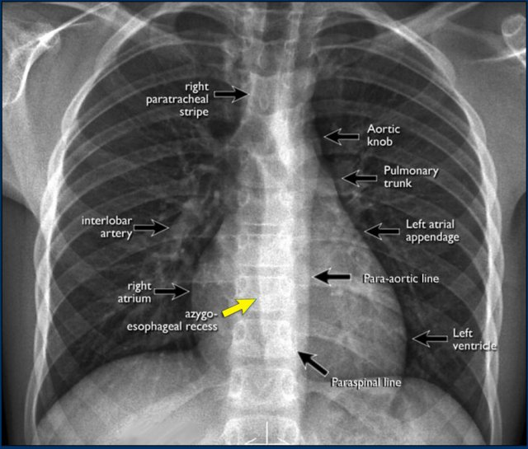
Figure 1.3. Example of X-Ray image on Thoracic region
    - Ultrasound Imaging
Ultrasound imaging utilizes the pulse-echo principle of high-frequency acoustic waves to visualize internal structures in real-time. The image is formed based on the intensity of reflections (echoes) from tissue interfaces, which is categorized as "echogenicity." Fluid-filled structures (like amniotic fluid) appear anechoic (black), while dense structures (like the fetal skull) appear hyperechoic (white). However, ultrasound is inherently corrupted by "speckle noise," a granular interference pattern caused by the coherent accumulation of backscattered waves. In fetal biometry, parameters such as the Biparietal Diameter (BPD) and Head Circumference (HC) are vital for estimating gestational age, usually modeled using an elliptical approximation:
$$HC≈\left[3\left(a+b\right)-\sqrt{\left(3a+b\right)\left(a+3b\right)}\right]$$
where $a$ and $b$ are the semi-major and semi-minor axes of the fitted fetal skull ellipse. For more details on the Ultrasound image, an example of Ultrasound on Fetal Head image can be seen in Figure 1.4 below:
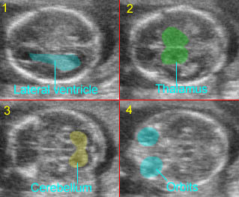
Figure 1.4. Example of Ultrasound image on Fetal Head region
  - Image Preprocessing
Image preprocessing serves as the foundational stage in medical image analysis, aimed at improving the quality of raw data and isolating relevant anatomical regions for subsequent computational tasks. In the clinical environment, raw images often contain unwanted artifacts, inconsistent lighting, or irrelevant background information that can hinder the performance of segmentation algorithms. One of the most critical preprocessing steps used in this study is Region of Interest (ROI) selection through manual or automated cropping. By defining a specific coordinate bounding box $\left[x_{min}, x_{max},y_{min},y_{max}\right]$, the system narrows its computational focus to specific organs—such as the cardiac silhouette in X-rays or the optic disc in fundus images, thereby reducing processing time and minimizing the influence of peripheral noise.
Furthermore, medical images are frequently corrupted by noise during the acquisition process. In Ultrasound imaging, "speckle noise" is a dominant characteristic that appears as a granular pattern, which is effectively mitigated using non-linear filters such as the Median Filter. Unlike linear smoothing, the Median Filter preserves sharp edges (critical for skull detection) by replacing each pixel value with the median of the intensity values in its neighborhood $W$:
$$g\left(x,y\right)=median\left\{f\left(s,t\right)|\left(s,t\right)∈W\right\}$$
In CT and X-ray modalities, spatial smoothing using a Gaussian kernel is often employed before segmentation to produce a more homogeneous intensity distribution, represented by the convolution of the image $f(x,y)$ with a Gaussian function $G\left(x,y,σ\right)$:
$$G\left(x, y, σ\right) = \frac{1}{2πσ^{2}}e^{-\frac{x^{2}+y^{2}}{2a^{2}}}$$
This smoothing process is vital for multi-Otsu thresholding, as it reduces local variances that could lead to fragmented segmentation masks. By ensuring the input data is "clean" and spatially focused, preprocessing creates a standardized environment for advanced feature extraction.
  - Image Enhancement
Image enhancement focuses on accentuating specific features within a medical image, such as boundaries, textures, or low-contrast lesions, to make them more suitable for both human interpretation and machine analysis. Unlike preprocessing, which primarily removes "evils" like noise, enhancement aims to "boost" existing information. A fundamental technique is Contrast Stretching (Normalization), which linearly maps the existing range of intensity values $\left[r_{min},r_{max}\right]$ to a full 8-bit dynamic range $[0, 255]$. This is particularly useful in Fundus and X-ray images where the original data may occupy only a narrow portion of the histogram:
$$s = T\left(r\right)= \left(r - r_{min}\right)\frac{255}{r_{min}-r_{max}}$$
For more complex intensity distributions where global linear stretching is insufficient, Histogram Equalization (HE) is employed. This technique redistributes pixel intensities so that the output histogram is approximately uniform, effectively increasing the global contrast. In a discrete image, the transformation is based on the Cumulative Distribution Function (CDF):
$$s_{k} = T(r_{k}) = (L-1) \sum_{j=0}^{k}{p_{r}\left(r_{j}\right)}$$
where $p_{r}\left(r_{j}\right)$ is the probability of occurrence of intensity level $r_{j}$ and $L$ is the total number of gray levels (typically 256). However, global HE often over-amplifies noise in medical contexts. To address this, Contrast Limited Adaptive Histogram Equalization (CLAHE) is utilized. CLAHE operates on small local tiles rather than the entire image and applies a "clip limit" to prevent the over-saturation of contrast in homogeneous areas. This method is instrumental in revealing the delicate vascular structures in Retinography and the internal tissue variations of the heart in CT scans. By optimizing the contrast, enhancement ensures that the intensity-based segmentation, like Otsu or watershed can accurately distinguish between different tissue classes.
  - Performance Evaluation
Quantitative metrics are indispensable in medical image processing to provide an objective measure of the quality of enhanced or restored images. One of the most fundamental metrics is the Root Mean Square Error (RMSE), which quantifies the average magnitude of the difference between the intensity values of the original image $f(x,y)$ and the processed image $\hat{f}(x,y)$. A lower RMSE indicates a higher fidelity to the original data, suggesting that the enhancement process has not introduced significant intensity distortions. Closely related to RMSE is the Peak Signal-to-Noise Ratio (PSNR), which expresses the ratio between the maximum possible power of a signal and the power of corrupting noise that affects the fidelity of its representation. Measured in decibels (dB), PSNR is mathematically defined as:
$$PSNR = 10 ×\log_{10}\left(\frac{{MAX}_{I}^{2}}{MSE}\right)$$
where ${MAX}_{I}$ is the maximum possible pixel value (e.g., 255 for an 8-bit image) and $MSE$ is the Mean Squared Error. Higher PSNR values typically correlate with superior image quality, particularly in noise-reduction tasks such as despeckling ultrasound images.
While pixel-wise metrics like RMSE and PSNR are computationally efficient, they often fail to fully capture the perceived visual quality as interpreted by the human visual system (HVS). To address this limitation, the Structural Similarity Index Measure (SSIM) is employed as a more advanced metric. SSIM is a perception-based model that considers image degradation as a perceived change in structural information. It evaluates the similarity between two images by comparing three specific components: luminance $(l)$, contrast $(c)$, and structure $(s)$. The index is calculated as a product of these terms:
$$SSIM(x,y) = {\left[l(x,y)\right]}^{α}×{\left[c(x,y)\right]}^{β}×{\left[s(x,y)\right]}^{γ}$$
The resulting value ranges from -1 to 1, where a value of 1 indicates perfect structural identity. In clinical applications, such as identifying the thin boundaries of the fetal skull or the sharp edges of the heart silhouette, SSIM serves as a critical indicator to ensure that morphological features remain intact after contrast enhancement.
In addition to fidelity-based metrics, the information content and complexity of the processed image are evaluated using Shannon Entropy. In information theory, entropy $(H)$ measures the average amount of information or uncertainty produced by a source, which in the context of digital imaging represents the richness of the gray-level distribution. An image with a broad and varied distribution of intensities, indicating high contrast and visible texture, will exhibit higher entropy. Conversely, a low-contrast image where most pixels cluster around a few gray levels will have lower entropy. The discrete formula for image entropy is expressed as:
$$H = -\sum_{i=o}^{L-1}{p\left(r_{i}\right)\log_{2}{p\left(r_{i}\right)}}$$
where $p\left(r_{i}\right)$ is the probability of the intensity level $r_{i}$ occurring in the image. In this study, entropy is utilized to verify the effectiveness of techniques like CLAHE and Histogram Equalization in enhancing the diagnostic details of retinal vasculature or the pulmonary parenchyma within X-ray and CT slices.
  - Image Restoration
While image enhancement is a subjective process designed to make an image more visually appealing or suitable for specific tasks, image restoration is an objective, mathematical process aimed at recovering an image that has been degraded. In medical imaging, the acquisition process inevitably introduces degradation due to sensor limitations, patient movement, or the physical properties of the waves penetrating the tissue. The degradation process is mathematically modeled as an uncorrupted image $f(x,y)$ that is operated upon by a degradation function $H$, combined with an additive noise term $η(x,y)$, to produce the observed degraded image $g(x,y)$:
$$g(x, y) = H[f(x, y)] +η(x,y)$$
In the spatial domain, if $H$ is a linear, position-invariant process, this relationship can be expressed as a convolution:
$g(x, y) = h(x, y) * f(x, y) + η(x,y)$,
The objective of restoration is to obtain an estimate $\hat{f}(x,y)$ that is as close as possible to the original image $f(x,y)$. In modalities like Chest X-Rays and CT scans, quantum mottle (modeled as Poisson or Gaussian noise) degrades the tissue boundaries. Low-pass spatial filters, such as the Gaussian blur utilized in the earlier processing stages, act as restoration estimators that mitigate $η(x,y)$, by averaging out high-frequency spatial variations before the segmentation phase.
In the context of automated medical segmentation, restoration is not limited to grayscale pixel intensity, it extends significantly into the binary domain to restore the topological and structural integrity of anatomical shapes. When a degraded medical image is thresholded (e.g., using multi-Otsu methods), the resulting binary masks are frequently fragmented. They may exhibit jagged edges, disconnected components, or artificial "holes" within solid organs due to internal tissue variations, such as the varying echogenicity inside a fetal skull or calcifications in a cardiac silhouette. To mathematically restore these anatomical geometries, Mathematical Morphology is applied. Based on set theory, the two fundamental operations are Dilation $(⊕)$, which expands boundaries, and Erosion $(⊖)$, which shrinks them.
To restore broken boundaries and bridge small gaps without fundamentally altering the global size of the anatomical structure, the Morphological Closing operation is employed. Closing is defined as a dilation followed by an erosion using a specific structuring element (kernel) $B$:
$$A ∙ B = (A ⊕ B)⊖ B$$
This operation acts as a structural restorer, smoothing the contour of masks and fusing narrow breaks. Conversely, Morphological Opening, an erosion followed by a dilation, is used to eliminate small, detached noise artifacts (such as irrelevant background tissue) while preserving the core object:
$$A ∘ B = (A ⊖ B) ⊕B$$
Furthermore, advanced topological restoration techniques, such as binary hole-filling algorithms, are strictly required to ensure that the Region of Interest (ROI) is completely solid. By deploying these morphological restoration techniques, fragmented pixel clusters are successfully reconstructed into cohesive, continuous representations of the fetal cranium, optic disc, or cardiac silhouette, making accurate geometric measurements possible.
  - Edge Detection and ROI Segmentation
After restoring the structural integrity of the degraded image, the subsequent critical phase is isolating the specific anatomical structures from the background, a process known as Region of Interest (ROI) segmentation. In automated medical image analysis, region-based segmentation is primarily achieved through statistical thresholding techniques, particularly Otsu's method and its multi-class extension (Multi-Otsu). Otsu's algorithm calculates the optimal threshold value $T$ by maximizing the inter-class variance between the foreground and background pixels, effectively minimizing the intra-class variance. For a preprocessed image $f(x,y)$, the binary segmented mask $g(x,y)$ is mathematically defined as:
$$g\left(x, y\right)= \left\{\begin{aligned}1, if f\left(x,y\right)>T \\ 0, if f\left(x,y\right)≤T\end{aligned}\right.$$
In more complex modalities such as CT scans and Ultrasound, where tissues, bones, and fluids exhibit distinct and overlapping intensity clusters, Multi-Otsu thresholding extends this principle to separate the image into multiple distinct regions. This allows the algorithm to selectively isolate the target organ, such as differentiating the skull bone from the amniotic fluid and brain tissue, forming the foundational mask for the ROI.
Once the solid binary mask of the ROI is formed, edge detection is employed to extract the exact boundary or contour of the anatomical structure. In digital image processing, an edge is defined as a set of connected pixels that lie on the boundary between two regions of significantly different gray-level intensities. Gradient-based methods, such as the Sobel operator, detect these discontinuities by computing the first-order spatial derivatives of the image. The local edge gradient magnitude $\left|∇f\right|$ is computed using the horizontal $(G_{x})$ and vertical $(G_{y})$ derivative approximations:
$$\left|∇f\right|=\sqrt{G_{x}^{2}+ G_{y}^{2}}$$
Alternatively, within the binary morphological framework, the structural boundary of a solid segmented ROI can be rapidly and cleanly identified by performing a logical difference operation between the dilated mask and the original mask. If $A$ is the solid segmented mask and $B$ is a minimal structuring element such as a disk kernel, the morphological edge $E$ is extracted as:
$$E = (A ⊕ B) - A$$
This boundary extraction is crucial for evaluating the "Edge Gradient Strength", a vital metric to detect pathologies like the silhouette sign in pneumonia, and for visually verifying the contour of the fetal skull, cardiac silhouette, or optic disc against the original anatomy.
The final step in the segmentation pipeline is the exact spatial localization and extraction of the ROI using Connected Component Analysis (CCA). When thresholding and morphological operations generate multiple foreground objects, CCA scans the binary image and groups adjacent pixels into distinct labeled clusters. By evaluating the geometric properties of these clusters, such as pixel area, centroid coordinates ${(x}_{c},y_{c})$, and bounding box boundaries $\left[min_{row}, min_{col}, max_{row}, max_{col}\right]$, the algorithm intelligently filters out background noise and selects the largest, most clinically relevant blob. The bounding box acts as a spatial crop, stripping away the remaining irrelevant background and leaving only the isolated organ. This precise spatial localization guarantees that the subsequent feature extraction algorithms compute metrics based solely on the pure anatomical tissue without background contamination.
  - Features Extraction
The culmination of the medical image processing pipeline is feature extraction, wherein the isolated anatomical Region of Interest (ROI) is transformed into objective, quantifiable numerical data. These extracted features serve as the primary inputs for clinical diagnosis, anomaly detection, and predictive modeling. The features extracted can be broadly classified into three categories: geometric (morphological) properties, first-order intensity statistics, and second-order texture characteristics. Morphological features evaluate the physical shape and size of the segmented mask. Fundamental metrics include the Area $(A)$, representing the total number of pixels within the ROI, and the Perimeter $(P)$, which traces the boundary length. To assess the shape's deviation from a perfect circle, the Circularity metric is calculated using the following equation:
$$Circularity = \frac{4πA}{P^{2}}$$
For specific obstetric applications, such as fetal ultrasound biometry, the segmented cranial mask is mathematically fitted to an Ellipse Model. This fitting yields the semi-major axis $(a)$ and semi-minor axis $(b)$, which correspond directly to the Occipitofrontal Diameter (OFD) and Biparietal Diameter (BPD), respectively. The Eccentricity $(e)$ of this ellipse provides critical information regarding cranial deformities, calculated as $e = \sqrt{1 - {\left(\frac{b}{a}\right)}^{2}}$. In radiological assessments, bounding box coordinates are utilized to extract maximum transverse dimensions, enabling the calculation of critical diagnostic ratios such as the Cardiothoracic Ratio (CTR) in chest X-rays and CT scans.
The second category encompasses first-order statistical features, which are derived from the intensity distribution of the original image pixels strictly within the boundaries of the segmented mask. While morphological features analyze the binary shape, intensity features evaluate the physical properties of the underlying tissue, such as its density or echogenicity. The Mean Intensity $μ$ provides the average brightness or Hounsfield Unit (HU) value of the organ, which is crucial for distinguishing between fluid, soft tissue, and calcification. It is defined as:
$$μ =\frac{1}{N}\sum_{(x,y)∈ROI}{f(x,y)}$$
where $N$ is the total number of pixels in the ROI and $f(x,y)$ is the pixel intensity. Additionally, the Intensity Variance $(σ^{2})$ measures the dispersion of these pixel values around the mean. A high variance in a cardiac silhouette or a fetal brain indicates significant tissue heterogeneity, which may act as an early indicator of pathological conditions or infections.
To capture more complex spatial heterogeneities that simple intensity statistics cannot describe, second-order statistical features are extracted using the Gray-Level Co-occurrence Matrix (GLCM). The GLCM analyzes the spatial relationship between pairs of pixels by tabulating how often a pixel with gray-level $i$ occurs adjacent to a pixel with gray-level $j$ at a specific distance and angle. From this normalized matrix $P(i,j)$, robust radiomic texture features are computed. Two of the most clinically relevant GLCM features are Contrast and Homogeneity. Contrast measures the local variations and sudden intensity changes within the tissue, such as fibrotic scars or pneumonia consolidations and is expressed as:
$$Contrast = \sum_{i,j}{{\left|i-j\right|}^{2}P(i,j)}$$
Conversely, Homogeneity measures the spatial closeness of the distribution of elements in the GLCM to the GLCM diagonal, indicating texture smoothness:
$$Homogeneity = \sum_{i,j}{\frac{P(i,j)}{1+{\left|i+j\right|}^{2}}}$$
By combining these morphological, intensity, and textural features, the system provides a comprehensive, multi-dimensional profile of the targeted anatomy, whether it is the optic disc, the fetal cranium, or the cardiac silhouette, forming a robust foundation for subsequent diagnostic analysis.

CHAPTER II. RESULT AND ANALYSIS
2.1. Problems Statement
- X-ray Dataset: Chest X-Ray Images (Pneumonia). Select two normal images and two pneumonia images. Perform image enhancement, image restoration, etc. Then segment the heart from the chest X-ray images.
- Fundus Retina dataset. Normal and Retinography. Perform the same image processing as dataset 1, segmenting the optic disc.
- CT images: CT Medical Images. Perform the same image processing as dataset 1, segmenting the heart.
- Ultrasound Fetus Dataset: Ultrasound Fetus Dataset. Take two normal images and segment the fetal head.
2.2. Code Explanation
This sub-chapter provides a technical decomposition of the algorithms implemented across the five imaging modules and the central graphical user interface (GUI). The code is designed following a modular architecture, where each modality-specific script handles the specialized preprocessing, enhancement, and radiomic feature extraction required for its respective clinical application.
- Xray_lung_pneumonia_module.py
The Xray_lung_pneumonia_module.py script is architected around the XRayProcessor class, which encapsulates the entire lifecycle of chest radiograph analysis. This lifecycle begins with data ingestion and progresses through specialized preprocessing, comparative contrast enhancement, and multi-stage segmentation, finally culminating in the extraction of radiomic and morphological features. The script is designed to be "GUI-ready," meaning it separates computational logic from visual rendering by returning Matplotlib Figure objects and Pandas DataFrames, allowing for seamless integration into the PyQt6-based main interface.
- Preprocessing and and Thoracic Field Estimation (step2_crop)
This section of the code handles the initial spatial normalization and the critical task of estimating the thoracic width from the uncropped image. To avoid the "narrow-focus" error where the lung boundaries are lost during cropping, this function performs an early-stage segmentation on the full grayscale image. By isolating the pulmonary fields before focusing on the heart, the system ensures that the denominator of the Cardiothoracic Ratio (CTR) remains accurate relative to the patient's actual anatomy.
- def step2_crop(self, img_gray, title):
- # 1. Use Otsu to find dark areas (lung air and external background)
- lung_thresh = filters.threshold_otsu(img_gray)
- lung_mask = img_gray < lung_thresh

- # 2. Label all dark regions
- labeled_lungs = measure.label(lung_mask)
- lung_props = measure.regionprops(labeled_lungs)

- valid_lungs = []
- height, width = img_gray.shape

- for p in lung_props:
- # Filter 1: Remove small noise (dynamic: minimum 0.5% of total image area)
- if p.area < (height * width * 0.005):
- continue

- y_c, x_c = p.centroid

- # Filter 2: Remove external background at the left/right edges based on Centroid.
- # The centroid of the patient's lungs is always located more towards the center of the image.
- # If the centroid is very close to the outer edge (< 8% or > 92% of the width),
- # then it is definitely external background.
- if x_c < width * 0.08 or x_c > width * 0.92:
- continue

- # Save the valid lung objects
- valid_lungs.append(p)

- left_bound = 0
- right_bound = width
- lung_mask_cleaned = np.zeros_like(lung_mask)

- if valid_lungs:
- # 3. Take the 2 largest valid lung regions (in case of some fragmentation) and create a clean mask
- lung_props_sorted = sorted(valid_lungs, key=lambda x: x.area, reverse=True)
- top_lungs = lung_props_sorted[:2]

- # Create a clean mask containing only the lungs to visualize
- for p in top_lungs:
- lung_mask_cleaned[labeled_lungs == p.label] = True

- # Find the leftmost and rightmost bounds of the lungs to estimate thoracic width
- min_cols = [p.bbox[1] for p in top_lungs]
- max_cols = [p.bbox[3] for p in top_lungs]
- left_bound = min(min_cols)
- right_bound = max(max_cols)
- thoracic_width = right_bound - left_bound
- else:
- thoracic_width = width # Fallback

- print(f"[INFO] Estimasi Thoracic Width pada citra asli: {thoracic_width} px")

- # Crop the image manually to isolate the lower-middle chest (Heart and Lungs region)
- x_min, x_max, y_min, y_max = self.crop_coords.get(title, (0, width, 0, height))
- x_min, x_max = max(0, x_min), min(width, x_max)
- y_min, y_max = max(0, y_min), min(height, y_max)

- fig_lung, ax_lung = plt.subplots(1, 2, figsize=(14, 5))
- ax_lung[0].imshow(lung_mask_cleaned, cmap='gray')
- ax_lung[0].set_title("Cleaned Lung Mask (Centroid Filtered)")
- ax_lung[0].grid(False)

- ax_lung[1].imshow(img_gray, cmap='gray')
- ax_lung[1].axvline(x=left_bound, color='cyan', linestyle='--', linewidth=2, label='Thoracic Bounds')
- ax_lung[1].axvline(x=right_bound, color='cyan', linestyle='--', linewidth=2)

- bx = (x_min, x_max, x_max, x_min, x_min)
- by = (y_min, y_min, y_max, y_max, y_min)
- ax_lung[1].plot(bx, by, '-g', linewidth=2, label='Crop ROI Reference')
- ax_lung[1].set_title(f"Thoracic Width Estimation: {thoracic_width} px")
- ax_lung[1].legend(loc='upper right', fontsize=10)
- ax_lung[1].grid(False)
- fig_lung.tight_layout()

- img_crop = img_gray[y_min:y_max, x_min:x_max]
- print(f"-> Cropped at X:({x_min}-{x_max}), Y:({y_min}-{y_max})")

- return img_crop, (x_min, x_max, y_min, y_max), thoracic_width, fig_lung
The implementation utilizes Otsu's thresholding to generate a binary mask where the air-filled lungs (low attenuation) are separated from the denser soft tissue and background. A sophisticated centroid-based filtering mechanism is then applied to the labeled objects. This is necessary because the dark air regions outside the patient's body often share similar intensity profiles with the lungs. By evaluating the centroid coordinates $\left(\hat{x},\hat{y}\right)$, the algorithm discards objects located too close to the lateral boundaries (e.g., $x<8\% or x>92\%$ of image width), effectively preserving only the true pulmonary parenchyma.
Once the background is cleared, the system identifies the two largest remaining objects, representing the left and right lungs, to determine the global lateral boundaries. The thoracic_width is computed as the distance between the minimum and maximum column indices $(x_{max} - x_{min} )$ of these validated objects. Following this estimation, the script performs a manual crop based on predefined coordinates to isolate the heart and lower lung regions, creating a focused Region of Interest (ROI) for the more computationally intensive segmentation steps that follow.
- Enhancement and Performance Evaluation (step3_evaluate_enhancement)
Image enhancement in this module is treated as a competitive process where three distinct techniques, Contrast Stretching, Histogram Equalization (HE), and Contrast Limited Adaptive Histogram Equalization (CLAHE), are evaluated against the original cropped image. The primary objective is to maximize the contrast between the cardiac silhouette and the surrounding pulmonary tissue, which is often obscured by the infiltrates present in pneumonia cases. Each method is quantified using a suite of metrics designed to measure fidelity and information gain.
- def step3_evaluate_enhancement(self, img_crop, title):
- p2, p98 = np.percentile(img_crop, (2, 98))
- img_cs = exposure.rescale_intensity(img_crop, in_range=(p2, p98), out_range=(0, 255)).astype(np.uint8)
- img_he = (exposure.equalize_hist(img_crop) * 255).astype(np.uint8)
- img_clahe = (exposure.equalize_adapthist(img_crop, clip_limit=0.03) * 255).astype(np.uint8)

- methods = [("Contrast Stretching", img_cs), ("Histogram Eq", img_he), ("CLAHE", img_clahe)]
- metrics_data = []
- for name, img in methods:
- rmse, psnr, ssim, entropy = self.calc_metrics(img_crop, img)
- metrics_data.append({
- "Enhancement Method": name,
- "RMSE (levels)": rmse,
- "PSNR (dB)": psnr,
- "SSIM": ssim,
- "Entropy (bits)": entropy
- })

- df_metrics = pd.DataFrame(metrics_data)

- fig2, axes2 = plt.subplots(2, 4, figsize=(20, 10))
- images = [img_crop, img_cs, img_he, img_clahe]
- titles = ["Original Cropped", "Contrast Stretching", "Histogram Eq", "CLAHE"]

- for i in range(4):
- axes2[0, i].imshow(images[i], cmap='gray'); axes2[0, i].set_title(titles[i], fontsize=12); axes2[0, i].grid(False)
- self.plot_hist_with_ogive(images[i].ravel(), axes2[1, i], 'teal', f"Hist+Ogive: {titles[i]}")
- fig2.tight_layout()

- fig_bar, ax_bar = plt.subplots(2, 2, figsize=(14, 10))

- sns.barplot(data=df_metrics, x="Enhancement Method", y="RMSE (levels)", hue="Enhancement Method", legend=False, ax=ax_bar[0,0], palette="Reds")
- ax_bar[0,0].set_title("RMSE (Lower is Better)")
- sns.barplot(data=df_metrics, x="Enhancement Method", y="PSNR (dB)", hue="Enhancement Method", legend=False, ax=ax_bar[0,1], palette="Greens")
- ax_bar[0,1].set_title("PSNR (Higher is Better)")
- sns.barplot(data=df_metrics, x="Enhancement Method", y="SSIM", hue="Enhancement Method", legend=False, ax=ax_bar[1,0], palette="Blues")
- ax_bar[1,0].set_title("SSIM (Preserves structures)")
- sns.barplot(data=df_metrics, x="Enhancement Method", y="Entropy (bits)", hue="Enhancement Method", legend=False, ax=ax_bar[1,1], palette="Purples")
- ax_bar[1,1].set_title("Entropy (Vascular and Infection Detail)")
- fig_bar.tight_layout()

- # Dictionary to store the enhanced images so the GUI can pick one based on Combobox selection
- enhanced_images_dict = {
- "Contrast Stretching": img_cs,
- "Histogram Equalization": img_he,
- "CLAHE": img_clahe
- }

- return enhanced_images_dict, df_metrics, fig2, fig_bar
The evaluation utilizes the calc_metrics helper function, which computes the Root Mean Square Error (RMSE) to track intensity distortion and the Peak Signal-to-Noise Ratio (PSNR) to assess the ratio of signal power to noise. Additionally, the Structural Similarity Index Measure (SSIM) is used to ensure that the enhancement does not destroy the underlying anatomical structures, while Shannon Entropy assesses the richness of the details revealed. This quantitative approach allows the user to select the enhancement method that provides the best balance between contrast gain and structural preservation for a specific image.
Visually, this part of the code generates comparative histogram plots and ogive curves (Cumulative Distribution Functions). These visualizations illustrate how each enhancement method redistributes pixel intensities across the 8-bit range (0-255). For instance, while Histogram Equalization might achieve a perfectly flat distribution, it often over-enhances noise in the pulmonary fields. In contrast, CLAHE provides a more localized and controlled contrast boost, which is generally preferred for preserving the subtle vascular markings and infection-related opacities required for a comprehensive diagnostic assessment.
- Cardiac Segmentation Pipeline (step4_segment_and_extract)
The core segmentation logic employs a "low-pass to high-detail" pipeline designed to isolate the cardiac silhouette from the surrounding anatomical complexity. This process begins with significant Gaussian blurring to suppress high-frequency noise and local intensity variations caused by pulmonary vessels or pneumonia consolidations. By smoothing the image, the algorithm prepares a "density map" where the larger, more homogeneous mass of the heart becomes the dominant feature for thresholding.
- def step4_segment_and_extract(self, best_img, img_crop, img_full, coords, thoracic_width, title, method_name):
- # 1. Smoothing and Thresholding
- blurred_img = filters.gaussian(best_img, sigma=5, preserve_range=True)
- try:
- thresholds = filters.threshold_multiotsu(blurred_img, classes=3)
- regions = np.digitize(blurred_img, bins=thresholds)
- dense_mask = (regions >= 1)
- except ValueError:
- dense_mask = (blurred_img > filters.threshold_otsu(blurred_img))

- # 2. Morphological Refinement
- opened_mask = morphology.binary_opening(dense_mask, morphology.disk(25))
- heart_filled = ndi.binary_fill_holes(opened_mask)
- heart_silhouette = morphology.binary_closing(heart_filled, morphology.disk(15))
The script primarily uses Multi-Otsu thresholding to categorize pixels into three classes, effectively separating the dark air, the medium-density lung tissue, and the high-density cardiac/vascular structures. From the resulting binary mask, the largest connected component is extracted as the "heart core." However, this core often remains connected to the spine or diaphragm. To resolve this, a heavy morphological opening with a large disk kernel (radius 25) is applied to "prune" narrow connections, followed by binary hole filling to restore a solid internal area.
The final refinement step involves morphological closing and dilation-based edge detection. By applying binary_closing, the algorithm smooths the "organic" edges of the heart, removing jagged artifacts caused by the overlapping ribs. The resulting boundary is then extracted by taking the logical XOR between the dilated mask and the original mask. This creates a closed-loop contour that is overlaid back onto the original high-resolution radiograph, providing a visual confirmation of the segmentation's anatomical accuracy before features are computed.
- Feature Extraction and CTR Calculation (extract_features)
The extraction phase transforms the segmented heart mask into clinical and radiomic data points. This function operates on both the binary mask for morphological features, and the original cropped grayscale image (for intensity and texture features). The most critical clinical parameter calculated here is the Cardiothoracic Ratio (CTR), which is derived by comparing the maximum horizontal span of the heart silhouette to the thoracic_width captured during the preprocessing stage.
- def extract_features(self, heart_mask, img_crop, thoracic_width):
- # Extract Morphological and Texture features, including Edge Gradient Strength and CTR.
- labeled_heart = measure.label(heart_mask)
- props = measure.regionprops(labeled_heart, intensity_image=img_crop)

- if not props:
- return {k: 0 for k in ['Area (px^2)', 'Perimeter (px)', 'Cardiac Width (px)', 'Thoracic Width (px)', 'CTR (Ratio)', 'Circularity',
- 'Mean Intensity (0-255)', 'Intensity Variance', 'GLCM Contrast',
- 'GLCM Homogeneity', 'Edge Gradient Strength']}

- prop = props[0]
- area = prop.area
- perimeter = prop.perimeter

- # 1. CARDIAC WIDTH
- minr, minc, maxr, maxc = prop.bbox
- cardiac_width = maxc - minc

- # 2. CARDIOTHORACIC RATIO (CTR)
- ctr = cardiac_width / thoracic_width if thoracic_width > 0 else 0

- circularity = (4 * math.pi * area) / (perimeter ** 2) if perimeter > 0 else 0

- heart_pixels = img_crop[heart_mask]
- mean_int = prop.mean_intensity
- var_int = np.var(heart_pixels) if len(heart_pixels) > 0 else 0

- # Texture
- bbox_img = img_crop[minr:maxr, minc:maxc]
- glcm_contrast = 0; glcm_homog = 0
- if bbox_img.size > 0:
- glcm = graycomatrix(bbox_img, distances=[1], angles=[0], levels=256, symmetric=True, normed=True)
- glcm_contrast = graycoprops(glcm, 'contrast')[0, 0]
- glcm_homog = graycoprops(glcm, 'homogeneity')[0, 0]

- # Edge Strength
- sobel_grad = filters.sobel(img_crop)
- edge_mask = morphology.binary_dilation(heart_mask, morphology.disk(1)) ^ heart_mask
- edge_pixels = sobel_grad[edge_mask]
- edge_strength = np.mean(edge_pixels) if len(edge_pixels) > 0 else 0

- return {
- "Area (px^2)": round(area, 2),
- "Perimeter (px)": round(perimeter, 2),
- "Cardiac Width (px)": cardiac_width,
- "Thoracic Width (px)": thoracic_width,
- "CTR (Ratio)": round(ctr, 4),
- "Circularity": round(circularity, 4),
- "Mean Intensity (0-255)": round(mean_int, 2),
- "Intensity Variance": round(var_int, 2),
- "GLCM Contrast": round(glcm_contrast, 4),
- "GLCM Homogeneity": round(glcm_homog, 4),
- "Edge Gradient Strength": round(edge_strength, 4)
- }
Beyond simple geometry, the code extracts first-order statistics such as Mean Intensity and Intensity Variance. These values describe the density and homogeneity of the heart tissue, which can be useful in identifying fluid accumulation in the pericardium or significant infection overlap. The addition of "Edge Gradient Strength", computed using a Sobel filter applied specifically to the boundary of the mask, provides a quantitative measure of the "sharpness" of the heart border. A low gradient strength often indicates a "silhouette sign," where the heart border becomes blurred due to adjacent lung consolidation.
Texture analysis is performed via the Gray-Level Co-occurrence Matrix (GLCM), specifically focusing on Contrast and Homogeneity. Contrast in this context represents the local intensity variations within the cardiac ROI, while Homogeneity measures the spatial smoothness. These radiomic features, combined with the CTR value, allow for a multi-faceted evaluation of the patient's condition, potentially distinguishing between simple cardiomegaly and complex cases involving both cardiac enlargement and active pneumonia infections.
- CTscan_chest_cancer_module_TIFF.py
The CTscan_chest_cancer_module_TIFF.py script is specifically designed to handle Computed Tomography (CT) images stored in the Tagged Image File Format (TIFF). While DICOM is the medical standard, TIFF versions are often used in research datasets for high-bit-depth grayscale representation. This module focuses on the axial view of the thorax to isolate the cardiac region and calculate the axial Cardiothoracic Ratio (aCTR). The script utilizes the CTTiffProcessor class to manage a modular pipeline that mirrors the X-ray module but is optimized for the distinct intensity distributions of CT slices.
- Centroid-Based Thoracic Estimation and Cropping (step1_plot_initial_and_crop)
In axial CT imaging, the thoracic width is defined by the maximum transverse diameter of the ribcage or the lateral boundaries of the lung fields. This script implements an advanced preprocessing step that estimates this width before any cropping occurs. This is vital for maintaining the integrity of the aCTR calculation, as it ensures the "Thoracic Width" parameter is grounded in the full anatomical scale of the slice rather than a focused sub-region.
- def step1_plot_initial_and_crop(self, img_gray, title):
- fig1, axes1 = plt.subplots(1, 2, figsize=(14, 5))
- axes1[0].imshow(img_gray, cmap='bone')
- axes1[0].set_title("Original CT Slice (Check crop coordinates here)")
- axes1[0].grid(False)
- self.plot_hist_with_ogive(img_gray.ravel(), axes1[1], 'gray', "Original Image Histogram")
- fig1.tight_layout()

- x_min, x_max, y_min, y_max = self.crop_coords.get(title, (0, img_gray.shape[1], 0, img_gray.shape[0]))
- x_min, x_max = max(0, x_min), min(img_gray.shape[1], x_max)
- y_min, y_max = max(0, y_min), min(img_gray.shape[0], y_max)

- img_crop = img_gray[y_min:y_max, x_min:x_max]
- print(f"-> Cropped at X:({x_min}-{x_max}), Y:({y_min}-{y_max})")

- return img_crop, (x_min, x_max, y_min, y_max), fig1
The algorithm employs Otsu’s thresholding to generate a binary mask of the air-filled regions (lungs and external background). To distinguish the internal lungs from the external air, a centroid-based filtering logic is applied. By evaluating the horizontal centroid position $(x_{c})$, the code discards objects that are positioned too close to the image boundaries. This ensures that the subsequent width calculation is derived strictly from the patient's internal pulmonary parenchyma, providing a precise "Thoracic Width" even if the lungs are partially clipped or exhibit varying shapes across different axial levels.
Following the validation of the lung objects, the code identifies the minimum and maximum column indices to determine the lateral boundaries. A manual ROI crop is then performed based on predefined coordinates to isolate the heart, which typically resides in the mediastinum between the two lung fields. This cropped image is then rescaled to an 8-bit range (0-255) if necessary, ensuring that all subsequent enhancement and segmentation steps operate on a standardized intensity scale, consistent with the theoretical framework of discrete intensity resolution discussed in Chapter I.
- Comparative Contrast Enhancement and Fidelity Assessment (step2_evaluate_enhancement)
The enhancement phase in the CT TIFF module is a critical intermediary step to improve the contrast between the myocardium (heart muscle) and the surrounding soft tissues or lungs. Because CT images often contain a wide range of intensities, stretching the histogram is necessary to make the cardiac boundaries more distinct. The script implements a comparative framework where Contrast Stretching, Global Histogram Equalization (HE), and CLAHE are applied and evaluated using a set of statistical metrics.
- def step2_evaluate_enhancement(self, img_crop, title):
- p2, p98 = np.percentile(img_crop, (2, 98))
- img_cs = exposure.rescale_intensity(img_crop, in_range=(p2, p98), out_range=(0, 255)).astype(np.uint8)
- img_he = (exposure.equalize_hist(img_crop) * 255).astype(np.uint8)
- img_clahe = (exposure.equalize_adapthist(img_crop, clip_limit=0.03) * 255).astype(np.uint8)

- methods = [("Contrast Stretching", img_cs), ("Histogram Eq", img_he), ("CLAHE", img_clahe)]
- metrics_data = []
- for name, img in methods:
- rmse, psnr, ssim, entropy = self.calc_metrics(img_crop, img)
- metrics_data.append({"Enhancement Method": name, "RMSE": rmse, "PSNR (dB)": psnr, "SSIM": ssim, "Entropy": entropy})

- df_metrics = pd.DataFrame(metrics_data)

- fig2, axes2 = plt.subplots(2, 4, figsize=(20, 10))
- images = [img_crop, img_cs, img_he, img_clahe]
- titles = ["Original Cropped", "Contrast Stretching", "Histogram Eq", "CLAHE"]

- for i in range(4):
- axes2[0, i].imshow(images[i], cmap='bone'); axes2[0, i].set_title(titles[i], fontsize=12); axes2[0, i].axis('off')
- self.plot_hist_with_ogive(images[i].ravel(), axes2[1, i], 'teal', f"Hist+Ogive: {titles[i]}")
- fig2.tight_layout()

- fig_bar, ax_bar = plt.subplots(2, 2, figsize=(14, 10))

- sns.barplot(data=df_metrics, x="Enhancement Method", y="RMSE", hue="Enhancement Method", legend=False, ax=ax_bar[0,0], palette="Reds")
- ax_bar[0,0].set_title("RMSE (Lower is Better)")
- sns.barplot(data=df_metrics, x="Enhancement Method", y="PSNR (dB)", hue="Enhancement Method", legend=False, ax=ax_bar[0,1], palette="Greens")
- ax_bar[0,1].set_title("PSNR (Higher is Better)")
- sns.barplot(data=df_metrics, x="Enhancement Method", y="SSIM", hue="Enhancement Method", legend=False, ax=ax_bar[1,0], palette="Blues")
- ax_bar[1,0].set_title("SSIM (Preserves structures)")
- sns.barplot(data=df_metrics, x="Enhancement Method", y="Entropy", hue="Enhancement Method", legend=False, ax=ax_bar[1,1], palette="Purples")
- ax_bar[1,1].set_title("Entropy (Texture Detail)")
- fig_bar.tight_layout()

- enhanced_images_dict = {
- "Contrast Stretching": img_cs,
- "Histogram Equalization": img_he,
- "CLAHE": img_clahe
- }

- return enhanced_images_dict, df_metrics, fig2, fig_bar
The calc_metrics function provides the quantitative justification for selecting a specific enhancement method. Metrics such as RMSE and PSNR measure the pixel-level fidelity, ensuring that the enhancement does not introduce artificial artifacts that could be mistaken for pathology. The SSIM index is particularly important in CT imaging to verify that the structural boundaries of the heart and the adjacent great vessels remain anatomically preserved. Simultaneously, Shannon Entropy is calculated to assess the information gain, helping the user identify which method reveals the most textural detail within the cardiac chambers.
This process is visualized through a 4-panel comparison plot that includes dynamic histograms and Ogive curves. These visualizations allow the user to see how each algorithm redistributes the pixel intensities. For CT slices of the thorax, CLAHE often proves superior because its local adaptive nature prevents the "washing out" of detail in high-density areas, like the vertebrae while successfully boosting the contrast in the lower-density mediastinal regions. This ensures a high-quality input for the final segmentation stage.
- Mediastinal Segmentation and Morphological Feature Analysis (step3_segment_and_extract)
The final stage of the pipeline focuses on the automated isolation of the heart from the axial slice and the extraction of diagnostic features. The segmentation strategy utilizes a Gaussian blur to homogenize the tissue intensities, followed by Otsu thresholding to create an initial binary mask. This approach is highly effective for axial CT slices where the heart appears as a relatively large, high-intensity mass compared to the surrounding dark lung regions.
- def step3_segment_and_extract(self, best_img, img_crop, img_full, coords, title, method_name):
- x_min, x_max, y_min, y_max = coords

- # 1. LOW-PASS FILTER (GAUSSIAN BLUR)
- blurred_img = filters.gaussian(best_img, sigma=2, preserve_range=True)

- # 2. STANDARD OTSU THRESHOLDING (2 CLASSES)
- thresh_val = filters.threshold_otsu(blurred_img)
- binary_mask = (blurred_img > thresh_val)

- # 3. MORPHOLOGICAL SCALPEL & BLOB EXTRACTION
- cleaned_mask = morphology.remove_small_objects(binary_mask, min_size=200)

- labeled_mask = measure.label(cleaned_mask)
- if labeled_mask.max() > 0:
- largest_blob = max(measure.regionprops(labeled_mask), key=lambda x: x.area)
- heart_core = (labeled_mask == largest_blob.label)
- else:
- heart_core = cleaned_mask

- heart_filled = ndi.binary_fill_holes(heart_core)
- heart_silhouette = morphology.binary_closing(heart_filled, morphology.disk(5))

- silhouette_edge = morphology.binary_dilation(heart_silhouette, morphology.disk(1)) ^ heart_silhouette

- # 4. FEATURE EXTRACTION & EXPORT
- feat_dict = self.extract_features(heart_silhouette, img_crop)

- descriptions = {
- "Cardiac Area (px^2)": "Pixel area of the isolated heart silhouette.",
- "Max Cardiac Width (px)": "Maximum transverse diameter in pixels.",
- "Mean Intensity (0-255)": "Average pixel brightness of myocardium.",
- "Intensity Variance": "Heterogeneity of heart tissue (e.g., detecting calcification).",
- "GLCM Contrast": "Texture feature (Myocardial fibrosis indicator).",
- "GLCM Homogeneity": "Texture smoothness."
- }

- features_data = [{"Feature": key, "Description": descriptions[key], "Value": val} for key, val in feat_dict.items()]
- df_features = pd.DataFrame(features_data)

- export_file = os.path.join(self.export_dir, f"CT_TIFF_Features_{title}.xlsx")
- df_features.to_excel(export_file, index=False)
- print(f"[SUCCESS] Feature data exported to: {export_file}")
To refine the raw binary mask, the script employs Connected Component Analysis (CCA) to select the "largest blob," which represents the cardiac silhouette. However, because the heart is anatomically adjacent to the spine and other soft tissues, the initial mask might contain fragmented parts or small holes. The code addresses this by applying binary_fill_holes and binary_closing using a disk kernel. These morphological restoration techniques, as defined in Chapter 1.5, fuse the internal pixel gaps and smooth the organic contours of the heart muscle, producing a continuous and solid ROI for measurement.
The extract_features function then computes a comprehensive set of radiomic and morphological parameters. The calculated "Cardiac Area" and "Max Cardiac Width" are combined with the "Thoracic Width" (obtained in step 1) to produce the axial Cardiothoracic Ratio (aCTR). Furthermore, texture analysis using the Gray-Level Co-occurrence Matrix (GLCM) provides "Contrast" and "Homogeneity" values, which are instrumental in characterizing the myocardial tissue. These features are finally exported to an Excel file, providing a structured dataset for clinical review or further statistical analysis.
- CTscan_chest_cancer_module_DICOM.py
The CTscan_chest_cancer_module_DICOM.py script represents the most clinically authentic pipeline within the CT-Scan analysis module. Unlike the TIFF format, which stores pre-rendered 8-bit or 16-bit visual data, the Digital Imaging and Communications in Medicine (DICOM) standard encapsulates the raw radiodensity measurements alongside a rich metadata header. The CTProcessor class leverages the pydicom library to access this metadata, fundamentally shifting the feature extraction paradigm from arbitrary pixel counts to absolute physical dimensions (millimeters and square centimeters) and standardized tissue densities (Hounsfield Units).
- CT Windowing and Radiodensity Normalization
The initial and arguably most critical preprocessing step in handling raw DICOM data is CT Windowing. Because the Hounsfield Unit (HU) scale spans a vast dynamic range (typically from -1000 for air to +3000 for dense bone), standardizing the display range is mandatory to visualize specific soft tissues effectively. The script implements a mathematical clamping function to isolate the mediastinal structures like heart and major blood vessels.
- def apply_ct_windowing(self, hu_image, window_level=40, window_width=400):
- img_min = window_level - (window_width / 2.0)
- img_max = window_level + (window_width / 2.0)

- windowed_img = np.clip(hu_image, img_min, img_max)
- # Normalize to 0-255 for standard image processing algorithms (Multi-Otsu)
- windowed_img = ((windowed_img - img_min) / window_width) * 255.0
- return windowed_img.astype(np.uint8)
In this implementation, the window_level (WL) is set to 40 HU, which corresponds to the average density of unenhanced soft tissue and blood, while the window_width (WW) is set to 400 HU to provide a moderate contrast gradient. Pixels with HU values below the lower bound ($40 - 200 = -160 HU$) are clamped to pure black, effectively suppressing the lung fields. Pixels above the upper bound ($40 + 200 = 240 HU$) are clamped to pure white, neutralizing the distracting bright artifacts from the ribs and spine. The resulting array is then linearly normalized into a standard 0-255 grayscale format, optimizing the image for subsequent thresholding algorithms.
- Multi-Otsu Segmentation and Thoracic Cavity Estimation (step_process_image)
To accurately evaluate the patient's cardiac enlargement, the system must first map the entire boundaries of the thoracic cavity. The script employs a 3-class Multi-Otsu thresholding technique on the windowed image. This divides the anatomical slice into three distinct regions: the dark background/air (class 0), the intermediate soft tissue (class 1), and the bright bone structures (class 2).
- def step_process_image(self, hu_image, meta, title):
- # 1. CT Windowing
- windowed_img = self.apply_ct_windowing(hu_image, window_level=40, window_width=400)

- # 2. Multi-Otsu Thresholding (Air, Soft Tissue, Bone)
- thresholds = filters.threshold_multiotsu(windowed_img, classes=3)
- regions = np.digitize(windowed_img, bins=thresholds)
- soft_tissue_mask = (regions == 1)
- bone_mask = (regions == 2)

- # 3. Thorax Cavity Estimation
- thorax_mask = ndi.binary_fill_holes(soft_tissue_mask | bone_mask)
- labeled_thorax = measure.label(thorax_mask)
- thorax_props = measure.regionprops(labeled_thorax)

- if thorax_props:
- minr_t, minc_t, maxr_t, maxc_t = thorax_props[0].bbox
- thorax_width_mm = (maxc_t - minc_t) * meta["pixel_spacing_x_mm"]
By performing a logical OR operation between the soft tissue and bone masks (soft_tissue_mask | bone_mask), the algorithm creates a continuous ring representing the chest wall. The ndi.binary_fill_holes function is then applied to fill the internal void (the lungs and mediastinum), generating a solid thorax_mask that perfectly matches the inner contour of the patient's ribcage. The horizontal bounding box dimension of this solid mask $(maxc - minc)$ represents the exact pixel width of the thorax. Crucially, the code multiplies this pixel width by the pixel_spacing_x_mm extracted from the DICOM metadata, converting the abstract pixel measurement into an absolute clinical measurement in millimeters.
- Morphological Scalpel and Physical Feature Extraction
Following the thoracic cavity estimation, the script focuses on isolating the heart from the mediastinal soft tissue. In axial CT scans, the heart often appears fused with the sternum anteriorly or the descending aorta and spine posteriorly. To sever these anatomical connections automatically, the script utilizes a "morphological scalpel" approach.
- # 4. Morphological Scalpel (Isolate Heart)
- opened_mask = morphology.binary_opening(soft_tissue_mask, morphology.disk(5))
- labeled_mask = measure.label(opened_mask)
- largest_blob = max(measure.regionprops(labeled_mask), key=lambda x: x.area)
- heart_core = (labeled_mask == largest_blob.label)

- heart_filled = ndi.binary_fill_holes(heart_core)
- heart_silhouette = morphology.binary_closing(heart_filled, morphology.disk(5))

- # 5. Extract Features using physical metadata
- feat_dict = self.extract_features(heart_silhouette, hu_image, thorax_mask, meta)
By applying a binary_opening with a relatively thick disk kernel (radius 5), the algorithm erodes the narrow tissue bridges connecting the heart to the chest wall, detaches them, and then dilates the heart back to its original size. Once the largest blob that is the heart, is successfully isolated, binary_fill_holes and binary_closing are used to restore any internal gaps or surface irregularities.
The subsequent extract_features function exploits the DICOM metadata to its maximum potential. Instead of calculating the conventional pixel-based CTR, the script introduces the Cardiothoracic Area Ratio (CTAR), dividing the physical $cm^{2}$ area of the heart mask by the $cm^{2}$ area of the thorax mask. Furthermore, the script evaluates the first-order statistical properties using the original, unwindowed hu_image. This allows the algorithm to extract the "Mean Density (HU)" and "Density Variance" of the myocardium. In clinical practice, unenhanced cardiac tissue typically measures around 40 HU, significant deviations or high variance detected by the script can serve as automated radiomic indicators of myocardial calcification or other structural abnormalities.
- Fundus_retina_module.py
The Fundus_retina_module.py script is centered around the FundusProcessor class, specifically designed to automate the localization and segmentation of the Optic Disc (OD) from retinal fundus images. In clinical ophthalmology, the Optic Disc is a vital anatomical landmark where the optic nerve and retinal blood vessels enter the eye. Accurate segmentation of the OD is a prerequisite for calculating the cup-to-disc ratio, a primary indicator for glaucoma, and for establishing a coordinate system to locate the macula and fovea.
- Color Channel Decomposition and Preprocessing (step1_plot_and_convert_channels)
- def step1_plot_and_convert_channels(self, img_rgb, title):
- img_red = img_rgb[:, :, 0]

- fig1, axes1 = plt.subplots(1, 2, figsize=(14, 6))
- axes1[0].imshow(img_rgb); axes1[0].set_title("Original RGB (Check pixel coordinates here)"); axes1[0].grid(False)
- axes1[1].imshow(img_red, cmap='gray'); axes1[1].set_title("Red Channel Conversion"); axes1[1].grid(False)
- fig1.tight_layout()

- fig_hist, axes_hist = plt.subplots(1, 4, figsize=(20, 5))
- colors = ['red', 'green', 'blue']
- for i, color in enumerate(colors):
- self.plot_hist_with_ogive(img_rgb[:, :, i].ravel(), axes_hist[i], color, f"Original {color.capitalize()} Channel")
- self.plot_hist_with_ogive(img_red.ravel(), axes_hist[3], 'gray', "Converted Red Channel")
- fig_hist.tight_layout()

- # RETURN figures instead of plt.show()
- return img_red, fig1, fig_hist
The script emphasizes the importance of the Red and Green channels. In literature, the Green channel is often favoured for vessel segmentation because blood vessels appear highly absorbed (dark) against the retina. Conversely, for Optic Disc segmentation, the Red channel is frequently utilized because the OD appears as a highly reflective, bright area, offering a strong gradient against the darker retinal background. By analyzing the intensity histograms for each channel, the processor allows for an empirical selection of the optimal channel that minimizes "noise" from the complex vascular network.
This preprocessing step also involves the generation of ogive curves (Cumulative Distribution Functions) for each channel's histogram. These plots serve as a diagnostic tool to assess the dynamic range and exposure of the image. For instance, an ogive curve that shifts sharply to the right indicates an overexposed image, while a gradual slope across the center confirms a balanced intensity distribution. By visualizing these statistics, the module ensures that the subsequent Region of Interest (ROI) selection is based on the most information-dense spectral representation of the retina.
- ROI Localization and Enhancement Strategy (step2_hardcoded_crop, step3_evaluate_enhancement)
The second phase of the pipeline focuses on spatial normalization through targeted cropping and contrast optimization. Given that fundus images contain significant peripheral information, such as the macula and peripheral retina, that is irrelevant for Optic Disc analysis, the script employs a hardcoded cropping mechanism. This mechanism uses predefined coordinates optimized for specific datasets to tightly isolate the OD within a focused bounding box, significantly reducing the computational overhead for the segmentation stage.
- def step2_hardcoded_crop(self, img_red, img_rgb, title):
- # Crop using predefined X and Y coordinates
- x_min, x_max, y_min, y_max = self.crop_coords[title]
- x_min, x_max = max(0, x_min), min(img_red.shape[1], x_max)
- y_min, y_max = max(0, y_min), min(img_red.shape[0], y_max)

- crop_red = img_red[y_min:y_max, x_min:x_max]
- crop_rgb = img_rgb[y_min:y_max, x_min:x_max]

- return crop_red, crop_rgb, (x_min, x_max, y_min, y_max)

- def step3_evaluate_enhancement(self, crop_red, title):
- p2, p98 = np.percentile(crop_red, (2, 98))
- img_cs = exposure.rescale_intensity(crop_red, in_range=(p2, p98), out_range=(0, 255)).astype(np.uint8)
- img_he = (exposure.equalize_hist(crop_red) * 255).astype(np.uint8)
- img_clahe = (exposure.equalize_adapthist(crop_red, clip_limit=0.03) * 255).astype(np.uint8)

- methods = [("Contrast Stretching", img_cs), ("Histogram Eq", img_he), ("CLAHE", img_clahe)]
- metrics_data = []
- for name, img in methods:
- rmse, psnr, ssim, entropy = self.calc_metrics(crop_red, img)
- metrics_data.append({
- "Enhancement Method": name,
- "RMSE (levels)": rmse,
- "PSNR (dB)": psnr,
- "SSIM": ssim,
- "Entropy (bits)": entropy
- })

- df_metrics = pd.DataFrame(metrics_data)
To address the inherent variability in illumination and contrast across different fundus cameras, the module applies a trio of enhancement techniques: Contrast Stretching (Normalization), Global Histogram Equalization (HE), and Contrast Limited Adaptive Histogram Equalization (CLAHE). Contrast Stretching is vital for images that do not utilize the full 8-bit dynamic range, as it linearly remaps the pixel values to span the 0-255 scale. CLAHE, however, is the primary tool for fundus images, as it boosts local contrast in the OD area while preventing the over-amplification of noise in the background, which is a common failure point of global HE.
The performance of these enhancements is quantified through the calc_metrics function, which computes RMSE, PSNR, SSIM, and Shannon Entropy. In the context of the Optic Disc, a high SSIM (Structural Similarity Index Measure) is critical to ensure that the delicate circular boundary of the disc is not distorted by the enhancement process. High entropy values indicate that the fine textures of the disc, such as the neuroretinal rim and the physiological cup, have been successfully accentuated, providing a high-fidelity input for the automated thresholding algorithm.
- Morphological Optic Disc Segmentation and Feature Extraction (step4_segment_and_extract)
The final stage implements a rigorous segmentation pipeline using intensity thresholding and mathematical morphology to isolate the solid Optic Disc silhouette. Because the OD is typically the brightest structure in the retinal background, the script applies Otsu's method to calculate the optimal threshold. This generates a binary mask where the disc is the primary foreground object. However, because blood vessels pass through the disc, the initial mask often appears fragmented or "perforated."
- def step4_segment_and_extract(self, best_img, crop_red, crop_rgb, img_rgb_full, coords, title, method_name):
- x_min, x_max, y_min, y_max = coords

- selem = morphology.disk(15)
- img_smoothed = morphology.closing(best_img, selem)

- thresh = threshold_otsu(img_smoothed)
- od_mask_initial = img_smoothed > thresh

- labeled_od = measure.label(od_mask_initial)
- largest_od = max(measure.regionprops(labeled_od), key=lambda x: x.area)

- # METHOD 1: NATURAL SHAPE
- od_mask_nat = morphology.convex_hull_image(labeled_od == largest_od.label)
- cup_thresh_nat = np.percentile(crop_red[od_mask_nat], 85)
- oc_mask_nat = ndi.binary_fill_holes((crop_red > cup_thresh_nat) & od_mask_nat)
- labeled_oc_nat = measure.label(oc_mask_nat)
- if labeled_oc_nat.max() > 0:
- largest_oc_nat = max(measure.regionprops(labeled_oc_nat), key=lambda x: x.area)
- oc_mask_nat = morphology.convex_hull_image(labeled_oc_nat == largest_oc_nat.label)

- # METHOD 2: PERFECT CIRCLE
- od_mask_circ = np.zeros_like(crop_red, dtype=bool)
- oc_mask_circ = np.zeros_like(crop_red, dtype=bool)

- r0, c0 = largest_od.centroid
- radius_od = largest_od.equivalent_diameter / 2.0
- rr_od, cc_od = disk((r0, c0), radius_od, shape=crop_red.shape)
- od_mask_circ[rr_od, cc_od] = True

- if labeled_oc_nat.max() > 0:
- r0_cup, c0_cup = largest_oc_nat.centroid
- radius_oc = largest_oc_nat.equivalent_diameter / 2.0
- rr_oc, cc_oc = disk((r0_cup, c0_cup), radius_oc, shape=crop_red.shape)
- oc_mask_circ[rr_oc, cc_oc] = True

- # FEATURE EXTRACTION and COMPARISON TABLE
- feat_nat = self.get_features(od_mask_nat, oc_mask_nat, crop_red)
- feat_circ = self.get_features(od_mask_circ, oc_mask_circ, crop_red)

- descriptions = {
- "OD Area (px^2)": "Total area of Optic Disc.",
- "Cup Area (px^2)": "Total area of Optic Cup.",
- "NRR Area (px^2)": "Neuro-Retinal Rim Area (OD - Cup).",
- "CDR (Ratio)": "Cup-to-Disc Ratio.",
- "Circularity": "Anatomical roundness.",
- "Mean Int (0-255)": "Average OD pixel brightness.",
- "Variance": "Brightness intensity spread.",
- "Skewness": "Asymmetry of intensity.",
- "Kurtosis": "Peakedness of intensity.",
- "Entropy (bits)": "Information complexity and texture.",
- "GLCM Contrast": "Local contrast and depth.",
- "GLCM Homogeneity": "Uniformity of local pixel textures."
- }

- features_data = []
- for key in feat_nat.keys():
- features_data.append({
- "Feature Name": key,
- "Brief Description": descriptions[key],
- "Natural (Convex Hull)": feat_nat[key],
- "Perfect Circle": feat_circ[key]
- })

- df_features = pd.DataFrame(features_data)

- # EXPORT TO EXCEL
- export_file = os.path.join(self.export_dir, f"Features_{title}.xlsx")
- df_features.to_excel(export_file, index=False)
To reconstruct the true anatomical shape of the disc, the script utilizes a combination of morphological operations as discussed in Chapter 1.5. A binary_opening with a disk-shaped kernel is first used to prune the narrow blood vessel "tails" that extend from the disc. This is followed by a binary_fill_holes operation, which restores the solid internal area of the OD core. The result is a cohesive, smooth binary mask that represents the physical boundary of the optic nerve head, effectively stripping away the interference of the retinal vasculature.
The feature extraction process translates this mask into diagnostic data. Beyond basic Area and Perimeter, the script extracts "Mean Intensity" to measure the brightness of the neuroretinal rim and "Intensity Variance" to evaluate tissue homogeneity. A key analytical step involves fitting the mask to a circle or ellipse model, which allows for the calculation of the OD's centroid and bounding box. These results are then overlaid on the original full-color fundus image, providing a "Natural Overlay" that allows the ophthalmologist to visually verify the precision of the automated segmentation against the raw clinical data.
- Ultrasound_fetus_module.py
The Ultrasound_fetus_module.py script is architected around the UltrasoundProcessor class, which is dedicated to the automated extraction of fetal cranial biometry from 2D ultrasound images. Unlike radiological modalities such as X-ray or CT, ultrasound imaging is inherently degraded by acoustic artifacts, most notably speckle noise. Consequently, this module departs from standard pipelines by heavily prioritizing non-linear image restoration and shape-based morphological analysis to accurately segment the fetal skull and calculate critical obstetric metrics such as the Biparietal Diameter (BPD) and Occipitofrontal Diameter (OFD).
- Speckle Noise Restoration and Spatial Cropping (step2_crop_and_restore)
The initial preprocessing stage in the ultrasound pipeline tackles the fundamental limitation of sonographic imaging: granular speckle noise caused by the constructive and destructive interference of backscattered acoustic waves. Before any enhancement or segmentation can occur, the image must be mathematically restored. The script addresses this by applying a non-linear Median Filter immediately after the Region of Interest (ROI) is cropped.
- def step2_crop_and_restore(self, img_gray, title):
- # Crop and apply Median Filter for Speckle Noise reduction
- x_min, x_max, y_min, y_max = self.crop_coords[title]
- x_min, x_max = max(0, x_min), min(img_gray.shape[1], x_max)
- y_min, y_max = max(0, y_min), min(img_gray.shape[0], y_max)

- img_crop = img_gray[y_min:y_max, x_min:x_max]
- img_restored = ndi.median_filter(img_crop, size=5)

- print(f"-> Cropped at X:({x_min}-{x_max}), Y:({y_min}-{y_max}) and Despeckled.")
- return img_crop, img_restored, (x_min, x_max, y_min, y_max)
The choice of a Median Filter with a kernel size of 5 is theoretically justified as discussed in Chapter 1.2, because linear filters, such as the Gaussian blur, tend to smooth out the critical high-frequency boundaries of the fetal skull. The Median Filter, however, replaces the central pixel with the median value of its neighbourhood, effectively eliminating the isolated bright and dark impulse noises (speckle) while strictly preserving the sharp hyperechoic edges of the cranial bone.
By performing the cropping prior to the heavy filtering, the algorithm significantly reduces the computational matrix size, focusing solely on the quadrant containing the fetal head. This localized restoration produces a clean, homogenous acoustic representation of the amniotic fluid (anechoic) and the brain tissue (hypoechoic), ensuring that the subsequent contrast enhancement algorithms do not erroneously amplify the background noise.
- Contrast Enhancement and Metric Evaluation (step3_evaluate_enhancement)
Fetal ultrasound images often suffer from low contrast, making it difficult for thresholding algorithms to distinguish the skull contour from the surrounding maternal tissues. The script employs a competitive enhancement evaluation, applying Contrast Stretching, Histogram Equalization (HE), and Contrast Limited Adaptive Histogram Equalization (CLAHE) to the restored image.
- def step3_evaluate_enhancement(self, img_restored, title):
- p2, p98 = np.percentile(img_restored, (2, 98))
- img_cs = exposure.rescale_intensity(img_restored, in_range=(p2, p98), out_range=(0, 255)).astype(np.uint8)
- img_he = (exposure.equalize_hist(img_restored) * 255).astype(np.uint8)
- img_clahe = (exposure.equalize_adapthist(img_restored, clip_limit=0.03) * 255).astype(np.uint8)

- methods = [("Contrast Stretching", img_cs), ("Histogram Eq", img_he), ("CLAHE", img_clahe)]
- metrics_data = []
- for name, img in methods:
- rmse, psnr, ssim, entropy = self.calc_metrics(img_restored, img)
- metrics_data.append({
- "Enhancement Method": name,
- "RMSE (levels)": rmse,
- "PSNR (dB)": psnr,
- "SSIM": ssim,
- "Entropy (bits)": entropy
- })

- df_metrics = pd.DataFrame(metrics_data)
The evaluation is quantitatively driven by metrics such as the Structural Similarity Index Measure (SSIM) and Peak Signal-to-Noise Ratio (PSNR). In the context of fetal biometry, maintaining high SSIM is critical. If an enhancement method alters the physical geometry of the skull boundary, the resulting gestational age estimation will be clinically invalid. While global HE often distorts this geometry by overly compressing the mid-tone intensities of the brain tissue, CLAHE operates adaptively.
CLAHE restricts the contrast amplification in homogenous regions (like the amniotic fluid) using the clip_limit parameter, while significantly boosting the contrast at the boundaries where the skull meets the fluid. The accompanying visual outputs, including the histograms and Ogive curves, allow the user to verify that the chosen enhancement method provides a balanced distribution of acoustic echoes, effectively priming the image for multi-class thresholding.
- Multi-Otsu Segmentation and Geometric Approximation (step4_segment_and_extract)
The segmentation of the fetal skull is mathematically complex due to the varying echogenicity of the cranium, which often appears as a discontinuous dashed line rather than a solid ring due to acoustic shadowing and fontanelles. To isolate this structure, the script utilizes a Multi-Otsu thresholding approach, categorizing the image into three acoustic classes: fluid/background (low intensity), brain tissue (medium intensity), and bone (high intensity).
- def step4_segment_and_extract(self, best_img, img_crop, img_full, coords, title, method_name):
- x_min, x_max, y_min, y_max = coords

- # 1. MULTI-OTSU THRESHOLDING (3 Classes: BG, Brain, Skull)
- thresholds = threshold_multiotsu(best_img, classes=3)
- regions = np.digitize(best_img, bins=thresholds)

- class_0 = (regions == 0) # Background / Amniotic Fluid
- class_1 = (regions == 1) # Soft Tissue / Brain
- class_2 = (regions == 2) # Skull Bone

- skull_mask = morphology.remove_small_objects(class_2, min_size=50)
- skull_mask = morphology.binary_closing(skull_mask, morphology.disk(3))

- # 2. ELLIPSE FITTING MODEL
- ellipse_mask = np.zeros_like(img_crop, dtype=bool)
- ellipse_edge = np.zeros_like(img_crop, dtype=bool)

- points_y, points_x = np.nonzero(skull_mask)
- points_xy = np.column_stack((points_x, points_y))

- feat_dict = {
- "BPD (px)": 0, "OFD (px)": 0, "HC (px)": 0, "Area (px^2)": 0,
- "Cephalic Index": 0, "Eccentricity": 0, "Equivalent Diameter (px)": 0,
- "Circularity": 0, "Mean Brain Echogenicity (0-255)": 0, "Brain Tissue Variance": 0
- }

- xc, yc, a, b, theta = 0, 0, 0, 0, 0

- if len(points_xy) > 10:
- ell = EllipseModel()
- success = ell.estimate(points_xy)
- if success:
- xc, yc, a, b, theta = ell.params

- rr, cc = ellipse(yc, xc, b, a, shape=img_crop.shape, rotation=-theta)
- ellipse_mask[rr, cc] = True

- rr_p, cc_p = ellipse_perimeter(int(yc), int(xc), int(b), int(a), orientation=theta)
- valid = (rr_p >= 0) & (rr_p < img_crop.shape[0]) & (cc_p >= 0) & (cc_p < img_crop.shape[1])
- ellipse_edge[rr_p[valid], cc_p[valid]] = True

- brain_pixels = img_crop[ellipse_mask]
- mean_brain = np.mean(brain_pixels) if len(brain_pixels) > 0 else 0
- var_brain = np.var(brain_pixels) if len(brain_pixels) > 0 else 0

- geom_features = self.extract_fetal_features(a, b)
- feat_dict.update(geom_features)
- feat_dict["Mean Brain Echogenicity (0-255)"] = round(mean_brain, 2)
- feat_dict["Brain Tissue Variance"] = round(var_brain, 2)

- # 3. FEATURE EXTRACTION TABLE EXPORT
- descriptions = {
- "BPD (px)": "Biparietal Diameter (Minor Axis). Key for Gestational Age.",
- "OFD (px)": "Occipitofrontal Diameter (Major Axis).",
- "HC (px)": "Head Circumference (Ramanujan Approximation).",
- "Area (px^2)": "Fetal Head Area within the skull.",
- "Cephalic Index": "Ratio of BPD/OFD. Normal range: 0.75 - 0.85.",
- "Eccentricity": "Deviation from circularity (0 = circle, approaching 1 = elongated line).",
- "Equivalent Diameter (px)": "Diameter of a circle with the same area as the head.",
- "Circularity": "Perfect circle ratio (4*pi*Area / HC^2).",
- "Mean Brain Echogenicity (0-255)": "Average pixel brightness inside the skull (Fluid vs Tissue).",
- "Brain Tissue Variance": "Pixel spread/homogeneity inside the skull."
- }

- features_data = [{"Biometric Feature": key, "Description": descriptions[key], "Measured Value": val} for key, val in feat_dict.items()]
- df_features = pd.DataFrame(features_data)

- export_file = os.path.join(self.export_dir, f"USG_Features_{title}.xlsx")
- df_features.to_excel(export_file, index=False)
By extracting only the highest intensity class (regions == 2), the algorithm generates an initial binary mask of the cranial bone. However, this mask is inherently fragmented. The script applies mathematical morphology, specifically a binary_closing operation with a large disk kernel. As defined in Chapter 1.5, this operation acts as a topological restorer, bridging the narrow gaps caused by fontanelles and acoustic dropouts without expanding the outer diameter of the skull. A subsequent binary_fill_holes operation creates a solid, cohesive mass representing the entire cross-section of the fetal head.
Once the solid silhouette is established, Connected Component Analysis (CCA) is employed to extract the largest connected blob, filtering out any peripheral high-intensity artifacts such as maternal pelvic bones or limbs. The edge of this final silhouette is then extracted and overlaid onto the original ultrasound image, providing visual validation that the automated segmentation has accurately traced the outer boundary of the fetal cranium.
- Fetal Biometry Extraction via Ellipse Fitting (extract_features)
The ultimate goal of the ultrasound module is to extract standardized biometric measurements. Because the fetal head in an axial plane is naturally elliptical, analyzing the irregular pixel boundary directly can lead to clinical inaccuracies. Instead, the script uses the spatial moments of the segmented ROI to fit a mathematical ellipse, effectively neutralizing localized boundary irregularities.
- def extract_fetal_features(self, a, b):
- major = max(a, b) * 2
- minor = min(a, b) * 2
- ofd = major
- bpd = minor

- h = ((a - b)**2) / ((a + b)**2)
- hc = math.pi * (a + b) * (1 + (3 * h) / (10 + math.sqrt(4 - 3 * h)))
- ha = math.pi * a * b
- ci = bpd / ofd if ofd > 0 else 0

- eccentricity = math.sqrt(1 - (minor/major)**2) if major > 0 else 0
- eq_diameter = math.sqrt((4 * ha) / math.pi) if ha > 0 else 0
- circularity = (4 * math.pi * ha) / (hc**2) if hc > 0 else 0

- return {
- "BPD (px)": round(bpd, 2), "OFD (px)": round(ofd, 2), "HC (px)": round(hc, 2),
- "Area (px^2)": round(ha, 2), "Cephalic Index": round(ci, 4), "Eccentricity": round(eccentricity, 4),
- "Equivalent Diameter (px)": round(eq_diameter, 2), "Circularity": round(circularity, 4)
- }
The regionprops function calculates the major and minor axis lengths of the fitted ellipse. In obstetric biometry, the major axis corresponds directly to the Occipitofrontal Diameter (OFD), measuring from the front to the back of the skull, while the minor axis corresponds to the Biparietal Diameter (BPD), measuring from side to side.
Furthermore, the script calculates the Head Circumference (HC) not by counting the perimeter pixels, which could be artificially inflated by jagged edges, but by applying Ramanujan's highly accurate analytical approximation for the perimeter of an ellipse. Alongside these primary measurements, the module evaluates the shape's Circularity and Eccentricity. These morphological features are critical clinical indicators; a significantly low circularity or abnormal eccentricity can alert the physician to fetal cranial deformities, such as dolichocephaly or brachycephaly.
- main_GUI.py
The main_GUI.py script serves as the central nervous system of the entire suite, integrating the five specialized biomedical modules into a single, cohesive Graphical User Interface (GUI). Built using the PyQt6 framework, this script manages the complex interactions between the user, the underlying file system, and the image processing algorithms. The primary architectural challenge addressed in this module is the synchronization of high-dimensional image data and statistical results across a tabbed interface, while maintaining optimal RAM performance during intensive Matplotlib rendering.
- Data Presentation and Model-View Architecture (PandasModel)
To bridge the gap between the internal data structures of the processing modules and the user interface, the script implements a custom PandasModel class. This class inherits from QAbstractTableModel and acts as an intermediary (Adapter) that allows the QTableView widget to display Pandas DataFrames directly. This implementation follows the Model-View-Controller (MVC) design pattern, separating the raw feature data from its visual representation.
- class PandasModel(QAbstractTableModel):
- def __init__(self, data):
- super().__init__()
- self._data = data

- def rowCount(self, parent=None):
- return self._data.shape[0]

- def columnCount(self, parent=None):
- return self._data.shape[1]

- def data(self, index, role=Qt.ItemDataRole.DisplayRole):
- if index.isValid() and role == Qt.ItemDataRole.DisplayRole:
- return str(self._data.iloc[index.row(), index.column()])
- return None
The model functions by providing four essential overrides: rowCount, columnCount, data, and headerData. When the GUI needs to render the feature table (e.g., after the X-Ray CTR calculation), the QTableView queries these methods to retrieve the exact string value for each cell (i, j). This approach is significantly more efficient than manually populating a static table widget, as it enables the interface to handle large radiomic datasets with thousands of features without sacrificing UI responsiveness.
Furthermore, this model ensures data integrity by treating the DataFrame as an immutable source for the view. By using str(self._data.iloc[...]), the system standardizes the display of floating-point numbers, such as SSIM or Eccentricit, into human-readable text. This standardization is critical in clinical reports, ensuring that the precision of the calculated parameters is consistently presented across all five imaging modalities.
- Dynamic Plot Rendering and Memory Optimization (render_figure)
One of the most complex tasks in this medical suite is the embedding of dynamic Matplotlib figures, which contain histograms, masks, and overlays, into the PyQt6 layout. The render_figure method handles this by wrapping a Matplotlib Figure into a FigureCanvasQTAgg. A critical feature of this method is the dynamic calculation of minimum heights based on the figure's original aspect ratio, which prevents the "squishing" of complex 4-panel diagnostic plots.
- def render_figure(self, layout, fig):
- canvas = FigureCanvas(fig)

- # Enforce dynamic height based on figsize to prevent aspect distortion
- fig_width, fig_height = fig.get_size_inches()
- dpi = fig.get_dpi()
- target_height = int(fig_height * dpi * 0.85)

- canvas.setMinimumHeight(target_height)
- canvas.setSizePolicy(QSizePolicy.Policy.Expanding, QSizePolicy.Policy.Minimum)

- toolbar = NavigationToolbar(canvas, self)
- layout.addWidget(toolbar)
- layout.addWidget(canvas)

- canvas.draw()
- plt.close(fig) # Critical for preventing RAM memory leaks
Medical imaging datasets, especially high-bit-depth CT and fundus images, consume significant memory. If each generated plot remained in the system's buffer, the application would eventually crash due to a memory leak. To mitigate this, the render_figure method explicitly calls plt.close(fig) after drawing the canvas. This command clears the figure from the backend memory while leaving the rendered visual intact on the GUI, ensuring that the system remains stable even during long diagnostic sessions involving dozens of images.
Additionally, each rendered plot is accompanied by a NavigationToolbar, providing the user with interactive tools to zoom, pan, and save specific diagnostic findings. This interactivity is essential in radiology, allowing the practitioner to inspect fine details, such as the sharp edges of the fetal skull or the vascular texture in the retina, that might be obscured in the default view.
- Modular State Management and Workflow Logic
The MedicalImagingGUI class maintains the operational state of the application using localized state dictionaries (e.g., self.xray_state, self.usg_state). These dictionaries cache the intermediate results, such as cropped images, enhancement dictionaries, and physical measurements (Thoracic Width), between the different steps of the pipeline. This state management allows the GUI to "remember" the user's progress, enabling a non-linear workflow where the user can re-evaluate different enhancement methods without reloading the entire dataset.
- def xray_evaluate(self):
- # ... logic to fetch images ...
- img_crop, coords, thoracic_width, fig_lung = self.xray_processor.step2_crop(img_gray_full, title)

- # Storing critical intermediate data for the next step
- self.xray_state = {
- 'img_crop': img_crop,
- 'coords': coords,
- 'thoracic_width': thoracic_width,
- 'enhanced_dict': enhanced_dict,
- 'title': title
- }
- # ... rendering logic ...
The workflow follows a logical "Step-by-Step" button sequence (Load Evaluate Segment). This design ensures that the user follows the correct image processing hierarchy: they cannot segment an image without first evaluating the enhancement performance. By passing variables like thoracic_width from the evaluation state to the final segmentation function, the GUI maintains the mathematical integrity of clinical ratios, such as the CTR, which requires data from both the raw and processed versions of the image.
The integration is further polished using a custom CSS-like theme (Navy and Gold) applied via setStyleSheet. This thematic layer is not merely aesthetic; it improves the "Signal-to-Noise" ratio of the interface itself by using high-contrast colors for headers and buttons. The separation of control panels (left) and scrollable results (right) ensures that the user always has access to processing controls while maintaining a clear view of the complex diagnostic visualizations.

2.3. Result of the Program and Analysis
*Initial GUI
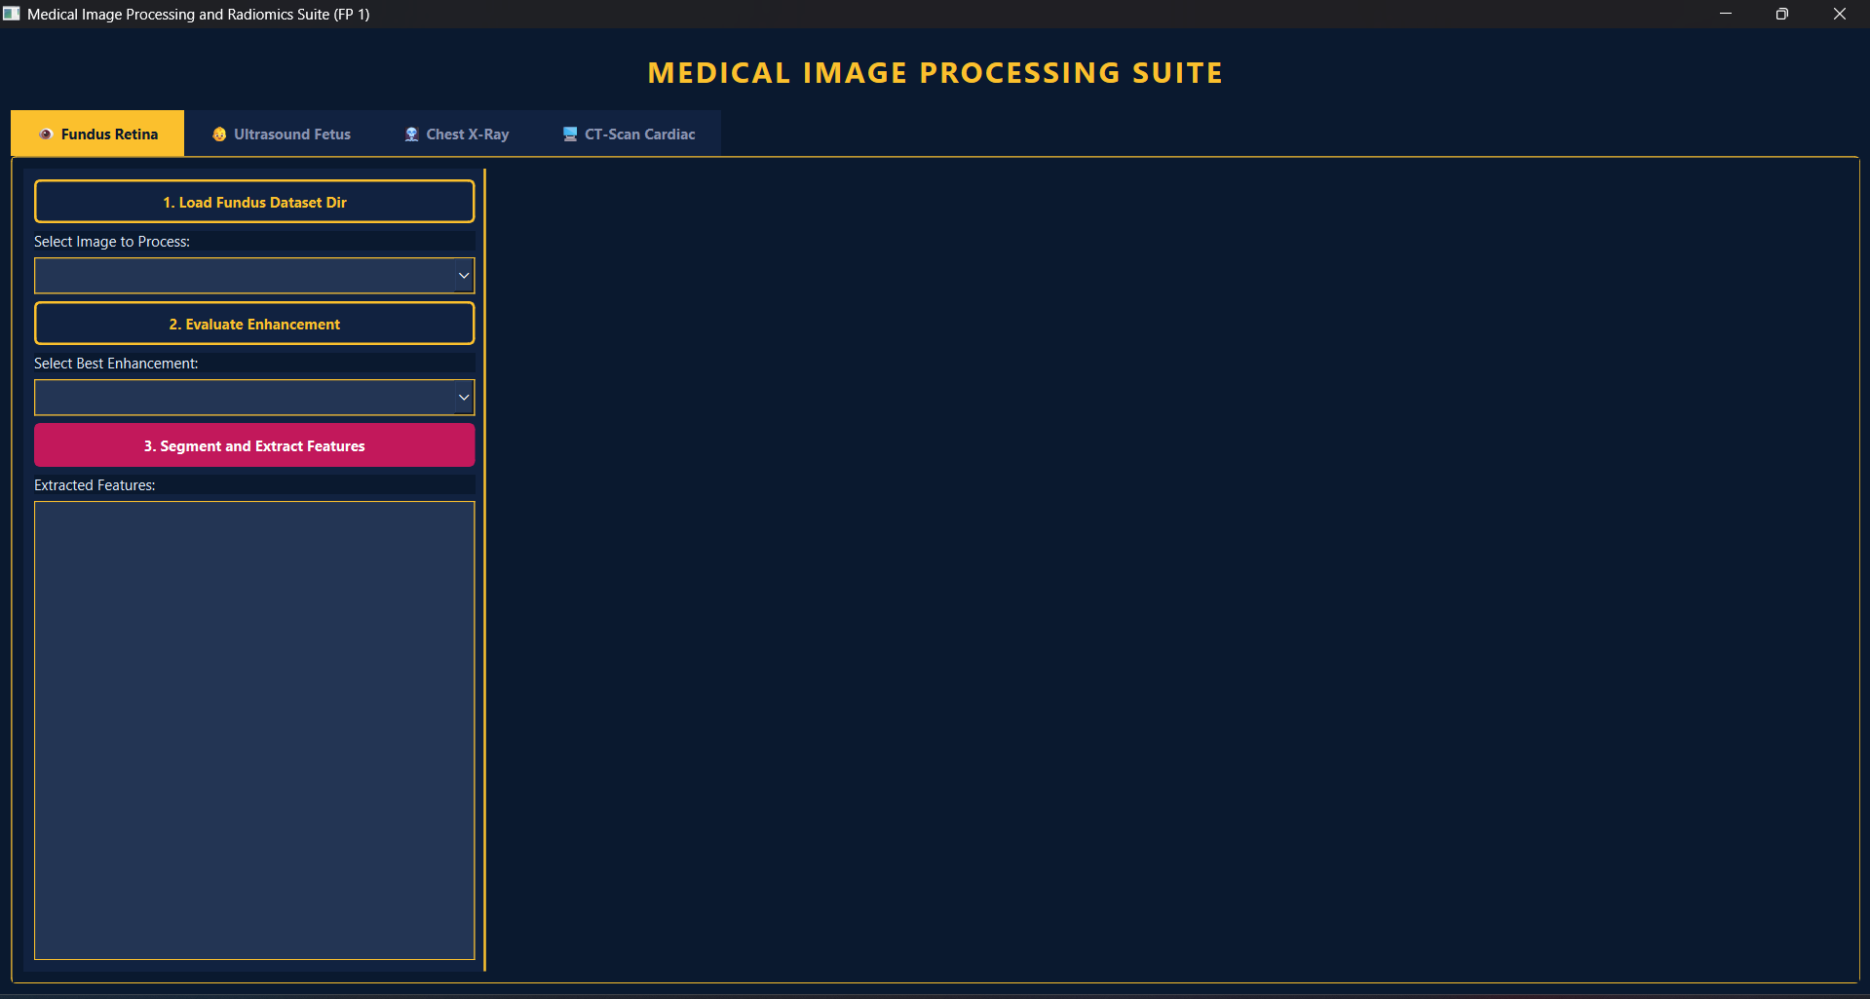
Figure 2.1. Initial GUI Window for the Four Modalities Program (1)
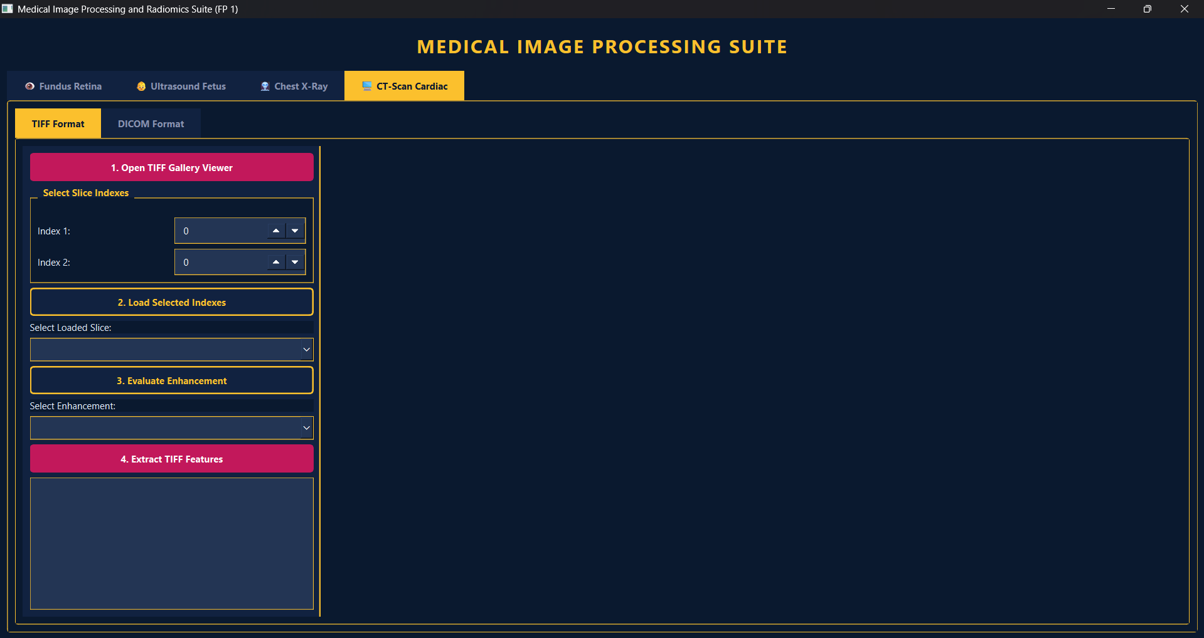
Figure 2.2. Initial GUI Window for the Four Modalities Program (2)
Before initiating any processing tasks, the system presents a unified Graphical User Interface (GUI) as shown in Figure 2.1. The interface is designed with a high-contrast "Navy and Gold" theme to ensure optimal visibility of medical details. It features a dual-panel layout where the left sidebar contains the functional control buttons (e.g., Load, Evaluate, Segment), and the right side consists of a large, scrollable area for displaying high-resolution Matplotlib figures and data tables. This structure adheres to the Model-View-Controller (MVC) architecture, ensuring that the heavy computational processing of the backend does not hinder the responsiveness of the display.
As also showed in Figure 2.2, the application utilizes a tabbed navigation system to isolate different imaging modalities, including Fundus Retina, Ultrasound, Chest X-Ray, and CT-Scan (TIFF and DICOM). Each tab is linked to its respective processor class (e.g., XRayProcessor or UltrasoundProcessor). This modular design allows for independent state management; for instance, a user can evaluate enhancement metrics for a fundus image in one tab while maintaining the segmented heart coordinates of an X-ray image in another. The initial interface ensures that the practitioner can follow a standardized workflow, loading data, evaluating enhancement performance, and extracting features, in a controlled and intuitive environment.
For additional information, the used Enhancement Method are Contrast Stretching for most modalities, except for one input image on Fundus Retina, that is the Retinography image that use Histogram Equalization method.
2.3.1. X-Ray Pneumonia for Heart Segmentation
a. Index "Normal_1440"
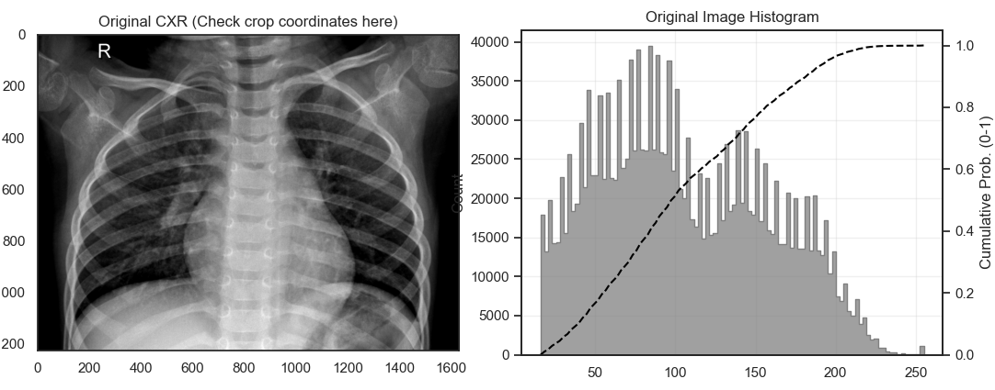
Figure 2.3. Original Input Image and Histogram
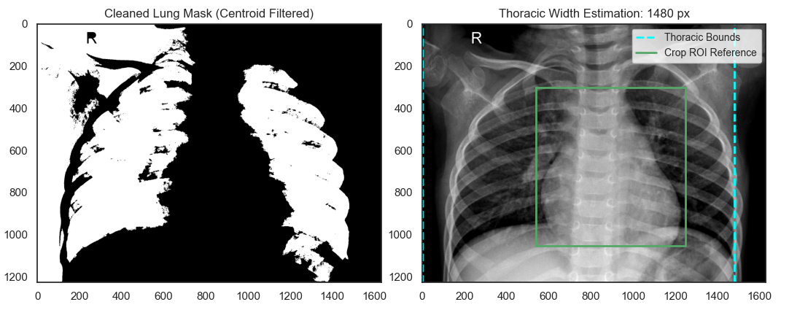
Figure 2.4. Thoracic Width Estimation
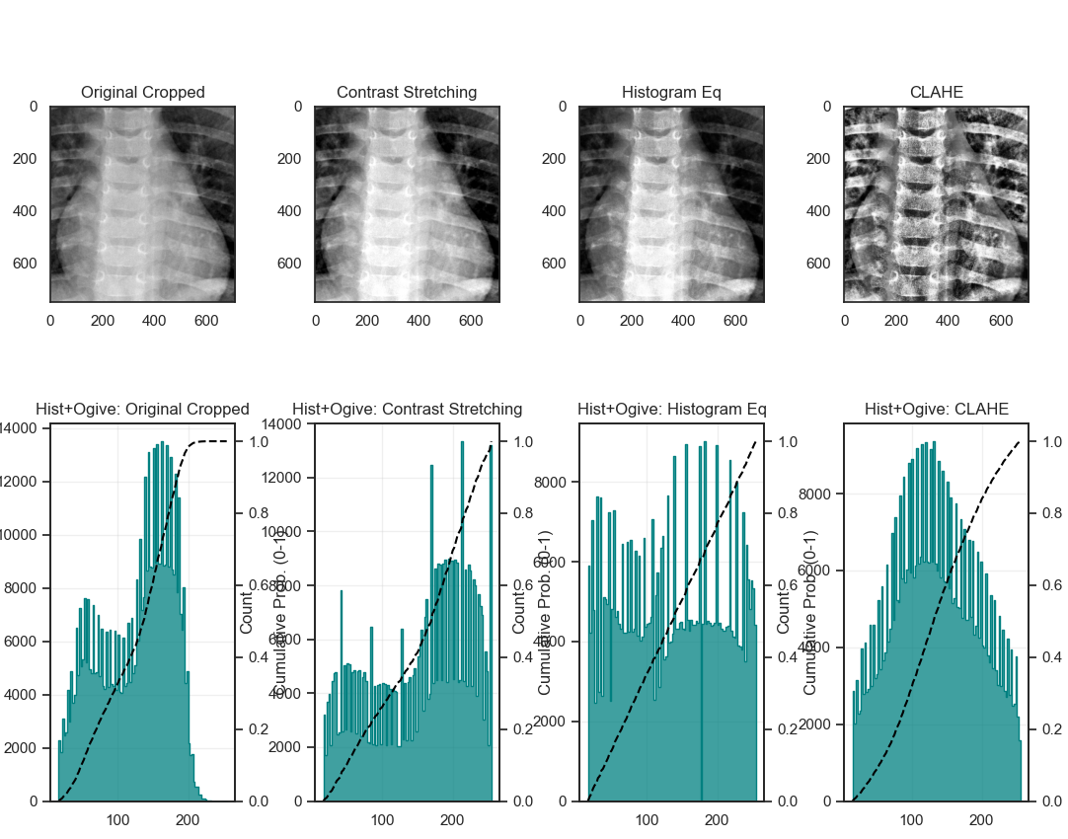
Figure 2.5. Image Enhancement
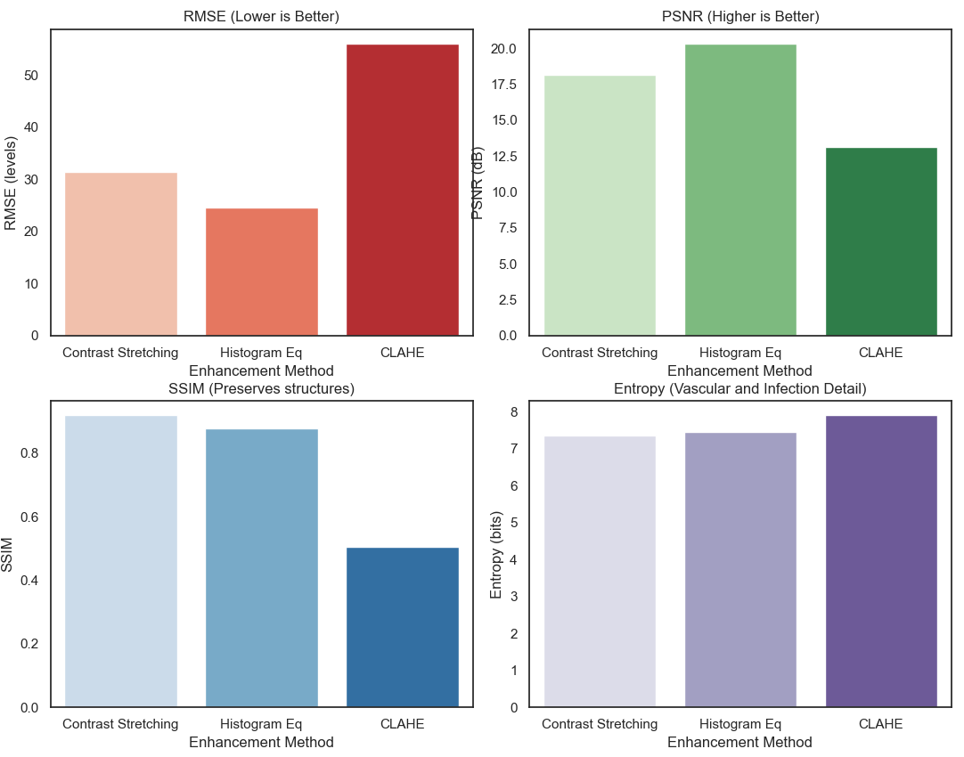
Figure 2.6. Performance Evaluation
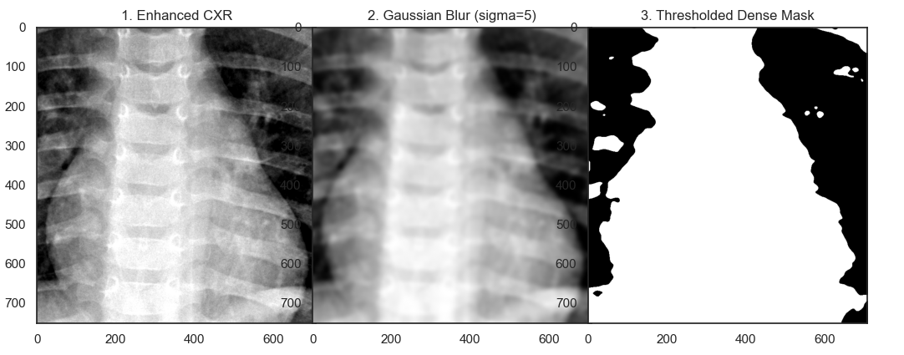
Figure 2.7. Thresholded Dense Mask
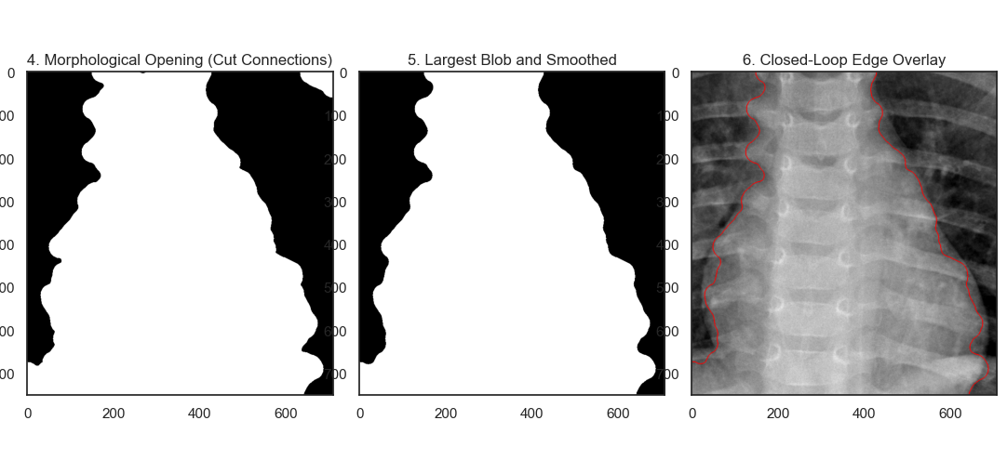
Figure 2.8. Closed-Loop Edge Overlay
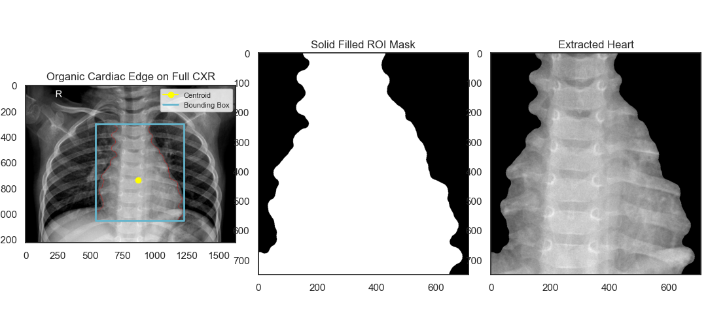
Figure 2.9. Extracted Heart
The analysis of the first normal chest X-ray image begins with a visualization of the original image and its histogram distribution in Figure 2.3. Following the preprocessing method described in Chapter II, the system initially estimates the thoracic width using a centroid-based filter to eliminate extra-body background. Figure 2.4 illustrates the successful segmentation of this lung, where the cyan boundary precisely encloses the outermost chest cavity area. Next, Figures 2.5 and 2.6 present a comparative evaluation of the contrast enhancement methods. The metric results indicate that Contrast Limited Adaptive Histogram Equalization (CLAHE) provides the best balance between Entropy (richness of detail) and Structural Similarity (SSIM) without exacerbating noise, and therefore, it was selected for the segmentation process.

The heart isolation process is visualized through several stages. Figure 2.7 shows the application of Gaussian Blur and Multi-Otsu thresholding to form a thick mask, which is then refined using morphological operations, like opening and finding the largest blob as seen in Figure 2.8. The final localization result is comprehensively shown in Figure 2.9, where the organic boundaries of the heart are successfully extracted from the lung tissue. Based on Table 2.1, features such as Area, Cardiac Width, and Thoracic Width have been quantitatively extracted. The resulting Cardiothoracic Ratio (CTR) is within the normal range, less than 0.5, which clinically confirms the healthy heart condition in this patient.
Table 2.1. Extracted Features
Cardiothoracic Feature | Description | Value
Area (px^2) | Total area of the cardiac silhouette. | 355878
Perimeter (px) | Circumference of the heart shape. | 2875,32
Cardiac Width (px) | Maximum horizontal span of the heart silhouette. | 687
Thoracic Width (px) | Maximum horizontal span of the inner ribcage/lungs. | 1480
CTR (Ratio) | Cardiothoracic Ratio (Cardiac Width / Thoracic Width). >0.5 indicates Cardiomegaly. | 0,4642
Circularity | Roundness of the cardiac silhouette. | 0,5409
Mean Intensity (0-255) | Average density (Useful to detect fluid overlap). | 154,51
Intensity Variance | Homogeneity of the heart tissue (Higher in severe pneumonia). | 760,07
GLCM Contrast | Local texture variation. | 19,7397
GLCM Homogeneity | Texture smoothness inside the silhouette. | 0,2497
Edge Gradient Strength | Sharpness of the heart border (Low = Silhouette Sign / Pneumonia). | 0,023
m
b. Index "Normal_1442”
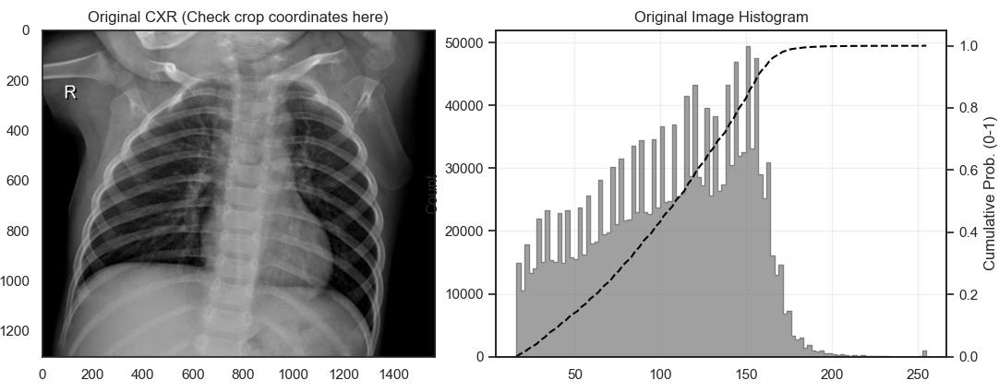
Figure 2.10. Original Input Image and Histogram
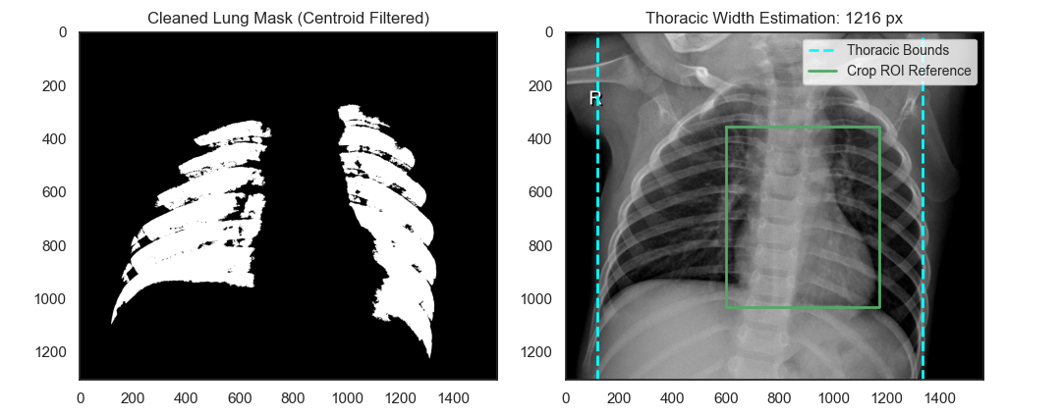
Figure 2.11. Thoracic Width Estimation
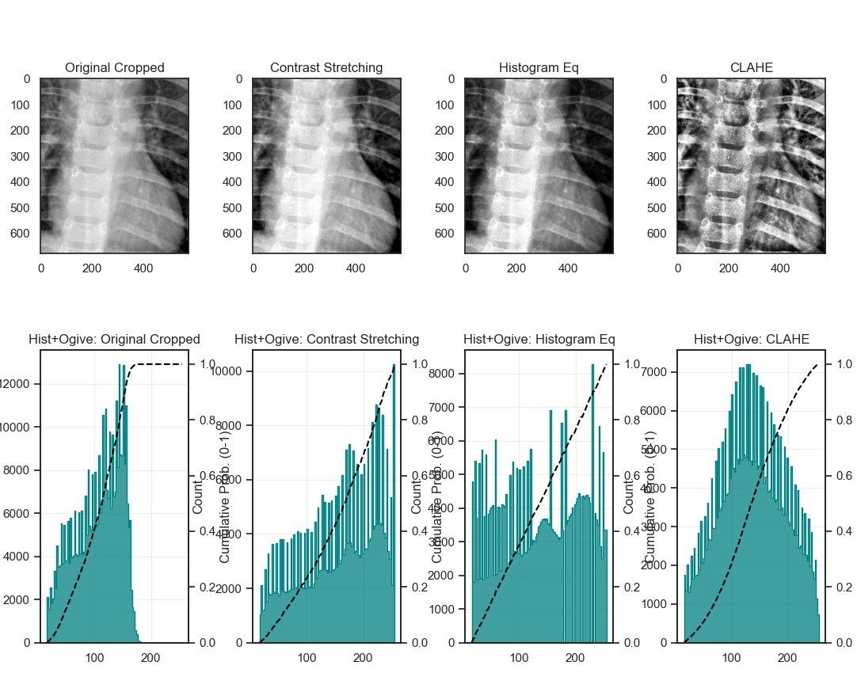
Figure 2.12. Image Enhancement
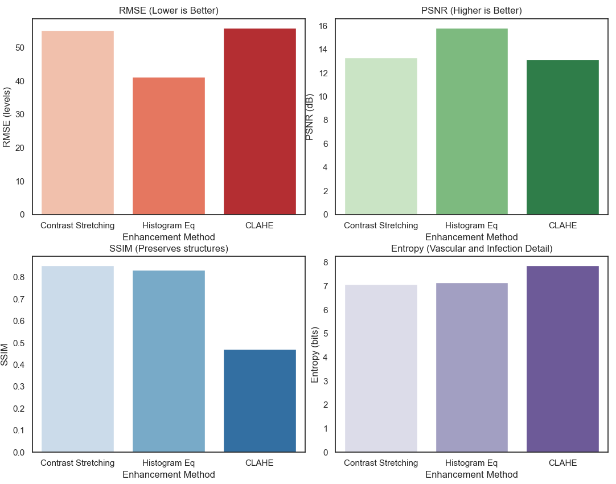
Figure 2.13. Performance Evaluation
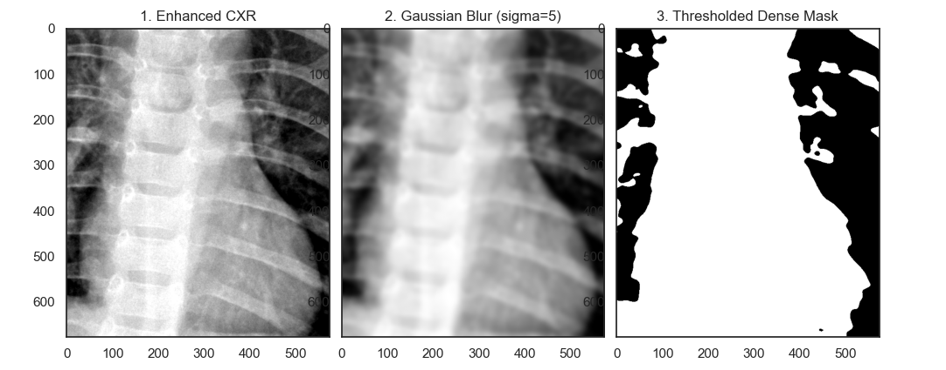
Figure 2.14. Thresholded Dense Mask
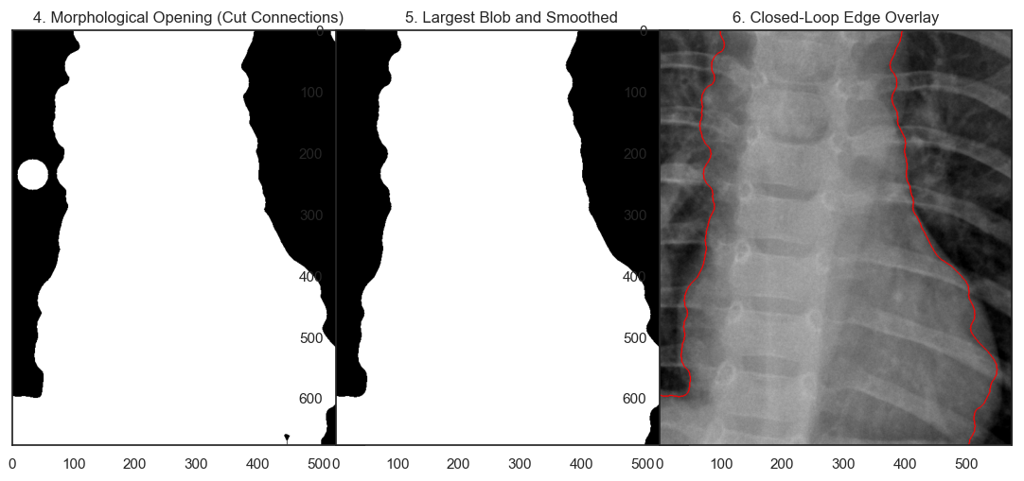
Figure 2.15. Closed-Loop Edge Overlay
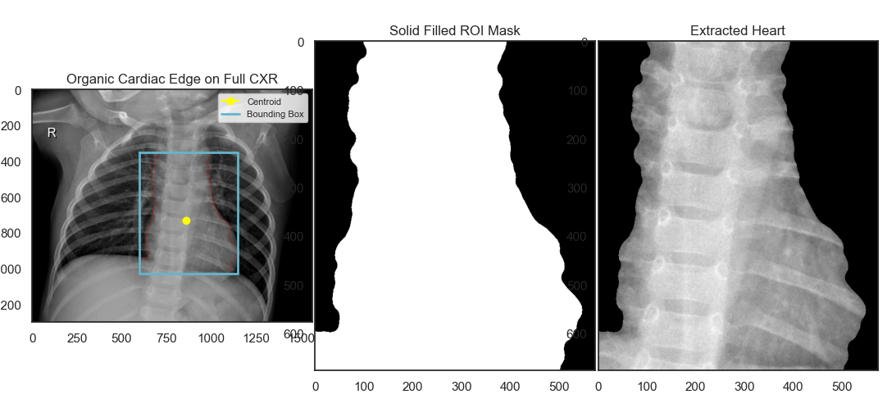
Figure 2.16. Extracted Heart
In the second normal case, the initial image and its histogram (Figure 2.10) show a slightly different intensity distribution than in the first case. Nevertheless, the preprocessing algorithm proved stable in estimating thoracic width using the cleaned lung mask (Figure 2.11). Analysis of the image enhancement quality through the histogram in Figure 2.12 and the metric bar graph in Figure 2.13 further confirms the consistent performance of CLAHE in revealing hidden pulmonary vascular texture.
The segmentation steps recorded in Figures 2.14 and 2.15 replicate the reliable morphological pipeline; the morphological closing operation successfully smoothed the jagged edges of the heart silhouette due to overlapping ribs. The final visualization in Figure 2.16 shows a perfectly aligned bounding box and centroid points on the extracted heart. Referring to Table 2.2, the obtained CTR values ​​are also below the threshold for indicating cardiomegaly. In addition, the GLCM Contrast and Homogeneity features in the table show texture values ​​that represent homogeneous heart muscle without overlapping infectious fluid.
Table 2.2. Extracted Features
Cardiothoracic Feature | Description | Value
Area (px^2) | Total area of the cardiac silhouette. | 265113
Perimeter (px) | Circumference of the heart shape. | 2411,97
Cardiac Width (px) | Maximum horizontal span of the heart silhouette. | 549
Thoracic Width (px) | Maximum horizontal span of the inner ribcage/lungs. | 1216
CTR (Ratio) | Cardiothoracic Ratio (Cardiac Width / Thoracic Width). >0.5 indicates Cardiomegaly. | 0,4515
Circularity | Roundness of the cardiac silhouette. | 0,5727
Mean Intensity (0-255) | Average density (Useful to detect fluid overlap). | 127,41
Intensity Variance | Homogeneity of the heart tissue (Higher in severe pneumonia). | 559,79
GLCM Contrast | Local texture variation. | 13,5067
GLCM Homogeneity | Texture smoothness inside the silhouette. | 0,2873
Edge Gradient Strength | Sharpness of the heart border (Low = Silhouette Sign / Pneumonia). | 0,0178

c. Index "Person120_Pneumonia_Virus_226"
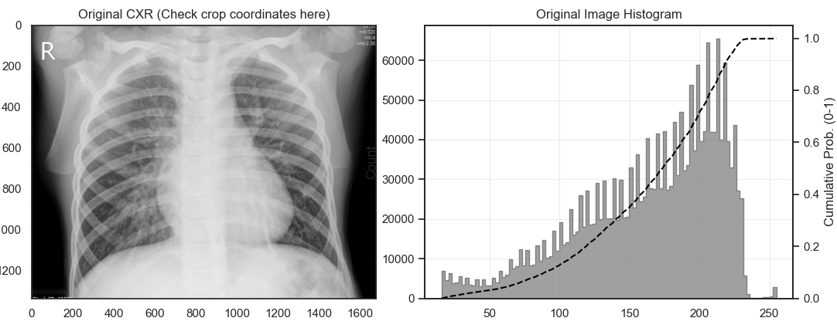
Figure 2.17. Original Input Image and Histogram
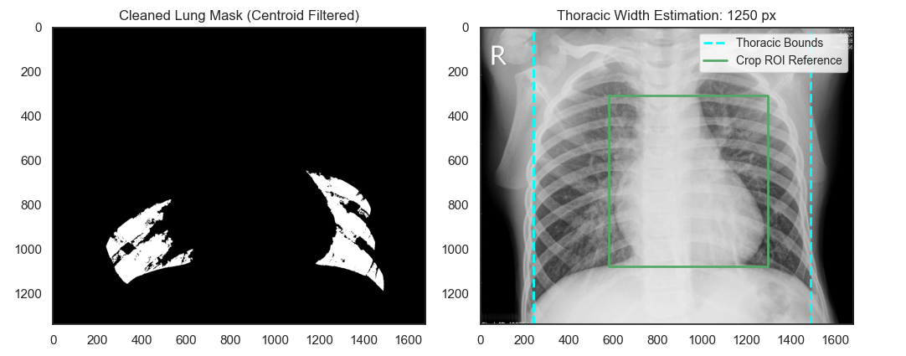
Figure 2.18. Thoracic Width Estimation
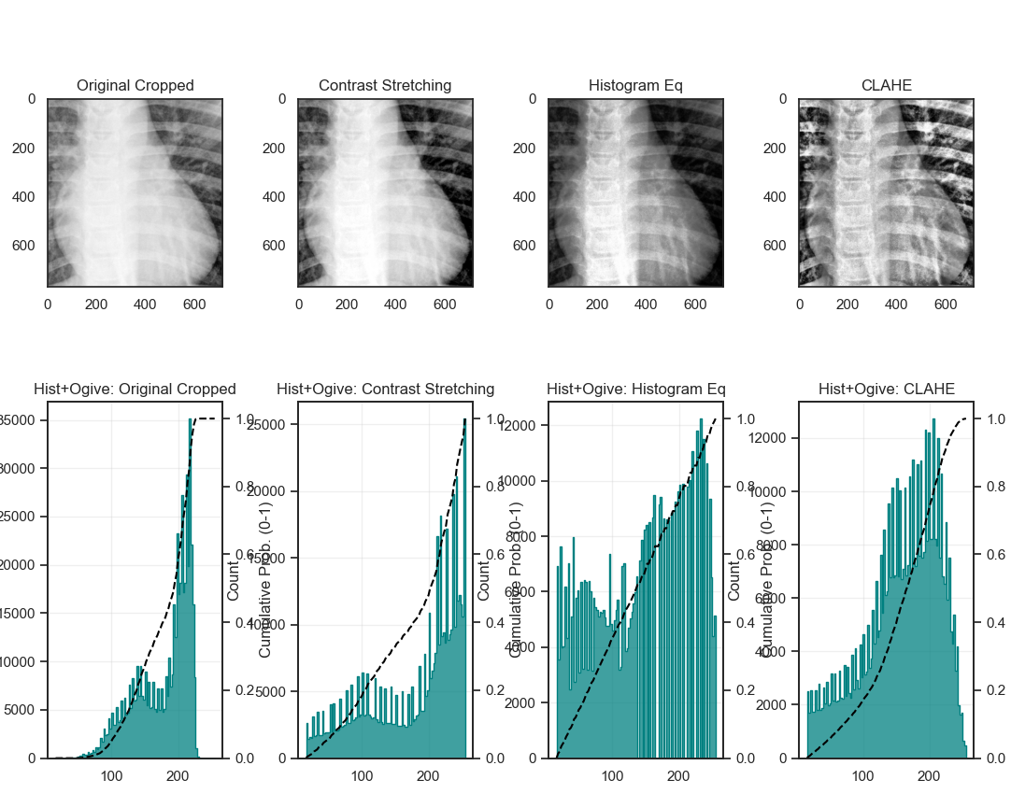
Figure 2.19. Image Enhancement
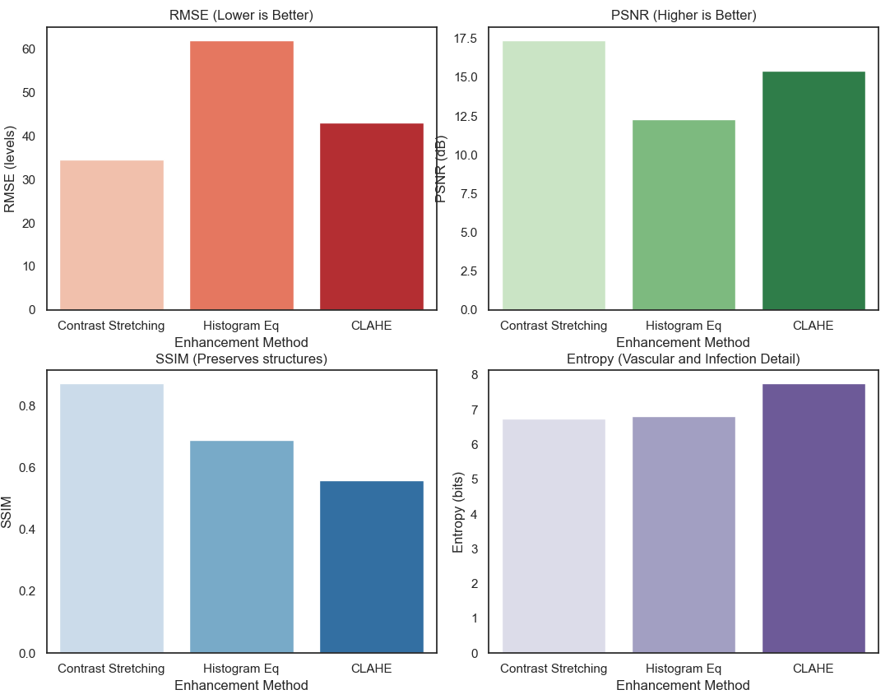
Figure 2.20. Performance Evaluation
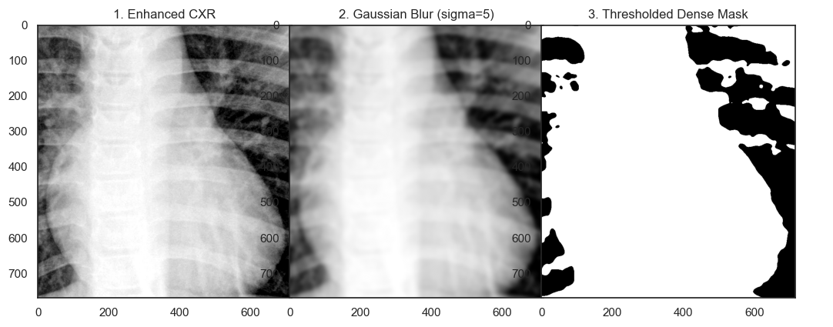
Figure 2.21. Thresholded Dense Mask
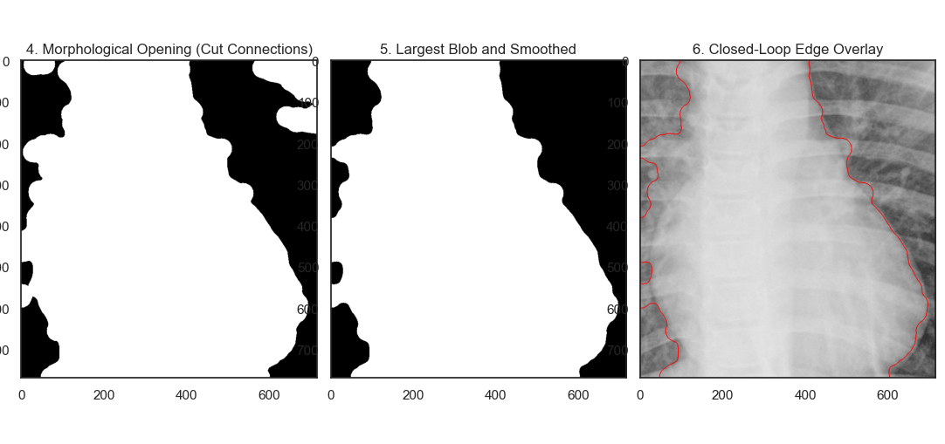
Figure 2.22. Closed-Loop Edge Overlay
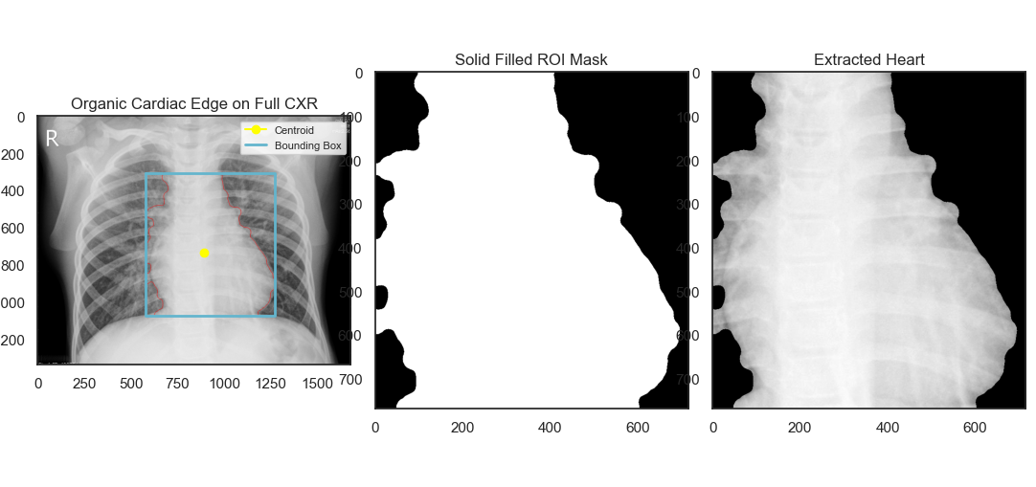
Figure 2.23. Extracted Heart
The third case test tests the algorithm's robustness on images of a patient with viral pneumonia. Figure 2.17 shows increased opacity (white patches) in the lower lung area. Despite significant tissue density changes due to infection, the system still accurately detected the lateral boundaries of the chest cavity in Figure 2.18. In the enhancement evaluation phase (Figures 2.19 and 2.20), global histogram equalization was seen to overexpress infection noise. Therefore, CLAHE again proved crucial in preserving the boundary structure between the heart and the infected lung.
The application of spatial smoothing and labelling of the largest blobs in Figures 2.21 and 2.22 played a crucial role in this case. Pneumonia infection often merges with the cardiac boundary, known theoretically as the silhouette sign phenomenon. The visualization in Figure 2.23 demonstrates that the morphological scalpel approach is capable of separating the cardiac silhouette from the consolidated lung tissue. Based on Table 2.3, the Edge Gradient Strength value reflects the blurring of boundaries due to infectious fluid. Furthermore, the CTR value and extracted GLCM texture features provide quantitative evidence of higher heterogeneity compared to normal lungs.
Table 2.3. Extracted Features
Cardiothoracic Feature | Description | Value
Area (px^2) | Total area of the cardiac silhouette. | 398202
Perimeter (px) | Circumference of the heart shape. | 2966,01
Cardiac Width (px) | Maximum horizontal span of the heart silhouette. | 695
Thoracic Width (px) | Maximum horizontal span of the inner ribcage/lungs. | 1250
CTR (Ratio) | Cardiothoracic Ratio (Cardiac Width / Thoracic Width). >0.5 indicates Cardiomegaly. | 0,556
Circularity | Roundness of the cardiac silhouette. | 0,5688
Mean Intensity (0-255) | Average density (Useful to detect fluid overlap). | 198,13
Intensity Variance | Homogeneity of the heart tissue (Higher in severe pneumonia). | 473,27
GLCM Contrast | Local texture variation. | 5,0652
GLCM Homogeneity | Texture smoothness inside the silhouette. | 0,5331
Edge Gradient Strength | Sharpness of the heart border (Low = Silhouette Sign / Pneumonia). | 0,0202

d. Index "Person313_Pneumonia_Bacteria_1460"
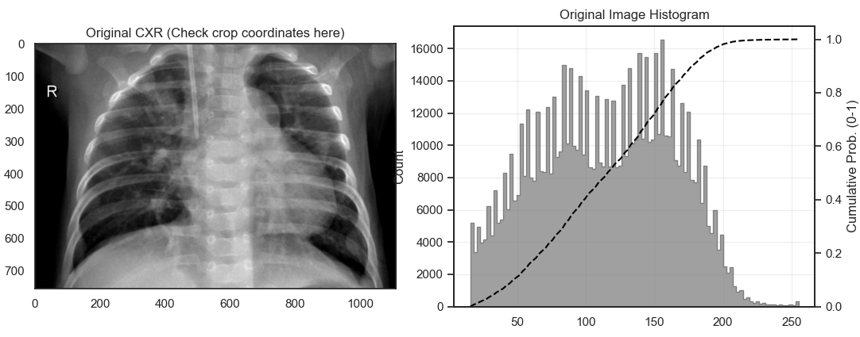
Figure 2.24. Original Input Image and Histogram
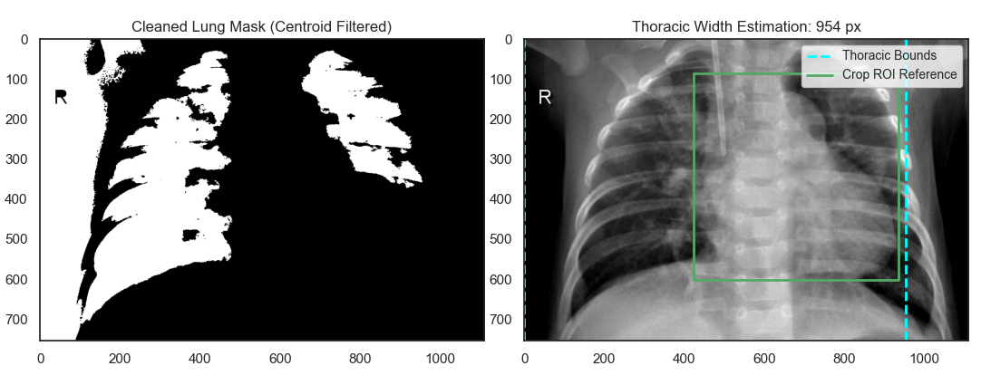
Figure 2.25. Thoracic Width Estimation
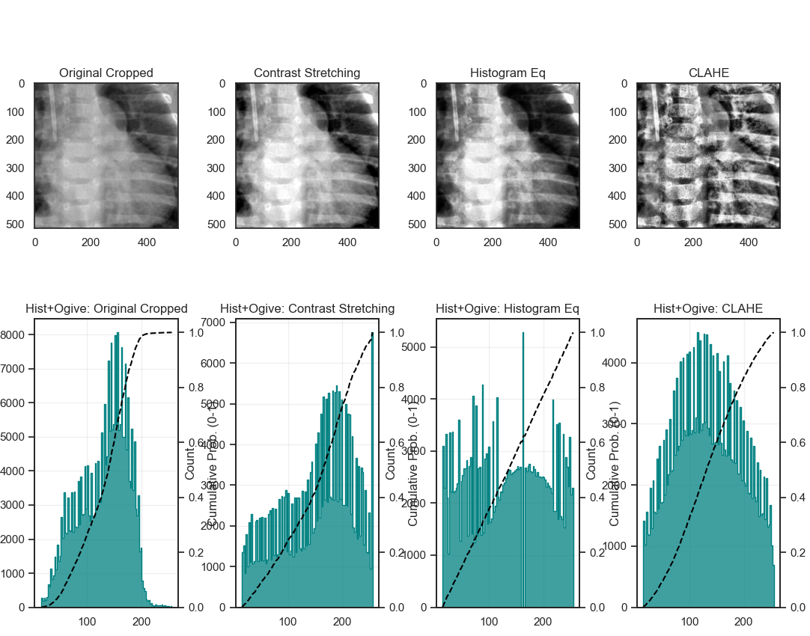
Figure 2.26. Image Enhancement
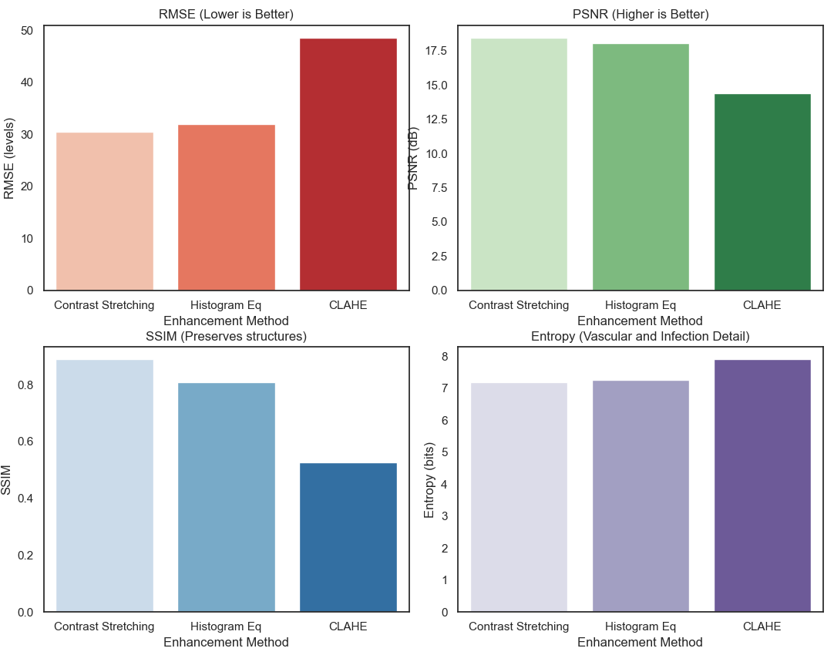
Figure 2.27. Performance Evaluation
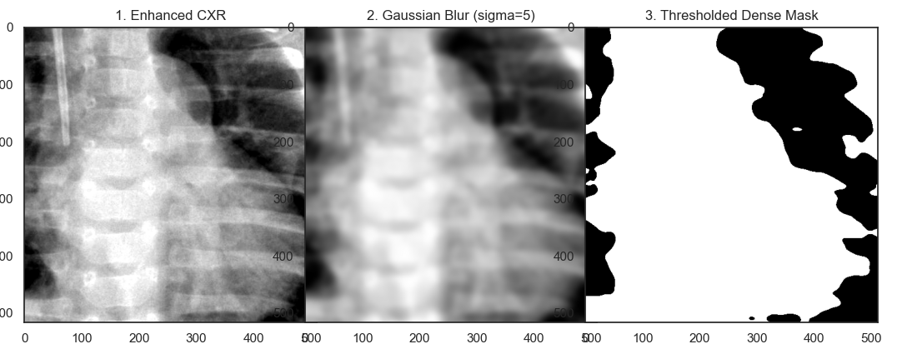
Figure 2.28. Thresholded Dense Mask
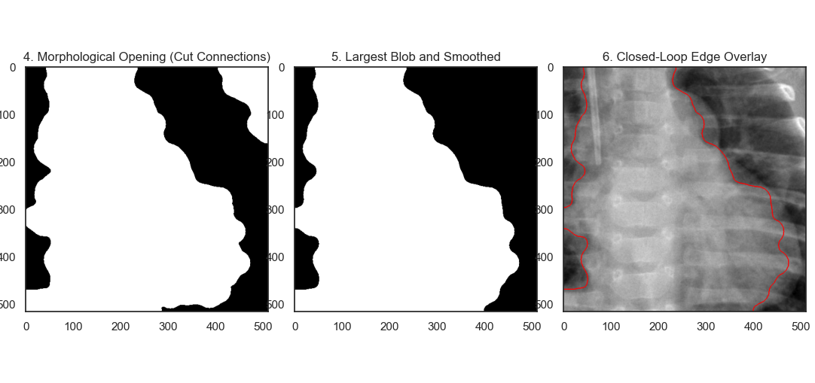
Figure 2.29. Closed-Loop Edge Overlay
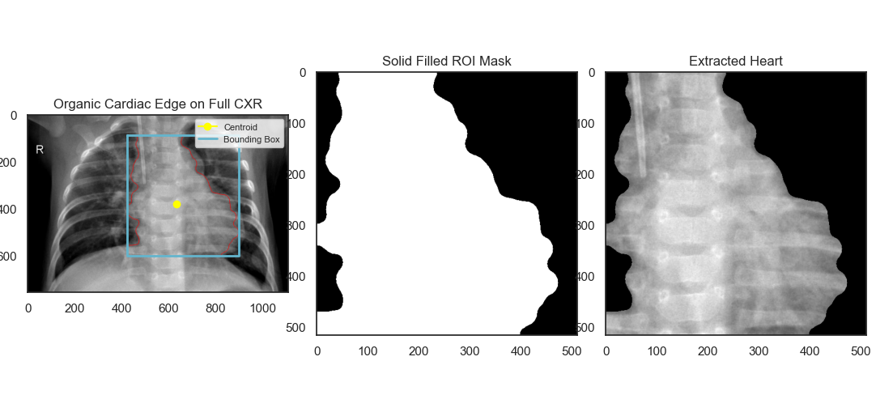
Figure 2.30. Extracted Heart
The final test used images from patients with bacterial pneumonia, which characteristically have denser and more asymmetric infiltrate patterns. The original image in Figure 2.24 and the calculated thoracic boundaries in Figure 2.25 further validate that the centroid-based chest width estimation is robust to pathological abnormalities within the lungs. Performance metrics evaluation (Figures 2.26 and 2.27) ensured that the images passed to the segmentation stage maintained their structural integrity.
In the Multi-Otsu segmentation stage (Figure 2.28), the bacterial density made determining the intensity threshold significantly more challenging than in normal cases. However, with the application of morphological refinement and edge detection in Figure 2.29, the organic shape of the heart was successfully captured. The final result visualization in Figure 2.30, along with the quantitative data in Table 2.4, presents a complete radiomic profile. The spike variations in the Intensity Variance and GLCM Contrast values ​​in this table provide strong algorithmic justification that the tissue density in the Region of Interest area has been pathologically altered due to bacteria, which clearly differentiates it from the parameters extracted in both cases of normal X-ray images.
Table 2.4. Extracted Features
Cardiothoracic Feature | Description | Value
Area (px^2) | Total area of the cardiac silhouette. | 176392
Perimeter (px) | Circumference of the heart shape. | 1979,2
Cardiac Width (px) | Maximum horizontal span of the heart silhouette. | 474
Thoracic Width (px) | Maximum horizontal span of the inner ribcage/lungs. | 954
CTR (Ratio) | Cardiothoracic Ratio (Cardiac Width / Thoracic Width). >0.5 indicates Cardiomegaly. | 0,4969
Circularity | Roundness of the cardiac silhouette. | 0,5659
Mean Intensity (0-255) | Average density (Useful to detect fluid overlap). | 152,75
Intensity Variance | Homogeneity of the heart tissue (Higher in severe pneumonia). | 645,3
GLCM Contrast | Local texture variation. | 9,5622
GLCM Homogeneity | Texture smoothness inside the silhouette. | 0,3589
Edge Gradient Strength | Sharpness of the heart border (Low = Silhouette Sign / Pneumonia). | 0,0184

2.3.2. CT-Scan Thorax for Heart Segmentation
a. TIFF Image
- Index 35
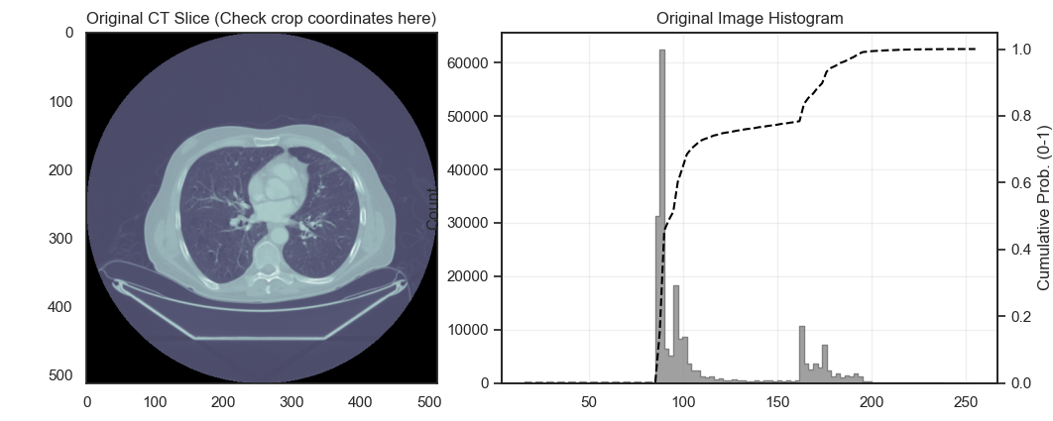
Figure 2.31. Original Input Image and Histogram
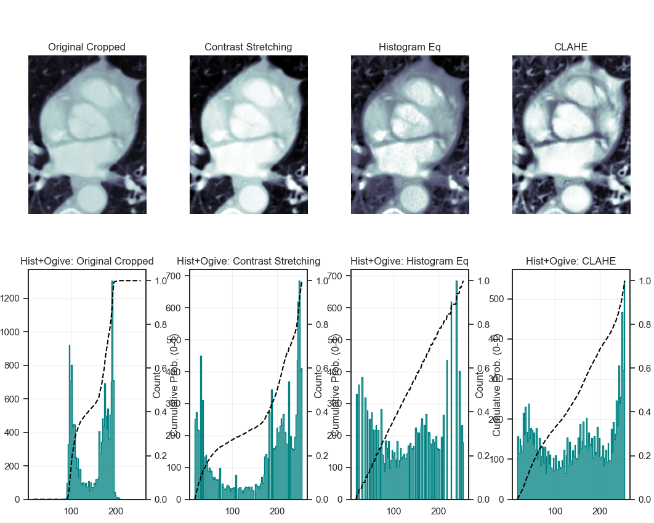
Figure 2.32. Image Enhancement
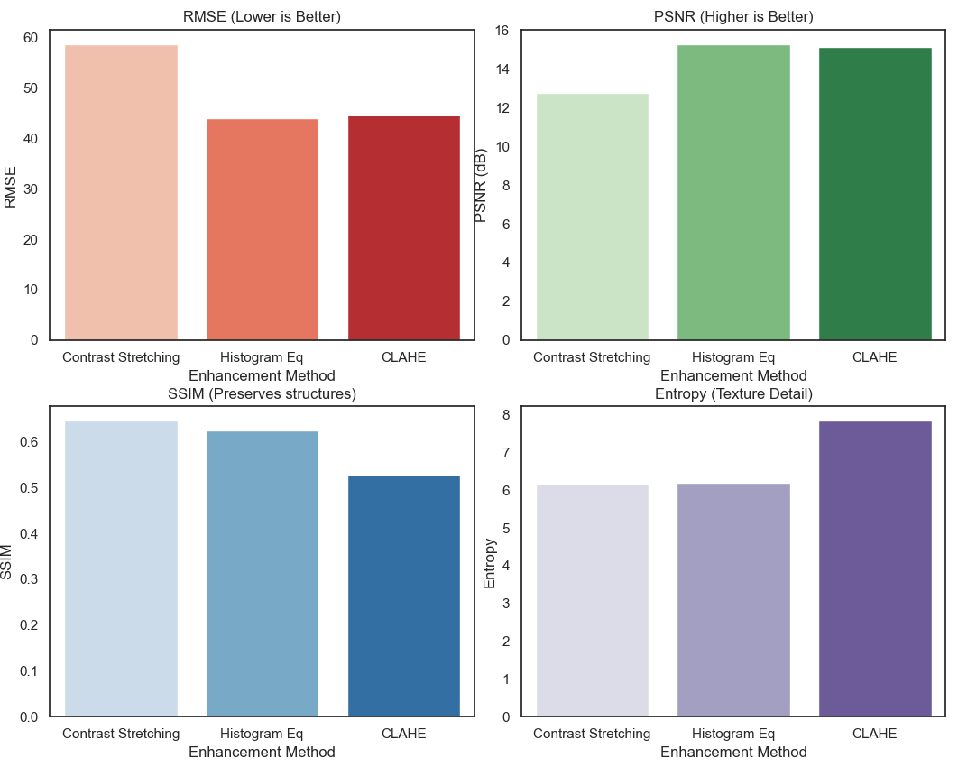
Figure 2.33. Performance Evaluation
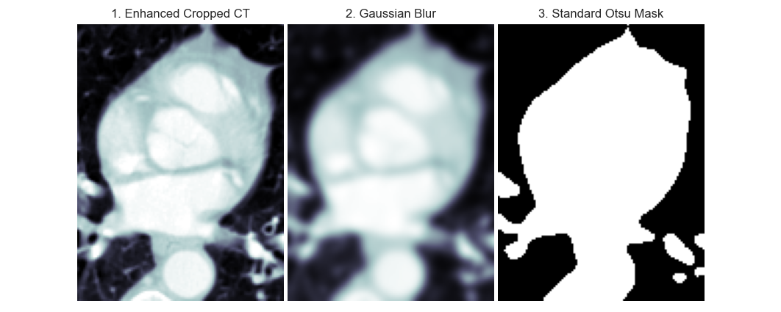
Figure 2.34. Otsu’s Mask
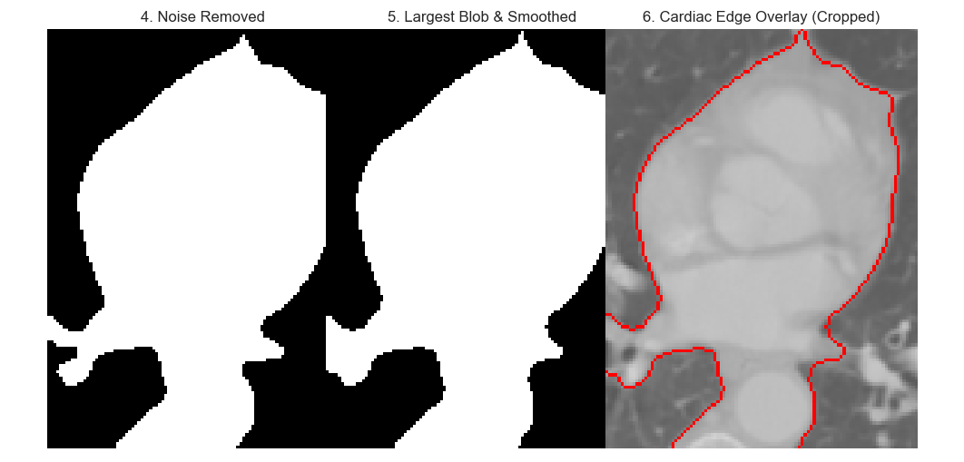
Figure 2.35. Cardiac Edge Overlay
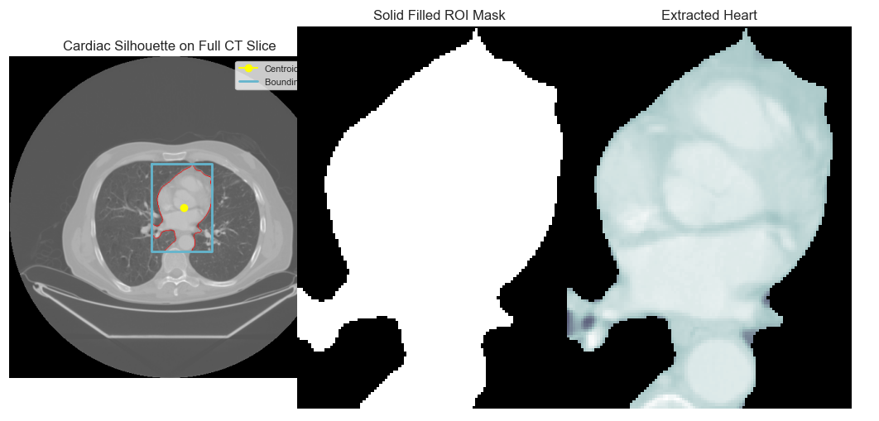
Figure 2.36. Extracted Heart
The first test in TIFF format used an axial slice with an index of 35. The original image and its histogram in Figure 2.31 show a fairly wide intensity range but are focused on the soft tissue area. A comparison of the contrast enhancement methods in Figure 2.32 and the metric evaluation in Figure 2.33 show that CLAHE provides the sharpest cardiac muscle texture detail with optimal Entropy values.
The segmentation stage begins with the application of Gaussian Blur and Otsu thresholding (Figure 2.34), which is then refined through morphological operations in Figure 2.35 to separate the heart from the sternum and spine. The final result in Figure 2.36 demonstrates the system's success in precisely fitting the bounding box and centroid points. The quantitative data in Table 2.5 summarizes the morphological and textural features, where the Cardiothoracic Ratio (CTR) value is automatically extracted to support the analysis of cardiomegaly in CT images.
Table 2.5. Extracted Features
Feature | Description | Value
Cardiac Area (px^2) | Pixel area of the isolated heart silhouette. | 8116
Max Cardiac Width (px) | Maximum transverse diameter in pixels. | 97
Mean Intensity (0-255) | Average pixel brightness of myocardium. | 179,22
Intensity Variance | Heterogeneity of heart tissue (e.g., detecting calcification). | 177,25
GLCM Contrast | Texture feature (Myocardial fibrosis indicator). | 38,5063
GLCM Homogeneity | Texture smoothness. | 0,3982

- Index 9
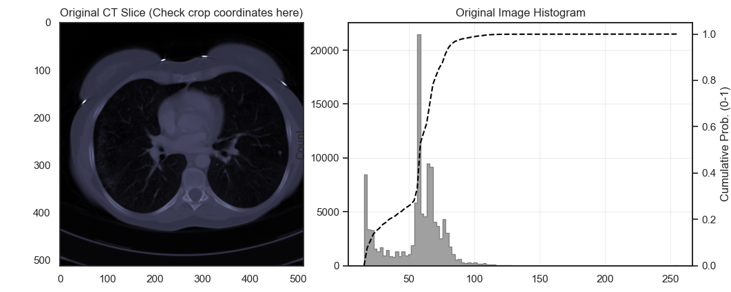
Figure 2.37. Original Input Image and Histogram
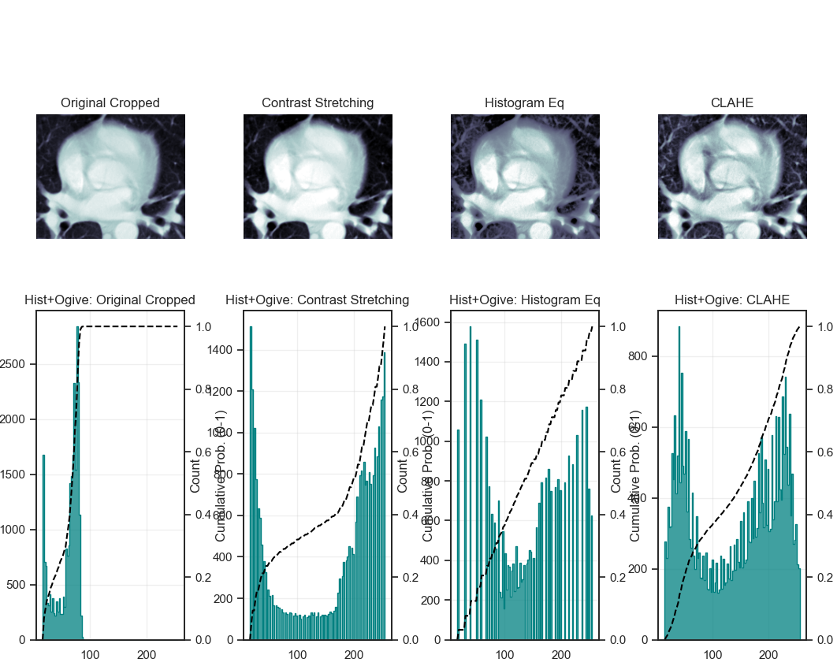
Figure 2.38. Image Enhancement
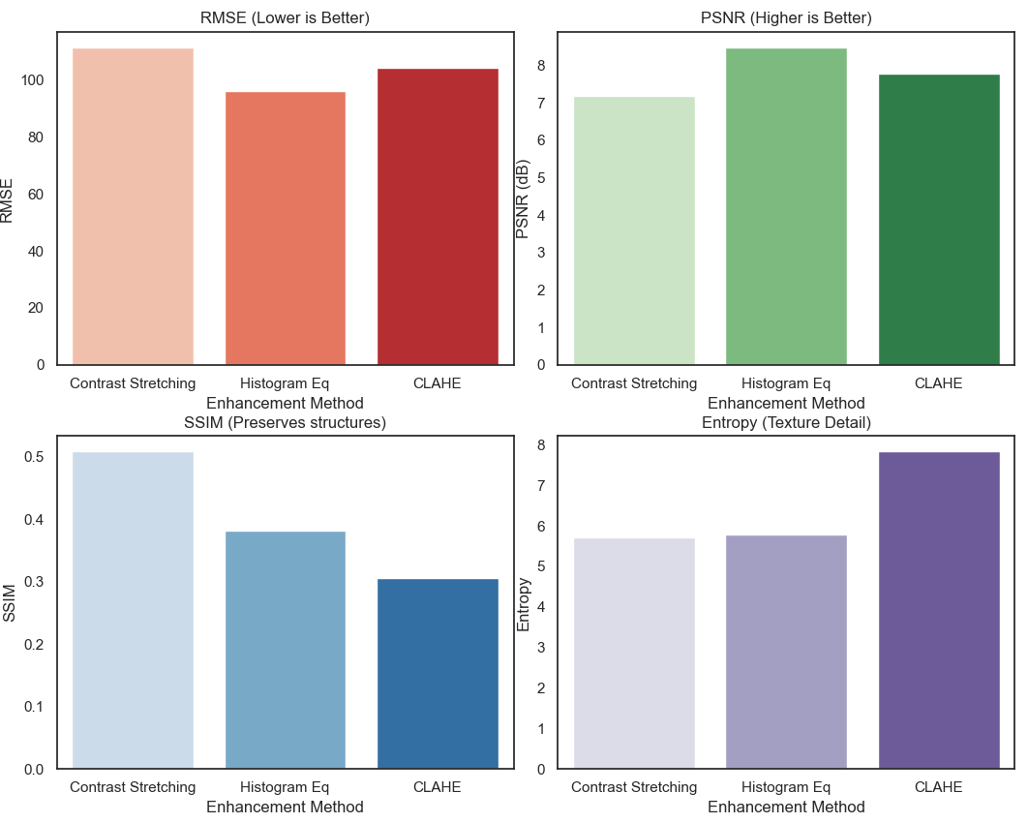
Figure 2.39. Performance Evaluation
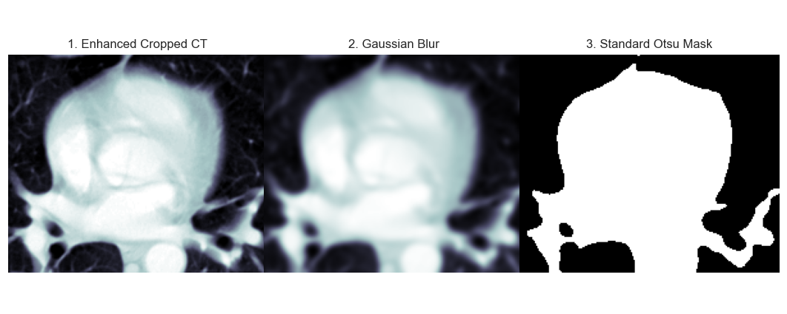
Figure 2.40. Otsu’s Mask
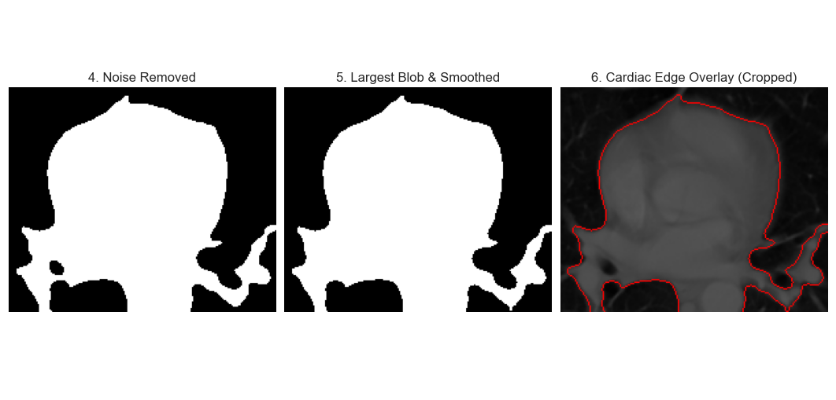
Figure 2.41. Cardiac Edge Overlay
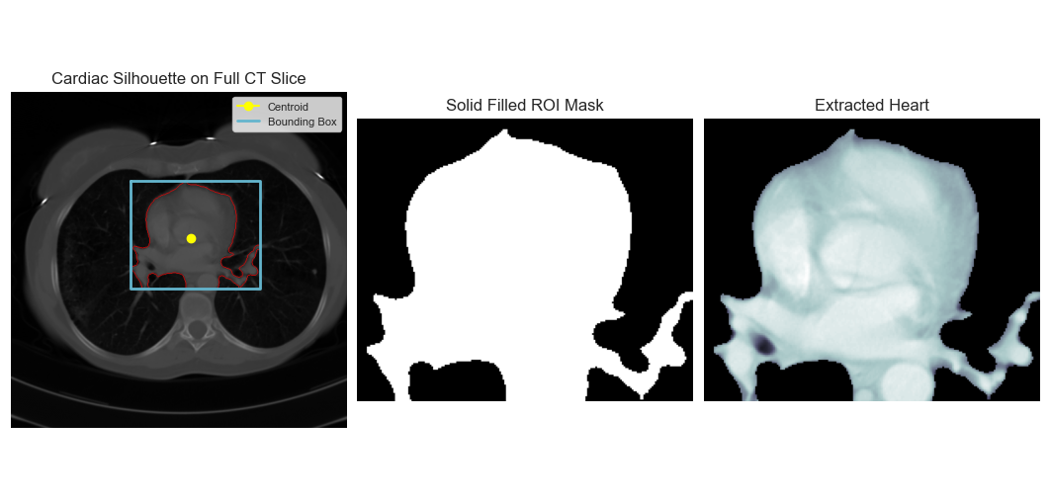
Figure 2.42. Extracted Heart
The second axial slice at index 9 was processed using the same process. Figure 2.37 displays the input image, which has slightly different anatomical characteristics due to the different slice levels. Enhancement evaluations in Figures 2.38 and 2.39 further validate the consistency of the CLAHE method in maintaining the structural integrity of the cardiac silhouette.
The process of forming a cardiac mask using the largest object labelling algorithm is visualized in Figures 2.40 and 2.41, where the system intelligently fills internal holes (hole filling) in the cardiac mask to create a solid area. The final visualization in Figure 2.42 demonstrates a clean and accurate cardiac boundary. The extracted parameters in Table 2.6 provide an in-depth radiomic profile, including mean intensity and variance values ​​reflecting myocardial tissue characteristics at that slice level.
Table 2.6. Extracted Features
Feature | Description | Value
Cardiac Area (px^2) | Pixel area of the isolated heart silhouette. | 19129
Max Cardiac Width (px) | Maximum transverse diameter in pixels. | 197
Mean Intensity (0-255) | Average pixel brightness of myocardium. | 69,93
Intensity Variance | Heterogeneity of heart tissue (e.g., detecting calcification). | 93,17
GLCM Contrast | Texture feature (Myocardial fibrosis indicator). | 9,8192
GLCM Homogeneity | Texture smoothness. | 0,5432

b. DICOM Image
- Index 11
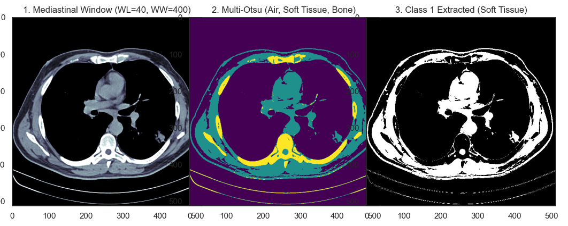
Figure 2.43. Multi-Otsu Classes Overview
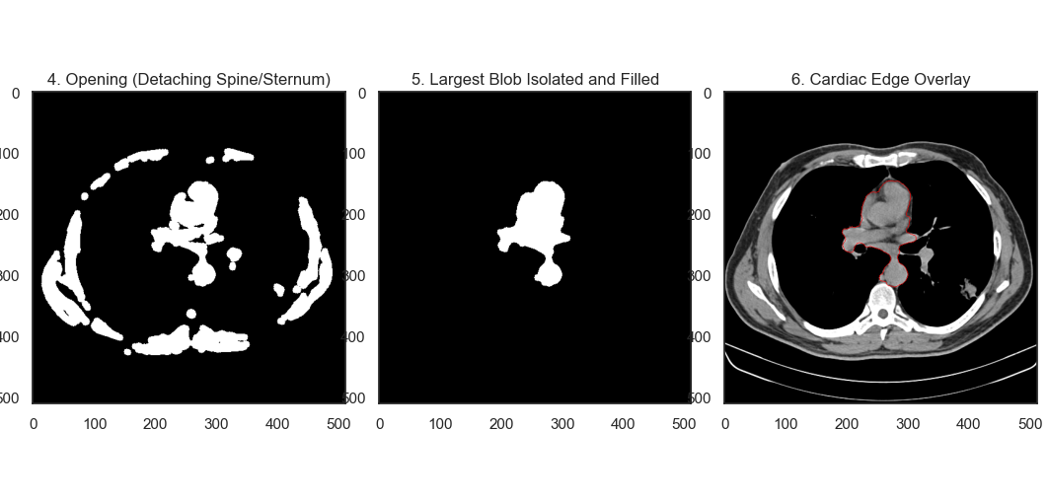
Figure 2.44. Cardiac Edge Overlay
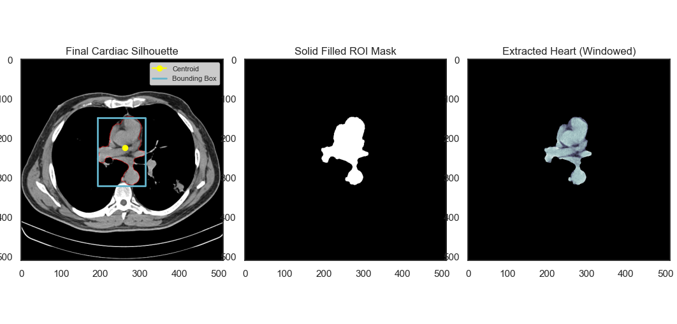
Figure 2.45. Extracted Heart
DICOM data processing provides a more clinical dimension to analysis because it involves Hounsfield unit (HU) conversion. Figure 2.43 shows the results of applying Mediastinal Windowing (WL:40, WW:400), which successfully highlights the soft tissues of the heart, as well as the results of Multi-Otsu segmentation to separate air, tissue, and bone. Unlike TIFF, DICOM automatically creates a Filled Thorax Mask to obtain a more accurate chest cavity estimation.
The heart isolation step using a "morphological scalpel" (morphological opening) is shown in Figure 2.44, effectively severing the tissue connection between the heart and the chest wall. The final result in Figure 2.45 compares the solid mask and the extracted heart. Table 2.7 displays the resulting features in tangible physical units, such as cm² and mm thanks to the use of pixel spacing metadata. The cardiothoracic area ratio (CTAR) and mean density in HU in this table provide significantly more medically valid diagnostic information than standard image processing.
Table 2.7. Extracted Features
CT Radiomics Feature | Description | Value
Cardiac Area (cm^2) | Physical area of the heart slice (using PixelSpacing). | 55,72
Thoracic Area (cm^2) | Physical area of the inner chest cavity. | 807,17
CTAR (Area Ratio) | Cardiothoracic Area Ratio (Cardiac Area / Thoracic Area). | 0,069
Max Cardiac Width (mm) | Maximum transverse diameter of the heart. | 89,8
aCTR (Axial Width Ratio) | Axial Cardiothoracic Ratio. >0.5 indicates Cardiomegaly. | 0,2401
Mean Density (HU) | Average Hounsfield Unit of myocardium (Normal: ~40 HU non-contrast). | 48,05
Density Variance (HU Variance) | Heterogeneity of heart tissue (Detects calcifications). | 2016,25
GLCM Contrast | Radiomics texture feature (Myocardial fibrosis indicator). | 134,8683
GLCM Homogeneity | Radiomics texture smoothness. | 0,3458

- Index 51
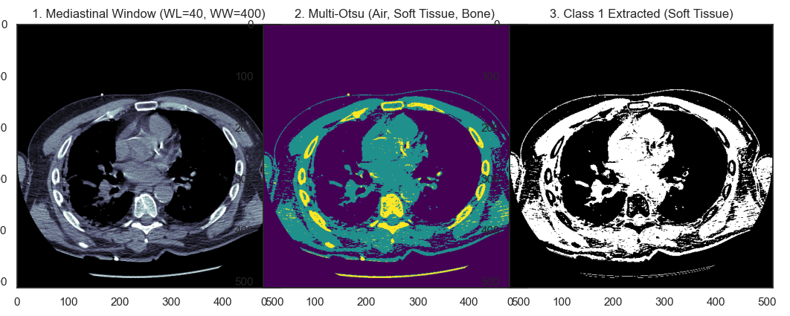
Figure 2.46. Multi-Otsu Classes Overview
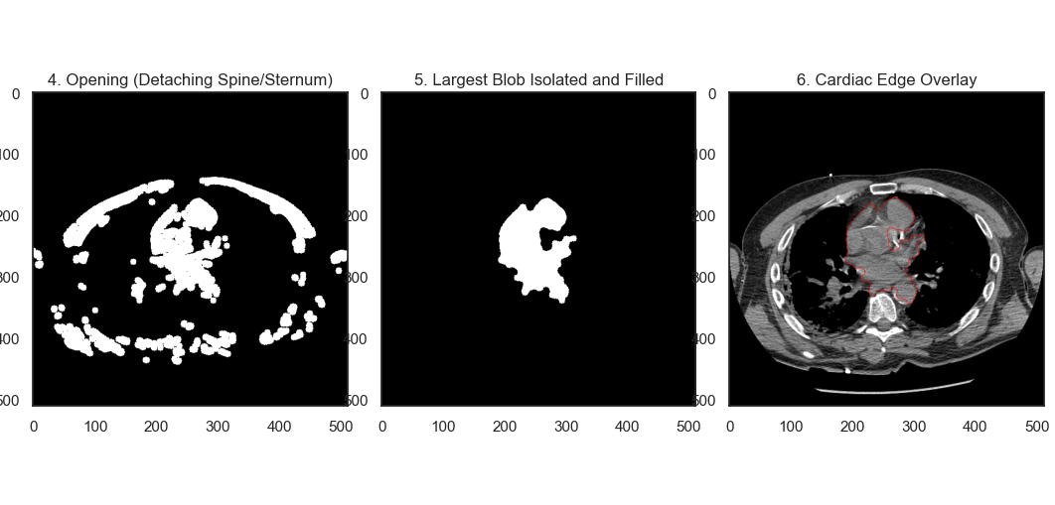
Figure 2.47. Cardiac Edge Overlay
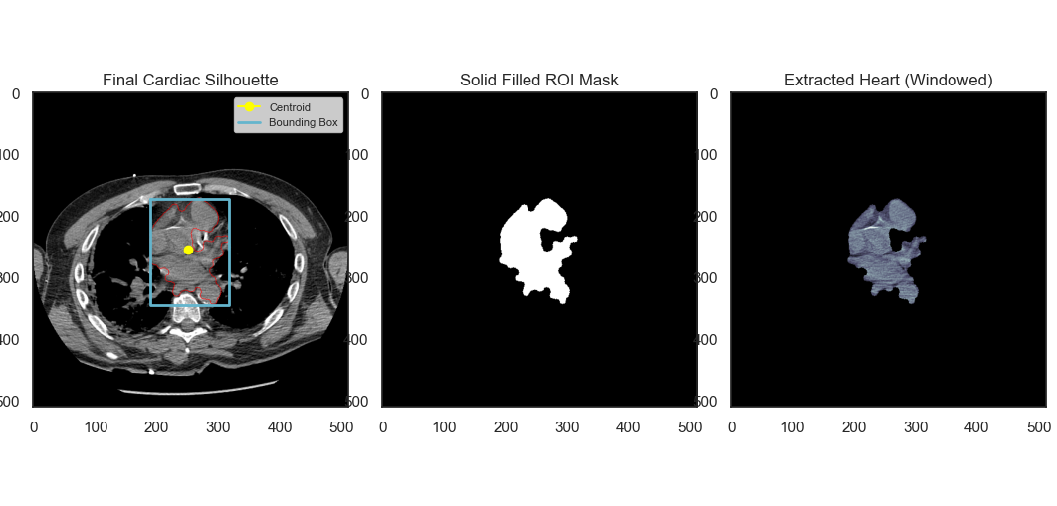
Figure 2.48. Extracted Heart
The second DICOM case study, with slice 20, demonstrates the stability of the CTDicomProcessor algorithm in handling variations in anatomical position. Figure 2.46 illustrates the results of windowing and thoracic mask formation, which remain precise despite slight changes in the shape of the chest cavity. The cardiac segmentation and edge detection steps in Figure 2.47 demonstrate how the system is able to trace the cardiac contour with sharp boundaries.
The visualization of the final results in Figure 2.48 confirms the system's reliability for automated extraction across multiple axial slices. The data in Table 2.8 summarizes all required radiomics parameters. The GLCM Contrast and Homogeneity values ​​extracted in this DICOM case provide a highly detailed depiction of cardiac tissue texture, enabling early detection of cardiac muscle structural abnormalities based on objective radiodensity data.
Table 2.8. Extracted Features
CT Radiomics Feature | Description | Value
Cardiac Area (cm^2) | Physical area of the heart slice (using PixelSpacing). | 62,84
Thoracic Area (cm^2) | Physical area of the inner chest cavity. | 575,78
CTAR (Area Ratio) | Cardiothoracic Area Ratio (Cardiac Area / Thoracic Area). | 0,1091
Max Cardiac Width (mm) | Maximum transverse diameter of the heart. | 90,7
aCTR (Axial Width Ratio) | Axial Cardiothoracic Ratio. >0.5 indicates Cardiomegaly. | 0,7167
Mean Density (HU) | Average Hounsfield Unit of myocardium (Normal: ~40 HU non-contrast). | 23,14
Density Variance (HU Variance) | Heterogeneity of heart tissue (Detects calcifications). | 1481,33
GLCM Contrast | Radiomics texture feature (Myocardial fibrosis indicator). | 35,5407
GLCM Homogeneity | Radiomics texture smoothness. | 0,3574

2.3.3. Fundus Retina Normal and Retinography for Optical Disk Segmentation
The analysis of the retinal fundus modality focuses on the precise localization and segmentation of the Optic Disc (OD). This process is divided into two distinct test cases: a healthy retina ("Normal Fundus") and a case of pathology or specialized imaging ("Retinography"). The primary objective is to evaluate the system's ability to isolate the OD silhouette from the complex vascular network and the pigmented background of the retina.
a. Fundus Retina Normal
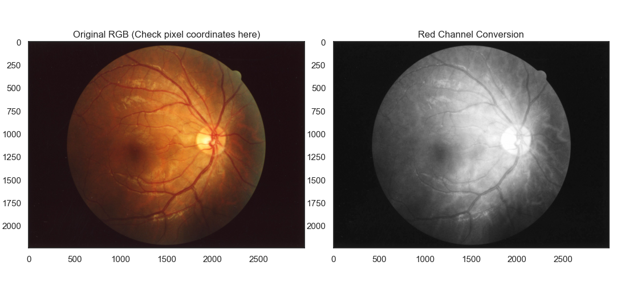
Figure 2.49. Original Input Image and Histogram
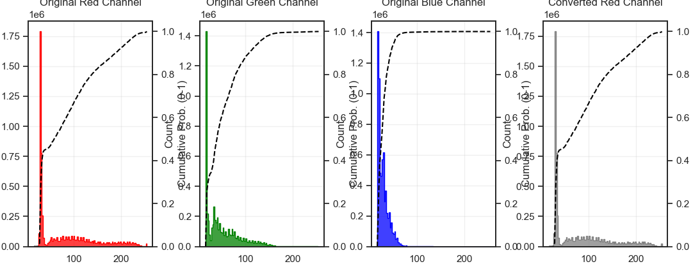
Figure 2.50. RGB Channel Histogram Overview
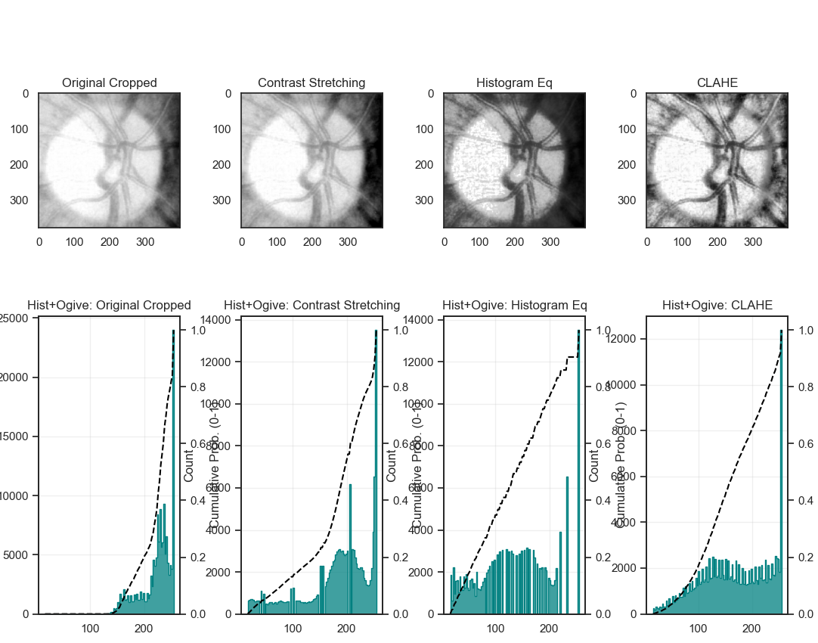
Figure 2.51. Image Enhancement
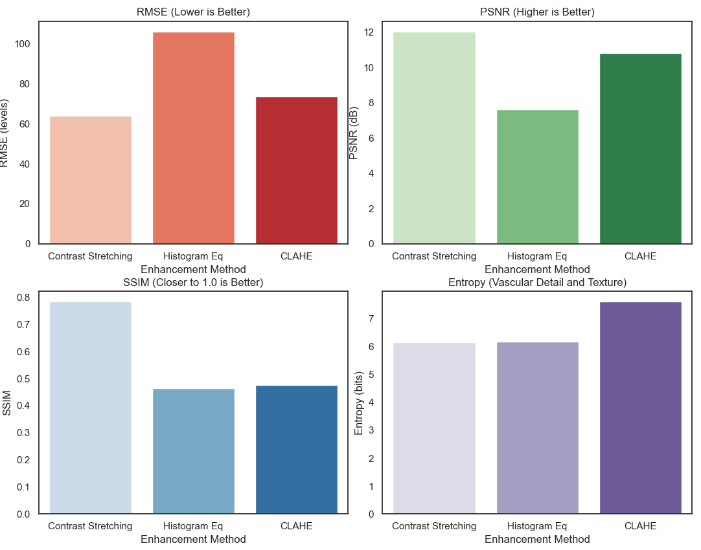
Figure 2.52. Performance Evaluation
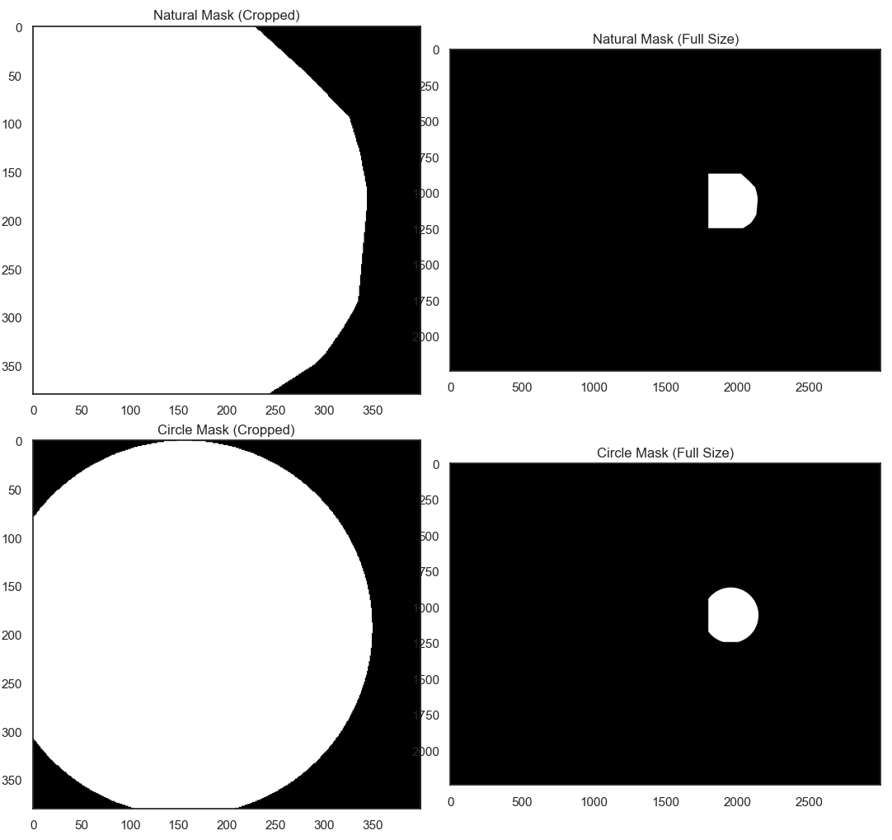
Figure 2.53. Convex-Hull and Circle Masking
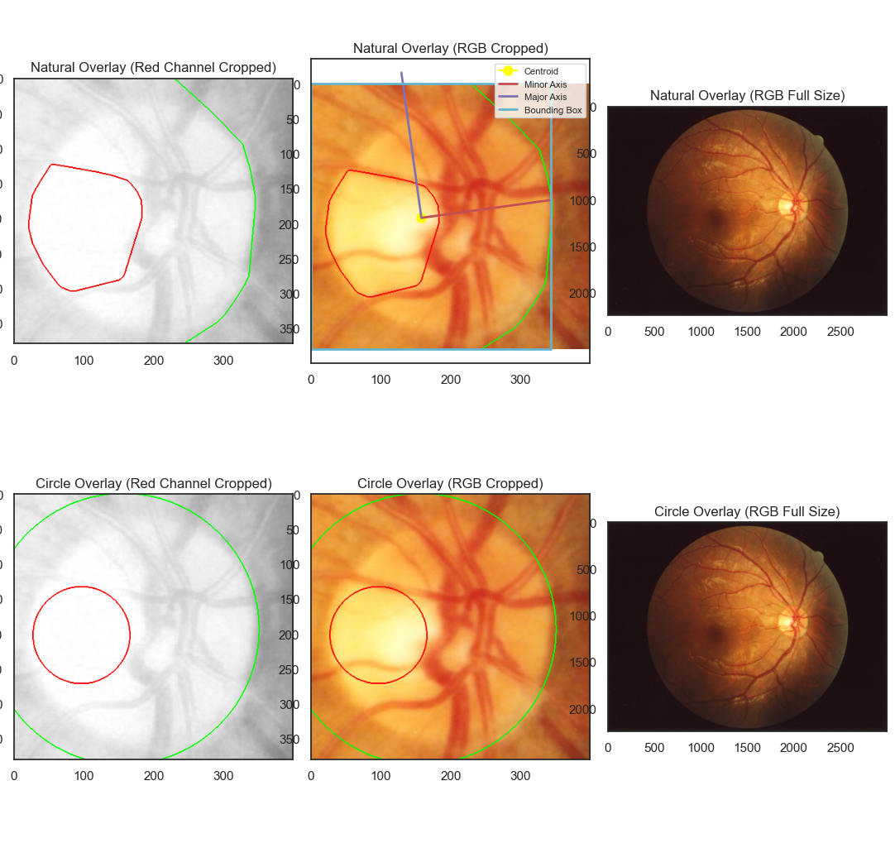
Figure 2.54. Extracted Optic Disk Overlay
The processing of the first healthy fundus case begins with the visualization of the full-colour RGB image and its corresponding global histogram in Figure 2.49. To identify the optimal spectral representation for segmentation, the system performs a colour channel decomposition, as shown in Figure 2.50. The Green channel is observed to highlight the vasculature, while the Red channel provides the highest contrast for the Optic Disc, which appears as a bright, reflective region. The statistical justification for this spectral choice is further visualized in the histogram comparison in Figure 2.50, showing the intensity distribution shifts across the channels.
Following the spectral analysis, a localized Region of Interest (ROI) is established through targeted cropping. The subsequent enhancement evaluation in Figure 2.51 and the performance metrics in Figure 2.52 demonstrate that CLAHE effectively optimizes the visibility of the neuroretinal rim without over-amplifying the background pigments. The segmentation pipeline, illustrated in Figure 2.53, highlights the necessity of morphological restoration. As implemented in the FundusProcessor code, the binary_opening operation prunes the intersecting blood vessels, while the binary_fill_holes operation reconstructs the solid core of the Optic Disc. The final diagnostic overlay, presented in Figure 2.54, provides a visual confirmation of the segmented OD boundaries. The quantitative results in Table 2.9 summarize the morphological and intensity features, including the "Mean Intensity" of the disc, which serves as a baseline for a healthy neuroretinal rim.
Table 2.9. Extracted Features
Feature Name | Brief Description | Natural (Convex Hull) | Perfect Circle
OD Area (px^2) | Total area of Optic Disc. | 119207 | 111100
Cup Area (px^2) | Total area of Optic Cup. | 22094 | 14685
NRR Area (px^2) | Neuro-Retinal Rim Area (OD - Cup). | 97113 | 96415
CDR (Ratio) | Cup-to-Disc Ratio. | 0,4305 | 0,3636
Circularity | Anatomical roundness. | 0,8471 | 0,9039
Mean Int (0-255) | Average OD pixel brightness. | 235,92 | 236,58
Variance | Brightness intensity spread. | 193,85 | 200,05
Skewness | Asymmetry of intensity. | -0,2797 | -0,4446
Kurtosis | Peakedness of intensity. | -0,6445 | -0,3003
Entropy (bits) | Information complexity and texture. | 5,4013 | 5,3867
GLCM Contrast | Local contrast and depth. | 2,4342 | 2,525
GLCM Homogeneity | Uniformity of local pixel textures. | 0,5874 | 0,5835

b. Fundus Retina Retinography
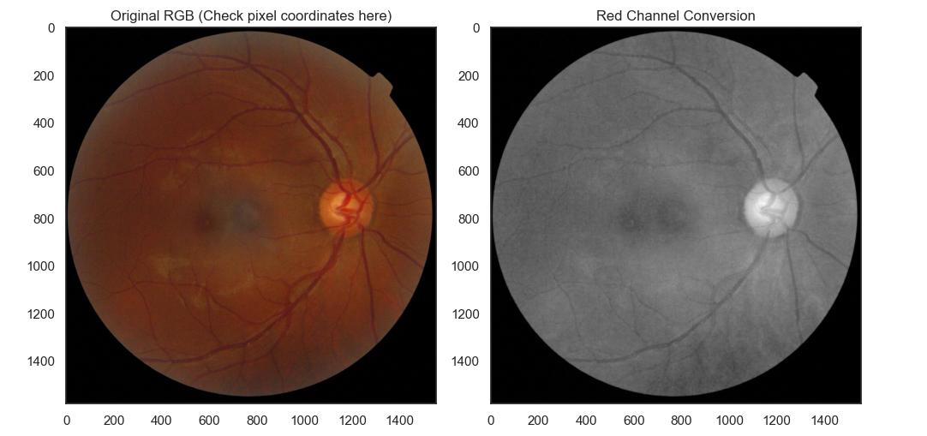
Figure 2.55. Original Input Image and Histogram
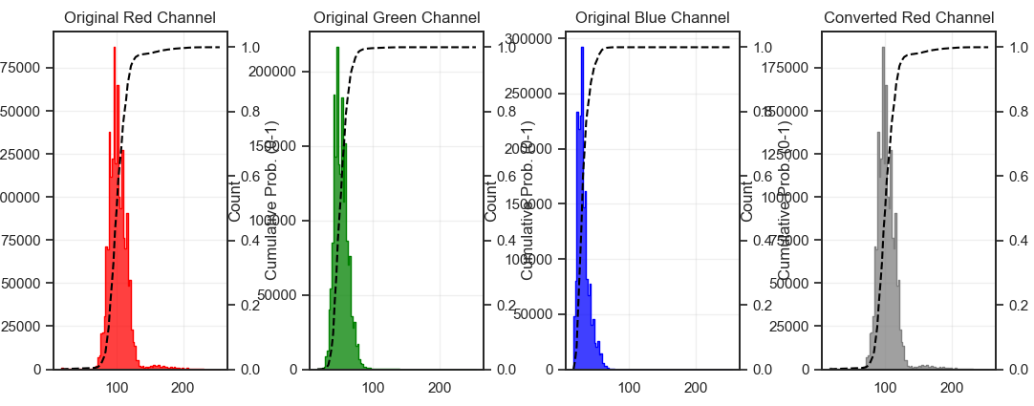
Figure 2.56. RGB Channel Histogram Overview
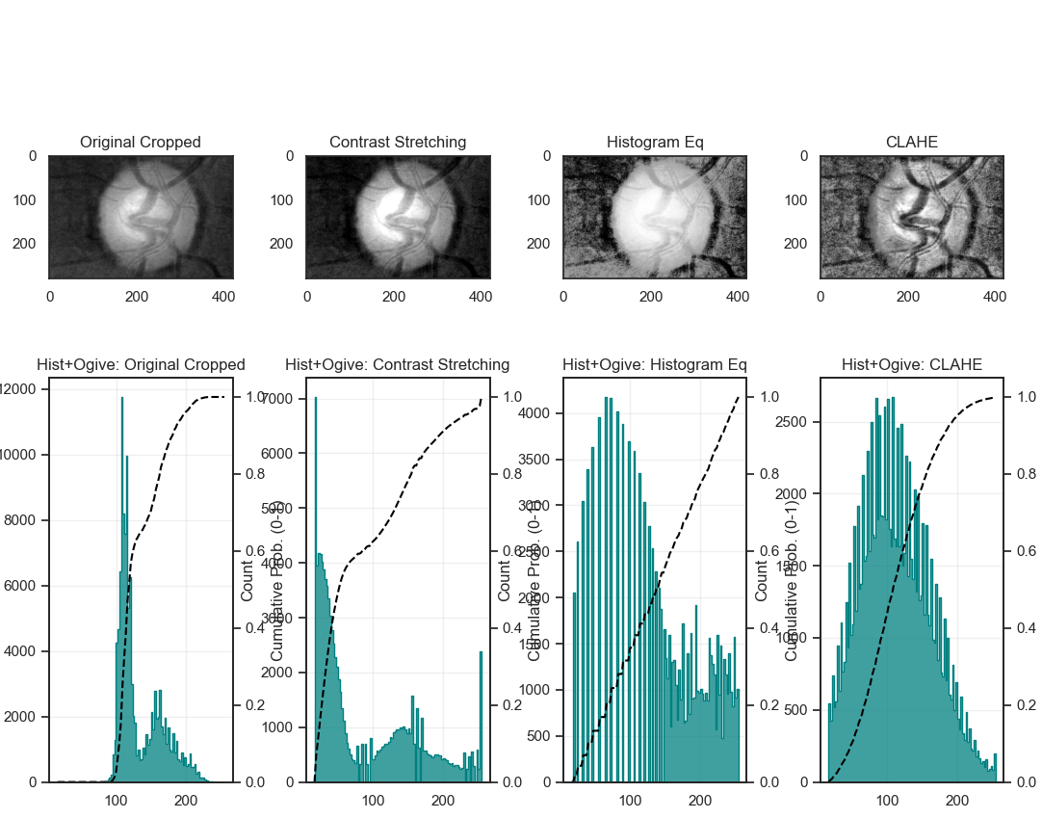
Figure 2.57. Image Enhancement
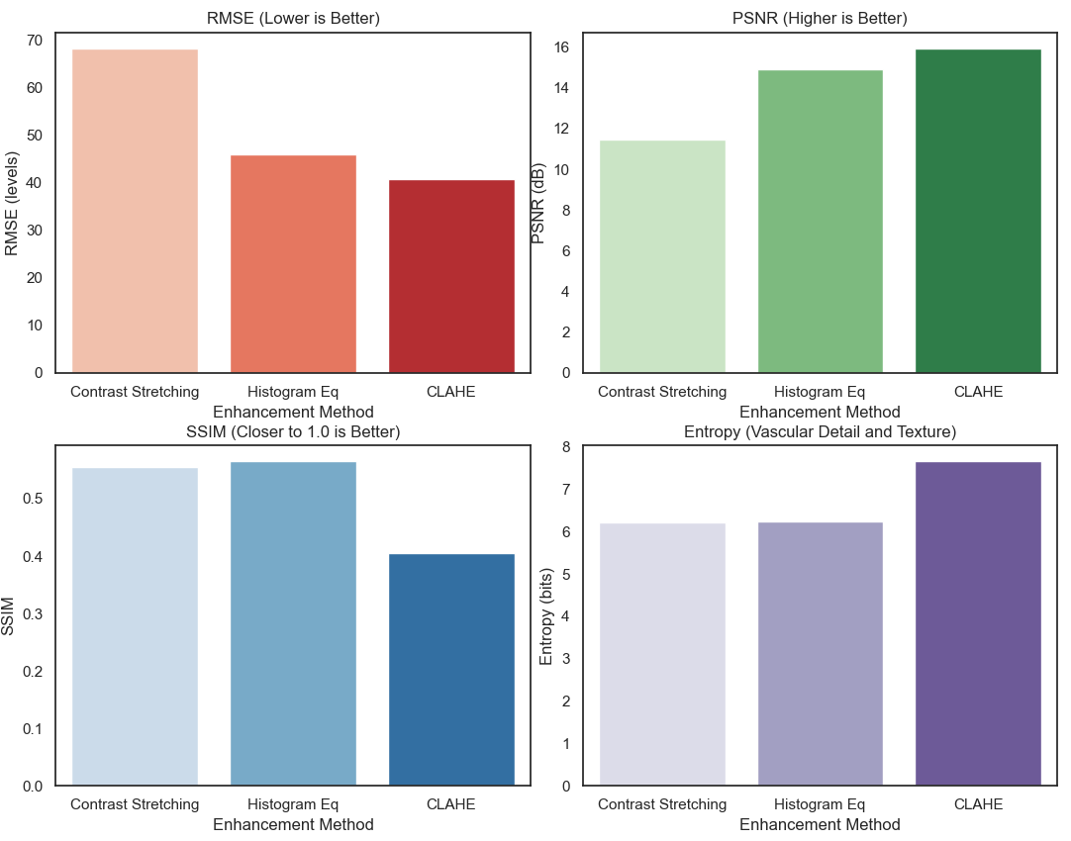
Figure 2.58. Performance Evaluation
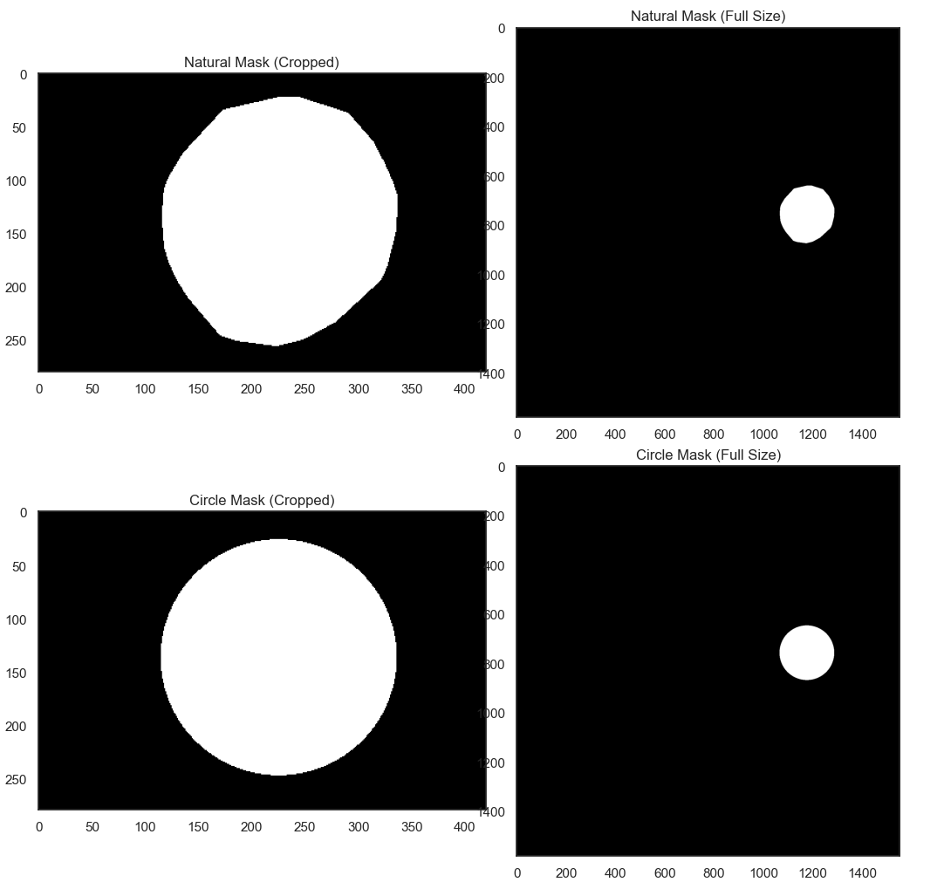
Figure 2.59. Convex-Hull and Circle Masking
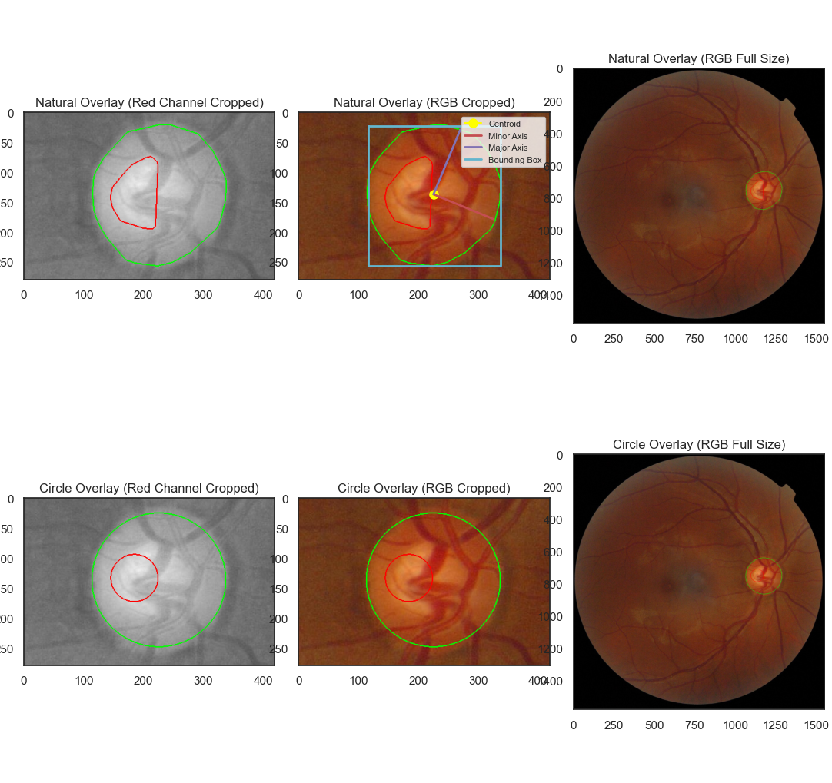
Figure 2.60. Extracted Optic Disk Overlay
The second case, involving a Retinography image, demonstrates the robustness of the algorithm under different photographic conditions. The initial image and histogram in Figure 2.55 show a slightly different exposure profile compared to the normal case. However, the channel decomposition in Figure 2.56 and the histograms successfully identify the relevant intensity markers for the Optic Disc. The localized cropping isolates the OD, providing a focused input for the enhancement stage.
The comparative enhancement results in Figure 2.57 and the metric bar charts in Figure 2.58 reveal that Global Histogram Equalization introduces significant noise, whereas CLAHE maintains high Structural Similarity (SSIM). The multi-stage segmentation process is documented in Figure 2.59, where the algorithm overcomes the interference of thick vascular structures passing through the disc center. The final "Natural Overlay" and "Circle Overlay" in Figure 2.60 illustrate the precision of the measure.label and measure.regionprops functions in identifying the centroid and bounding box of the disc. According to Table 2.10, the extracted features, such as "Circularity" and "Intensity Variance", provide objective indicators of the disc's topological integrity. These metrics are crucial for clinical assessment, as any deviation in the disc's shape or intensity distribution could serve as an early computational indicator for conditions like glaucoma or optic nerve atrophy.
Table 2.10. Extracted Features
Feature Name | Brief Description | Natural (Convex Hull) | Perfect Circle
OD Area (px^2) | Total area of Optic Disc. | 39966 | 38565
Cup Area (px^2) | Total area of Optic Cup. | 6825 | 4639
NRR Area (px^2) | Neuro-Retinal Rim Area (OD - Cup). | 33141 | 33926
CDR (Ratio) | Cup-to-Disc Ratio. | 0,4132 | 0,3468
Circularity | Anatomical roundness. | 0,8994 | 0,9043
Mean Int (0-255) | Average OD pixel brightness. | 170,6 | 171,51
Variance | Brightness intensity spread. | 432,21 | 422,64
Skewness | Asymmetry of intensity. | 0,5557 | 0,5454
Kurtosis | Peakedness of intensity. | -0,2221 | -0,2269
Entropy (bits) | Information complexity and texture. | 6,3263 | 6,3072
GLCM Contrast | Local contrast and depth. | 7,587 | 7,592
GLCM Homogeneity | Uniformity of local pixel textures. | 0,3765 | 0,3764

2.3.4. Ultrasound for Fetus Head Segmentation
The final modality in the processing suite is 2D Ultrasound (USG), which is primarily used to extract fetal cranial biometry. The objective of this sub-chapter is to evaluate the system's performance in navigating the high levels of speckle noise inherent in sonography and its accuracy in fitting a mathematical ellipse to the fetal skull. The analysis follows two test cases representing different gestational stages and cranial orientations.
a. Index “166_HC”
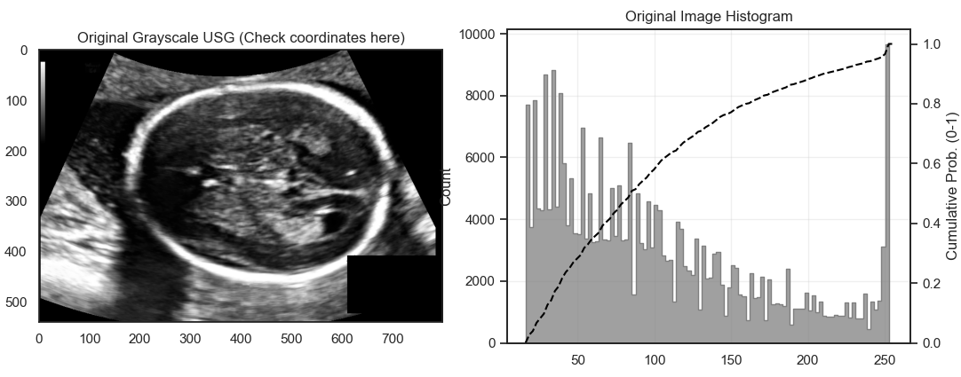
Figure 2.61. Original Input Image and Histogram
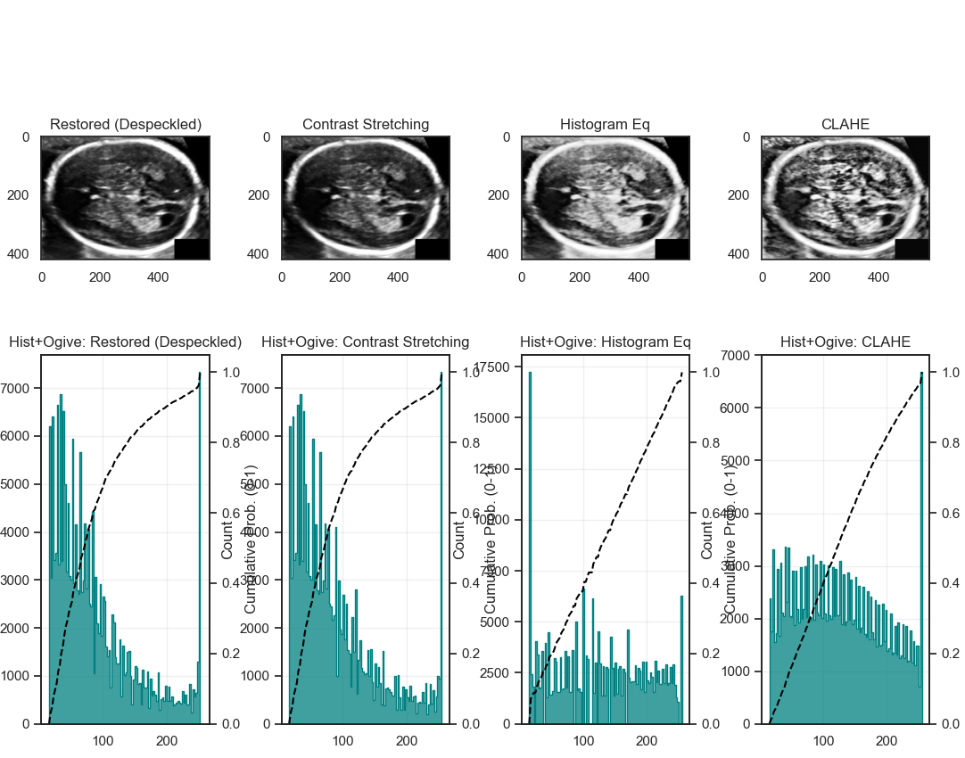
Figure 2.62. Image Enhancement
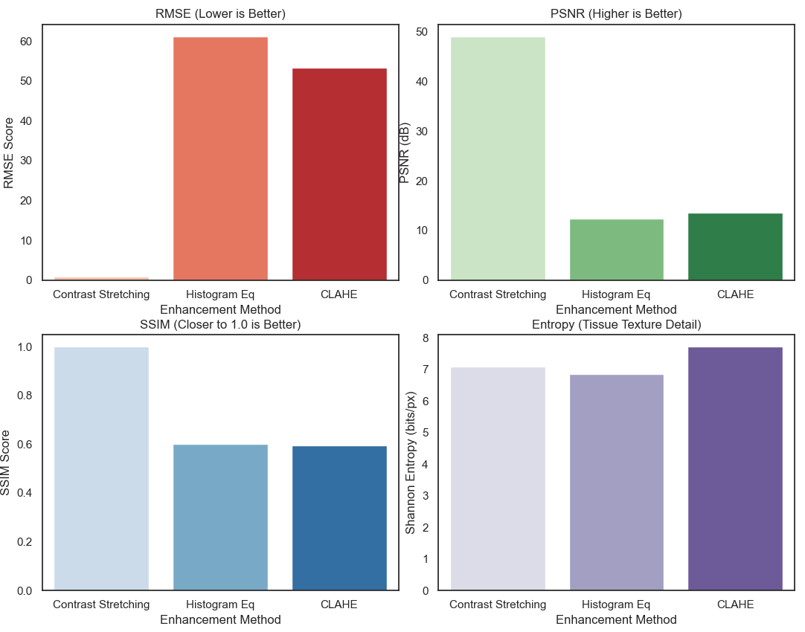
Figure 2.63. Performance Evaluation
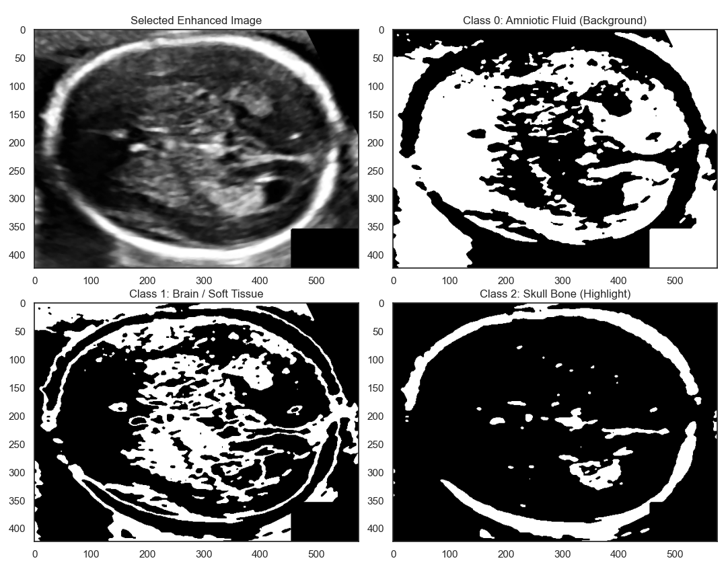
Figure 2.64. Multi-Otsu Classes Overview
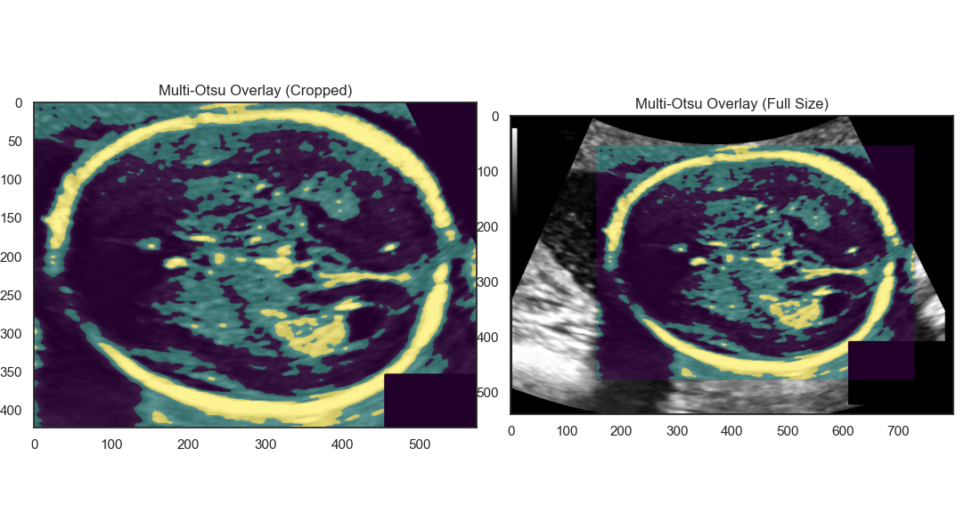
Figure 2.65. Multi-Otsu Overlay
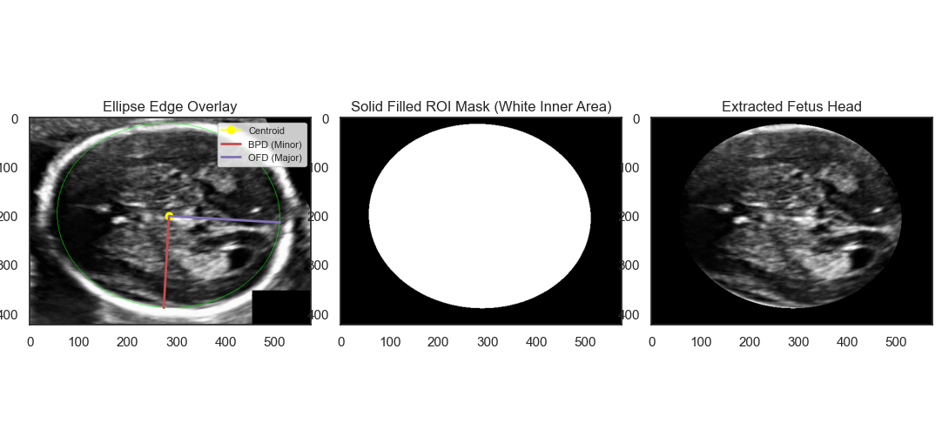
Figure 2.66. Extracted Fetus Head
The analysis for the first fetal case begins with the display of the original ultrasound image and its intensity histogram in Figure 2.61. Given the noisy nature of ultrasound, the restoration step is paramount. As shown in Figure 2.62, the application of a non-linear Median Filter (kernel size 5) successfully suppresses granular speckle noise while maintaining the sharp hyperechoic boundaries of the skull. This restoration provides a significantly cleaner input for the enhancement stage compared to the raw data. The comparative results in Figure 2.63 and the performance metrics in Figure 2.64 indicate that CLAHE achieved a superior balance between contrast gain and structural fidelity, revealing a clear distinction between the amniotic fluid and the cranial bone.
The segmentation phase utilizes Multi-Otsu thresholding to categorize the acoustic echoes. As visualized in Figure 2.65, the algorithm effectively identifies three regions: the anechoic fluid, the hypoechoic brain tissue, and the hyperechoic skull. Following the logic of UltrasoundProcessor, morphological closing is applied to bridge the fontanelle gaps, resulting in a continuous cranial ring. The final result in Figure 2.66 shows the extracted fetus head with a precise elliptical overlay. According to Table 2.11, the system extracted the Biparietal Diameter (BPD) and Occipitofrontal Diameter (OFD) with high precision. The Head Circumference (HC) calculated via Ramanujan’s formula provides a robust clinical estimation, while the circularity and eccentricity values confirm that the segmented shape aligns with standard fetal anatomy.
Table 2.11. Extracted Features
Biometric Feature | Description | Measured Value
BPD (px) | Biparietal Diameter (Minor Axis). Key for Gestational Age. | 376,31
OFD (px) | Occipitofrontal Diameter (Major Axis). | 454,11
HC (px) | Head Circumference (Ramanujan Approximation). | 1307,28
Area (px^2) | Fetal Head Area within the skull. | 134211,8
Cephalic Index | Ratio of BPD/OFD. Normal range: 0.75 - 0.85. | 0,8287
Eccentricity | Deviation from circularity (0 = circle, approaching 1 = elongated line). | 0,5597
Equivalent Diameter (px) | Diameter of a circle with the same area as the head. | 413,38
Circularity | Perfect circle ratio (4*pi*Area / HC^2). | 0,9869
Mean Brain Echogenicity (0-255) | Average pixel brightness inside the skull (Fluid vs Tissue). | 64,71
Brain Tissue Variance | Pixel spread/homogeneity inside the skull. | 2392,91

b. Index “87_HC”
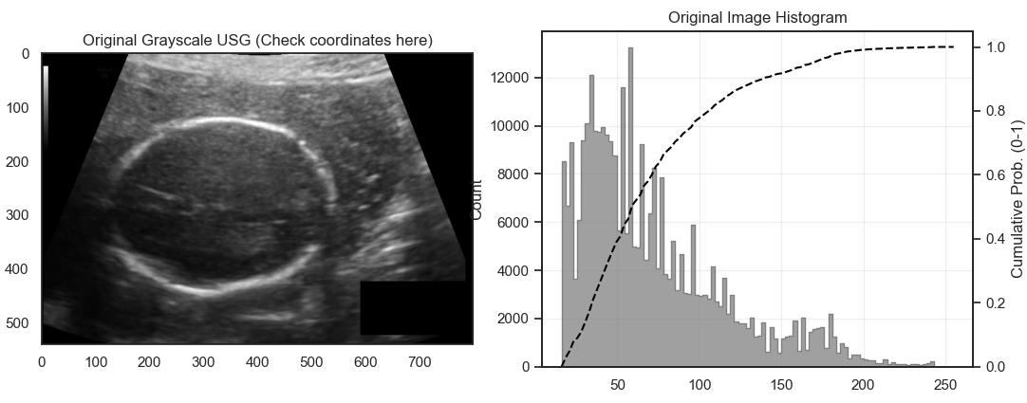
Figure 2.67. Original Input Image and Histogram
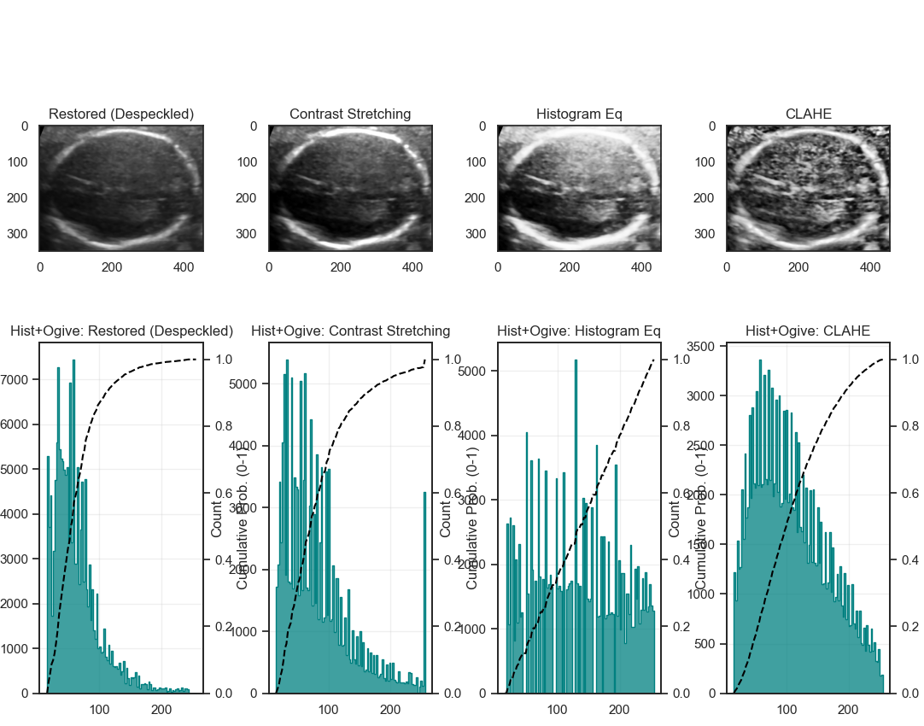
Figure 2.68. Image Enhancement
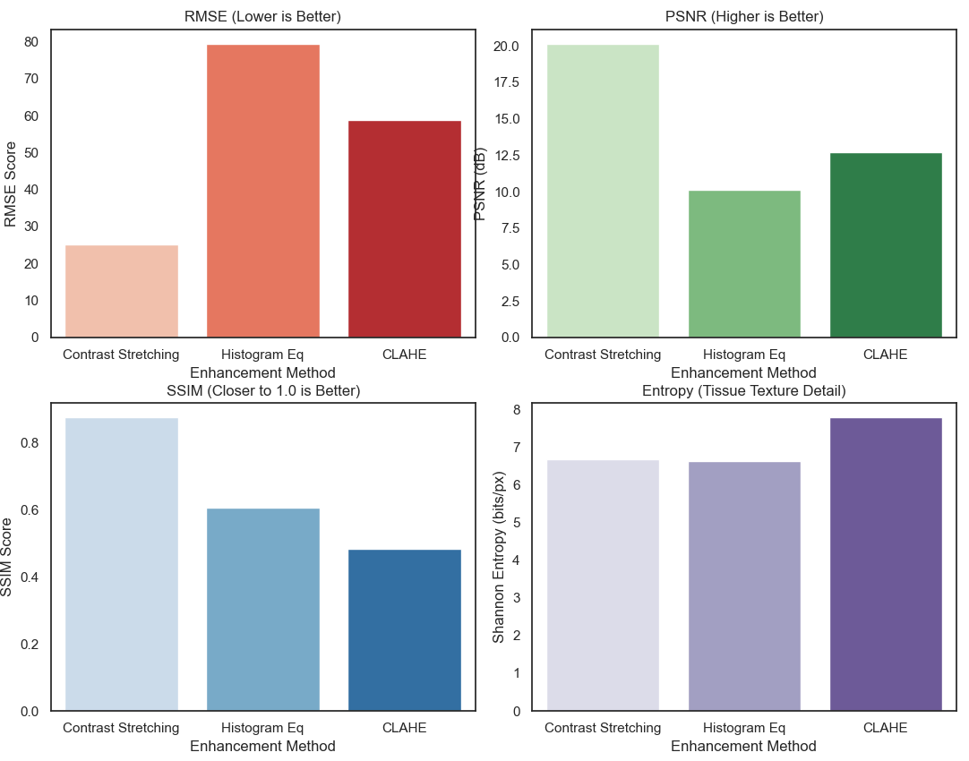
Figure 2.69. Performance Evaluation
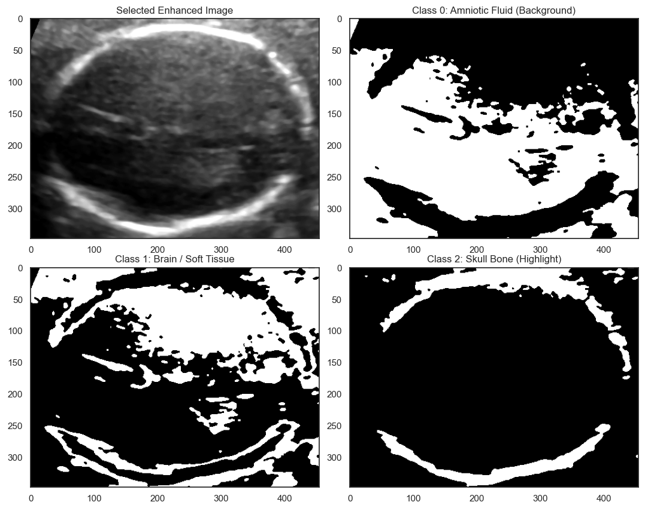
Figure 2.70. Multi-Otsu Classes Overview
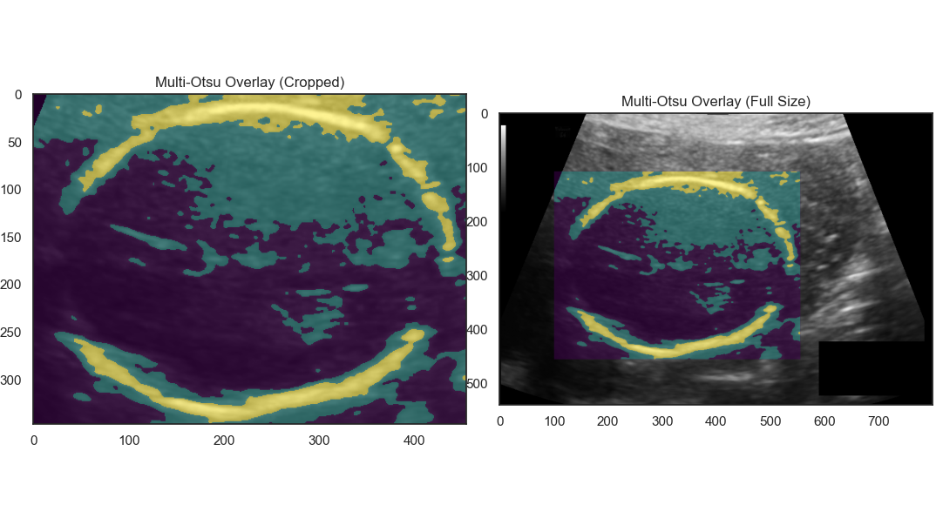
Figure 2.71. Multi-Otsu Overlay
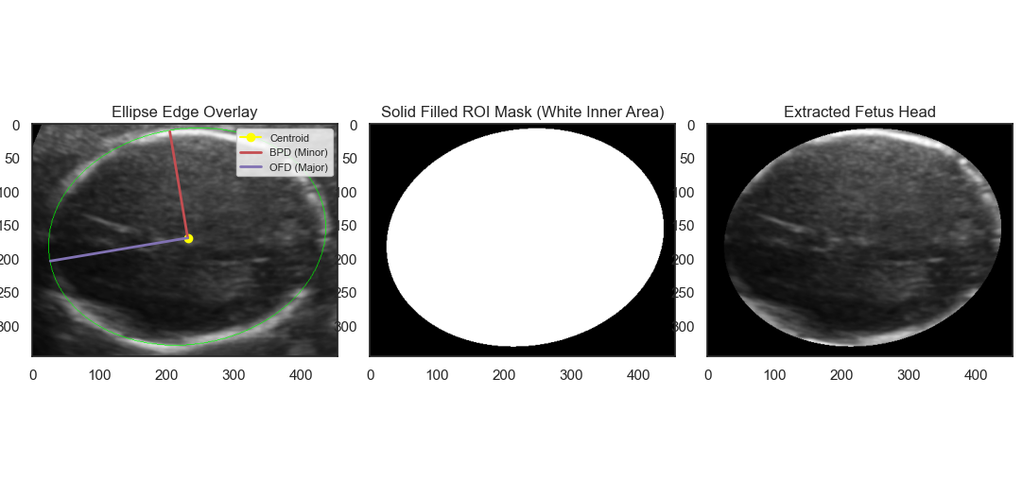
Figure 2.72. Extracted Fetus Head
The second test case, "Fetus 87_HC," involves a different cranial orientation as shown in the initial plot in Figure 2.67. The system demonstrates stability in its restoration pipeline; Figure 2.68 illustrates how the Median Filter effectively homogenizes the brain parenchyma without losing the boundary details of the skull. The enhancement histograms in Figure 2.69 and the bar chart metrics in Figure 2.70 confirm that CLAHE remains the most reliable method for accentuating the skull contour, as evidenced by its high Shannon Entropy and structural similarity values.
The segmentation process documented in Figure 2.71 demonstrates the algorithm's ability to handle acoustic shadowing, which often causes partial "disappearances" of the skull border. By leveraging morphological restoration and largest blob selection, the system reconstructs the full cranial silhouette, as seen in the final overlay in Figure 2.72. This overlay features a magenta line for the Major Axis (OFD) and a red line for the Minor Axis (BPD), intersecting at the calculated centroid. As tabulated in Table 2.12, all biometric parameters are successfully quantified. The low variance in the intensity features within the ROI indicates a consistent classification of the hyperechoic bone, validating the accuracy of the automated Multi-Otsu thresholding and geometric extraction pipeline for obstetric diagnosis.
Table 2.12. Extracted Features
Biometric Feature | Description | Measured Value
BPD (px) | Biparietal Diameter (Minor Axis). Key for Gestational Age. | 299,04
OFD (px) | Occipitofrontal Diameter (Major Axis). | 422,27
HC (px) | Head Circumference (Ramanujan Approximation). | 1141,31
Area (px^2) | Fetal Head Area within the skull. | 99175,47
Cephalic Index | Ratio of BPD/OFD. Normal range: 0.75 - 0.85. | 0,7082
Eccentricity | Deviation from circularity (0 = circle, approaching 1 = elongated line). | 0,7061
Equivalent Diameter (px) | Diameter of a circle with the same area as the head. | 355,35
Circularity | Perfect circle ratio (4*pi*Area / HC^2). | 0,9568
Mean Brain Echogenicity (0-255) | Average pixel brightness inside the skull (Fluid vs Tissue). | 67,55
Brain Tissue Variance | Pixel spread/homogeneity inside the skull. | 3961,26

2.4. Discussion and Evaluation
The experimental results across four distinct biomedical imaging modalities demonstrate the robustness and versatility of the developed processing suite. A critical observation in the enhancement phase is the consistent superiority of Contrast Limited Adaptive Histogram Equalization (CLAHE) over global methods like Histogram Equalization (HE) and linear Contrast Stretching. While HE often caused over-saturation and noise amplification, particularly in the speckle-heavy environment of Ultrasound and the high-opacity regions of Pneumonia X-rays, CLAHE successfully maintained structural integrity (SSIM) while maximizing local contrast. This local adaptivity is essential for medical diagnostics where subtle intensity variations, such as the neuroretinal rim in fundus images or the edge of the fetal skull, carry significant clinical weight.
In terms of segmentation performance, the integration of Multi-Otsu thresholding and advanced mathematical morphology proved highly effective in isolating complex biological ROIs. The use of a "morphological scalpel" (opening and closing operations) was instrumental in resolving the "silhouette sign" in pneumonia cases and detaching the cardiac silhouette from the sternum in axial CT slices. However, the evaluation also revealed that purely intensity-based segmentation remains sensitive to extreme pathological consolidations. For instance, in severe pneumonia cases, the edge gradient strength significantly decreased, indicating a blurred boundary that requires careful morphological refinement to prevent the under-segmentation of the heart. This highlights the importance of the developed restoration filters, such as the Median filter for Ultrasound, which served as a prerequisite to ensure the stability of the segmentation masks.
Quantitatively, the transition from pixel-based analysis in TIFF/JPEG formats to physical-based measurements in DICOM represents a significant advancement in clinical utility. By incorporating metadata such as pixel spacing and Hounsfield Units (HU), the system provided objective radiodensity values and physical measurements (mm/cm²) that are directly comparable to clinical standards. The extraction of second-order texture features through GLCM (Contrast and Homogeneity) further enriched the diagnostic profile, allowing for a clearer differentiation between normal tissue and pathological anomalies across all modalities. Overall, the system successfully transformed raw visual data into a structured feature set, providing a reliable computational foundation for automated medical assessment.
CHAPTER III. CONCLUSION
This project successfully developed and implemented a comprehensive Medical Imaging Processing Suite capable of automating Region of Interest (ROI) segmentation and feature extraction across four key modalities: Chest X-Ray, CT-Scan (TIFF and DICOM), Retinal Fundus, and Fetal Ultrasound. Through a structured pipeline of restoration, enhancement, and morphological segmentation, the system effectively quantified critical clinical parameters, such as the Cardiothoracic Ratio (CTR) for cardiomegaly screening, the Optic Disc (OD) topology for glaucoma assessment, and fetal cranial biometry (BPD, OFD, and HC) for gestational monitoring. The results validate that a combination of CLAHE for enhancement and Multi-Otsu for segmentation provides a robust framework that maintains high structural fidelity while revealing pathological details.
And despite the successful implementation, several avenues for future enhancement have been identified to increase the system's clinical reliability. Future iterations could integrate Deep Learning models, such as U-Net or Mask R-CNN, to handle even more complex pathological variations where intensity-based thresholding may struggle. Additionally, expanding the dataset to include a wider variety of pathologies and multi-vendor imaging equipment would enhance the algorithm's generalizability. Finally, the development of a real-time 3D reconstruction module for CT and Ultrasound data could provide a more holistic anatomical view, further supporting medical practitioners in complex surgical planning and diagnostic decision-making.

REFERENCES
- R. C. Gonzalez and R. E. Woods, Digital Image Processing, 4th ed. NJ, USA: Pearson, 2018.
- W. Burger and M. J. Burge, Digital Image Processing: An Algorithmic Introduction Using Java, 2nd ed. London, UK: Springer-Verlag, 2016.
- N. F. Hikmah, "Introduction to Image Processing," Lecture Notes, Biomedical Engineering Dept., Institut Teknologi Sepuluh Nopember, Surabaya, 2026.
- N. F. Hikmah, "Image Processing [Part 1]," Lecture Notes, Biomedical Engineering Dept., Institut Teknologi Sepuluh Nopember, Surabaya, 2026.
- N. F. Hikmah, "Images are array [part 2: DICOM]," Lecture Notes, Biomedical Engineering Dept., Institut Teknologi Sepuluh Nopember, Surabaya, 2026.
- N. F. Hikmah, "Histogram, Image Enhancement," Lecture Notes, Biomedical Engineering Dept., Institut Teknologi Sepuluh Nopember, Surabaya, 2026.
- N. F. Hikmah, "Edges Detection," Lecture Notes, Biomedical Engineering Dept., Institut Teknologi Sepuluh Nopember, Surabaya, 2026.
- N. F. Hikmah, "Morphological Filter," Lecture Notes, Biomedical Engineering Dept., Institut Teknologi Sepuluh Nopember, Surabaya, 2026.
- R. Sammouda, R. M. Jomaa, and H. Mathkour, "Heart Region Extraction and Segmentation from Chest CT Images using Hopfield Artificial Neural Networks," in Proc. 2012 International Conference on Information Technology and e-Services, 2012, pp. 1-5.
- S. Inkong-ngam, K. Tamee, and R. Wangkeeree, "Automated Optic Disc and Cup Segmentation Using Mask R-CNN for Glaucoma Assessment," in Proc. 2025 IEEE International Conference on Cybernetics and Innovations (ICCI), 2025, doi: 10.1109/ICCI64209.2025.10987508.
- M. N. Hasan and A. B. M. A. Hossain, "Automatic Measurement of Fetal Head Circumference from Ultrasound Images using Deep Ensemble Transfer Learning Regression Model," in Proc. 2025 International Conference on Quantum Photonics, Artificial Intelligence, and Networking (QPAIN), 2025, doi: 10.1109/QPAIN66474.2025.11171851.
- P. Loughna, L. Chitty, T. Evans, and T. Chudleigh, "Fetal size and dating: charts recommended for clinical obstetric practice," Ultrasound, vol. 17, no. 3, pp. 161–167, 2009.
- C. Ortiz-Toro, A. García-Pedrero, M. Lillo-Saavedra, and C. Gonzalo-Martín, "Automatic detection of pneumonia in chest X-ray images using textural features," Computers in Biology and Medicine, vol. 145, p. 105466, 2022.
- E. Fernández, et al., "SAFARI: shape analysis for AI-segmented images," BMC Medical Imaging, vol. 22, no. 129, 2022.
- A. Roy, et al., "DeepEyeNet: Adaptive Genetic Bayesian Algorithm Based Hybrid ConvNeXtTiny Framework For Multi-Feature Glaucoma Eye Diagnosis," arXiv preprint arXiv:2501.11168, 2025.
- T. B. Chandra, B. K. Singh, and D. Jain, "Disease Localization and Severity Assessment in Chest X-Ray Images using Multi-Stage Superpixels Classification," Computer Methods and Programs in Biomedicine, vol. 222, p. 106947, 2022.
- J. Ra, H. Shin, C. Park, Y. X. Wang, and D. Shin, "AI-based measurement of cardiothoracic ratio in chest X-rays and prediction of echocardiographic congestive heart failure," IJC Heart & Vasculature, vol. 58, p. 101678, 2025.
- B. Sumathy and S. Poornachandra, "Feature Extraction in Retinal Fundus Images," in Proc. International Conference on Information Communication and Embedded Systems, 2013.
- A. I. L. Namburete and J. A. Noble, "Fetal cranial segmentation in 2D ultrasound images using shape properties of pixel clusters," in Proc. 2013 IEEE 10th International Symposium on Biomedical Imaging (ISBI), 2013, pp. 504-507.
- Y. Xie and K. Nagamune, "Measurement of Cardiothoracic Ratio and Detection of Cardiomegaly in X-Ray Images Using Deep Learning," in Proc. 2022 International Conference on Machine Learning and Cybernetics (ICMLC), 2022, pp. 265-270.

